# Numerical results

In this chapter, we present simulation and analytical results to demonstrate system performance in the following four scenarios: (1) only one node and the energy consumed by each packet is identical, (2) only one node and the energy consumed by each packet is different, (3) a network with three interconnected nodes and the energy consumed by each packet is identical, (4) a network with three interconnected nodes and the energy consumed by each packet is different. In addition, different parameters are analyzed for their effects on the system performance as well.

Specifically, we devised ten performance measures to evaluate the effectiveness of our proposed system models, not only for all packets and HP/LP packets, but also for each node in the three-node network.

## Scenario 1

Unless otherwise stated, the default values of the various system parameters are as follows: $λ_{H}=0.1$, $λ_{L}=0.5$ $β=0.3$, $α_{H}=0.02$, $α_{L}=0.01$, $μ_{H}=μ_{L}=1$, the packet queue size $(N)$ is 9, and energy queue size $(K)$ is 100. The energy requirement for both HP and LP packets is one unit, i.e., $e_{H}=e_{L}=1$. We assume that the HP and LP packs have the same regular battery usage probability, i.e., $θ_{H}=θ_{L}$, for the convenience of discussion. Moreover, in order to study the impact of different energy arrival rates on the use of the regular battery, a case of is considered simultaneously.

It is noted that the energy request rate is , and the effective service rate is defined as

In this scenario, we first use the default parameters to determine suitable regular battery usage probabilities $θ_{H}/θ_{L}$. As shown in Fig. 5 - 1 and Fig. 5 - 2, when $β=0.3$, it can be clearly observed that as $θ_{H}/θ_{L}$ gradually increases, $P_{tl}$ decreases and $RECR$ increases accordingly. This is because the larger , the more packets can enter the server immediately by using the regular battery before being blocked or running out of patience. However, this also leads to a shorter lifetime of the regular battery since it drains more energy. For the above reasons, we set as the upper limit, and select the minimum on the curve such that the upper bound is not violated as the suboptimal parameter value, that is, . Afterwards, the influences of HP packet arrival rate on various performance measures are studied as follows, and the results are shown in Fig. 5 - 3 to Fig. 5 - 12.

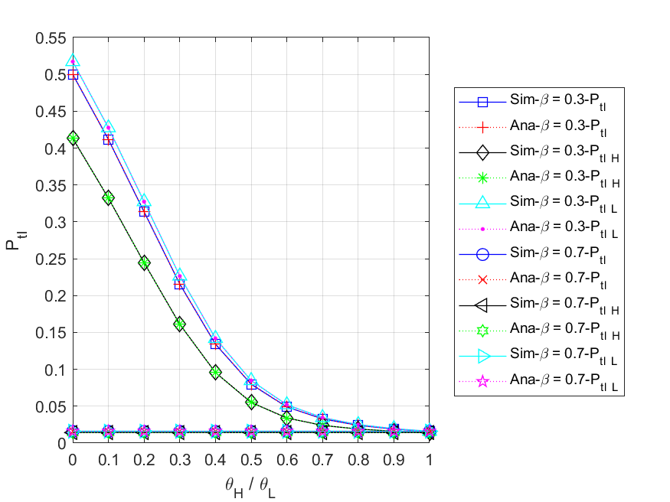

Fig. 5 - 1: The total loss probability of all ($HP,LP$) packets vs. the regular battery usage probabilities

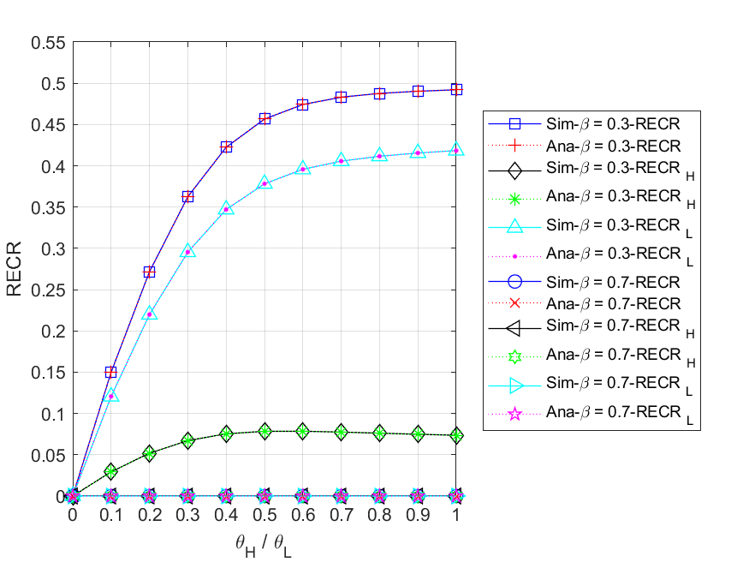

Fig. 5 - 2: The regular energy consumption ratio for serving all ($HP,LP$) packets vs. the regular battery usage probabilities

* + 1. **Energy arrival rate**

Fig. 5 - 3 shows the relationship between the expected number of all $(HP,LP)$ packets in the system and HP packet arrival rate $λ_{H}$ for different energy arrival rates . First, for or , we observe that their respective , , and all increase as increases. This is because the higher the HP packet arrival rate, the more packets are able to enter the system. Second, since HP packets have non-preemptive priority over LP packets, most LP packets are backlogged in the queue. This results in that will always be greater than for both and . Third, we compare the curves of and for , , and , respectively. It is obvious to find the curve of is higher than that of for both and . This is because the higher the energy arrival rate, the more sufficient energy in the energy queue, and the fewer packets need to wait in the system. Additionally, it is worth pointing out that in the case of ${E[N]}_{H}$, the curve for $β=0.3$ is initially higher than the curve for $β=0.7$ and then falls below it. We discuss this situation in two parts. In the former part, the effective service rate with $β=0.7$ is greater than the energy request rate, but that with is less than it. Therefore, has enough energy to provide the service, and its will also be lower. In the latter part, both the energy supplies with and are insufficient in terms of energy request rate, i.e. $ϕ_{req}>μ_{eff}$. As a result, the lower the energy arrival rate, the longer the packets have to wait in the system, which increases the probability of impatience. Thus, ${E[N]}_{H}$ with $β=0.3$ will be lower than the one with $β=0.7$.

Fig. 5 - 4 shows the relationship between the expected number of all $(HP,LP)$ packets in the packet queue $E[N_{q}]$ $\left({E[N_{q}]}_{H},{E[N_{q}]}_{L}\right)$ and HP packet arrival rate $λ_{H}$ for different energy arrival rates . First, for or , we observe that their respective , , and all increase as increases. This is because the higher the HP packet arrival rate, the more packets are able to enter the queue. Second, since HP packets have non-preemptive priority over LP packets, most LP packets are backlogged in the queue. This results in that will always be greater than for both and . Third, we compare the curves of and for , , and , respectively. It is obvious to find the curve of is higher than that of for both and . This is because the higher the energy arrival rate, the more sufficient energy in the energy queue, and the fewer packets need to wait in the packet queue. Additionally, it is worth pointing out that in the case of ${E[N_{q}]}_{H}$, the curve for $β=0.3$ starts out higher than the curve for $β=0.7$ and ends up slightly below it. We discuss this situation in two parts. In the former part, the effective service rate with $β=0.7$ is greater than the energy request rate, but that with is less than it. Therefore, has enough energy to provide the service, and its will also be lower. In the latter part, both the energy supplies with and are insufficient in terms of energy request rate, i.e. $ϕ_{req}>μ_{eff}$. As a result, the lower the energy arrival rate, the longer the packets have to wait in the queue, which increases the probability of impatience. Thus, ${E[N_{q}]}_{H}$ with $β=0.3$ will be lower than the one with $β=0.7$.

Fig. 5 - 5 shows the relationship between the throughput of all $(HP,LP)$ packets $TH$ $\left({TH}_{H},{TH}_{L}\right)$ and the HP packet arrival rate $λ_{H}$ for different energy arrival rates . First, we compare the curves of and for , , and , respectively. It is obvious to find that all curves with are lower than those with . This is because the higher the energy arrival rate, the more sufficient energy in the energy queue, and the more packets can be served. Second, for or , we can observe that increases as increases, while gradually decreases. This is because HP packets have a non-preemptive priority over LP packets. Therefore, the higher HP packet arrival rate, the more HP packets enter the server to complete the service, the fewer LP packets can be served. Additionally, since the regular battery acts as an auxiliary energy source, it allows the throughput to increase without being limited by the arrival rate of harvesting energy. Nevertheless, the energy supply will become insufficient as $λ_{H}$ increases, which makes the packets in the queue vulnerable to impatience and more difficult to be served. This results in $TH$ with $β=0.3$ rising first, then falling, and $TH$ with $β=0.7$ showing a slow upward trend at the end.

Fig. 5 - 6 shows the relationship between the mean waiting time of all $(HP,LP)$ packets $E[W]$ $\left({E\left[W\right]}_{H},{E\left[W\right]}_{L}\right)$ and the HP packet arrival rate $λ_{H}$ for different energy arrival rates . First, for or , we observe that their respective $E[W]$, ${E\left[W\right]}_{H}$, and ${E\left[W\right]}_{L}$ all increase as increases. This is because the higher the HP packet arrival rate, the more packets are able to enter the system. Second, since HP packets have non-preemptive priority over LP packets, most LP packets are backlogged and waiting in the queue. This results in that will always be greater than for both and . In addition, it is worth noting that the difference between the ${E\left[W\right]}_{H}$ curves for $β=0.3$ and $β=0.7$ will appear smaller than the difference between the ${E\left[W\right]}_{L}$ curves. The reason is that regardless of the energy arrival rate, most of the energy will be used to serve the HP packets before the LP packets due to the priority policy.

Fig. 5 - 7 shows the relationship between the energy loss probability $P_{el}$ and the HP packet arrival rate $λ_{H}$ for different energy arrival rates . First, for , we can observe that remains zero. This is because energy is always insufficient to provide the service (), so whenever an energy unit arrives, it will be immediately consumed by the packet waiting in the queue. Second, for $β=0.7$, it can be found that the curve of $P_{el}$ decreases sharply with the increase of $λ_{H}$ and finally remains at zero. The reason is that the higher HP packet arrival rate, the more packets need to be served. This causes most of the arriving energy to be consumed immediately, and the energy queue is less likely to become full.

Fig. 5 - 8 shows the relationship between the blocking probability of all $(HP,LP)$ arrived packets $P_{bl}$ $(P_{bl_H}, P_{bl_L})$ and the HP packet arrival rate $λ_{H}$ for different energy arrival rates . First, for and , we can observe that their respective , , and are the same. This is because once the packet queue is full, an arrival packet will be blocked regardless of its priority. Second, since more and more packets enter the system as the HP packet arrival rate increases, it makes the packet queue more likely to become full. Therefore, for both and , their will significantly grow with increasing . Third, we compare the curves of for and simultaneously. It is obvious to find that the curve with is higher than the one with . The reason is that the smaller the energy arrival rate, the longer the packet has to wait in the queue, which makes the packet queue more likely to be full.

Fig. 5 - 9 shows the relationship between the impatient loss probability of all $(HP,LP)$ arrived packets $P_{imp(arr)}$ $(P_{imp\left(arr\right)_H},P_{imp\left(arr\right)_L})$ and the HP packet arrival rate for different energy arrival rates . First, for and 0.7, we can observe that their and curves rise first and then fall with the increase of , while the curves of keep rising. The reason is that with sufficient energy, most packets can enter the system, which results in the number of impatient packets in the queue increasing; however, as the HP packet arrival rate continues to grow until the energy supply gets insufficient, the packet queue will become congested, and a significant number of packets will be blocked out of the system, so the probability of impatience for arrival packets will gradually decrease. On the other hand, for LP packets, where their priority is lower than that of HP packets, the waiting time in the queue is much longer, and impatience is more likely to occur. Second, we compare the curves of and for , , and , respectively. According to the figure, it can be seen that not only the curves with $β=0.3$ are higher than the curves with $β=0.7$ in most cases, but as $λ_{H}$ increases, the pairs of curves will become more and more close or even staggered. This is because in the case of $β=0.3$, the energy supply being relatively insufficient, an arrived packet has a higher blocking probability and an impatient loss probability, meaning that even if it successfully enters the queue, it is still easy to lose patience while waiting. Furthermore, as increases, the situation described in the preceding paragraph becomes more severe, which leads to an accelerated increase in blocked packets. As a result, the number of impatient packets has decreased rapidly for arrived packets, and the two curves of $P_{imp(arr)}$, $P_{imp\left(arr\right)_H}$, and $P_{imp\left(arr\right)_L}$ will get closer.

Fig. 5 - 10 shows the relationship between the impatient loss probability of all $(HP,LP)$ admitted packets $P_{imp(adm)}$ $(P_{imp\left(adm\right)_H},P_{imp\left(adm\right)_L})$ and the HP packet arrival rate for different energy arrival rates . First, for or , we observe that their respective , , and all increase as increases. This is because the higher the HP packet arrival rate, the more likely the system will be congested, therefore, the longer the packets have to wait in the queue, and the more impatient they will become. Second, since HP packets have non-preemptive priority over LP packets, most LP packets are backlogged and waiting in the queue, which makes impatience more likely to occur. As a result, are always greater than for both and . Third, it is obvious to find the curve of is higher than that of for , and . The reason is that the higher the energy arrival rate, the less time a packet needs to wait in the queue, and the less likely it will become impatient.

Fig. 5 - 11 shows the relationship between the total loss probability of all $(HP,LP)$ arrived packets $P_{tl}$ $(P_{tl_H}, P_{tl_L})$ and the HP packet arrival rate $λ_{H}$ for different energy arrival rates . First, for or , we observe that their respective , , and all increase as increases. The main reason is that the higher the HP packet arrival rate, the more likely the system becomes full, therefore, the number of blocked packets will increase rapidly. Second, since HP packets have non-preemptive priority over LP packets, most LP packets are backlogged and waiting in the queue, which makes impatience more likely to occur. As a result, are always greater than for both and . Third, it is obvious to find the curve of is higher than that of for , , and . This is because the lower the energy arrival rate, the easier the packet queue gets congested, and the more likely the packets are lost due to blocking or impatience. Lastly, it should be noted that $P_{tl}$ is equal to the sum of $P_{bl}$ and $P_{imp(arr)}$.

Fig. 5 - 12 shows the relationship between regular energy consumption ratio for serving all $(HP,LP)$ packets $RECR$ $({RECR}_{H},{RECR}_{L})$ and the HP packet arrival rate $λ_{H}$ for different energy arrival rates $β$. First, for $β=0.3$, we observe that with the increase of $λ_{H}$, $RECR$ will increase first and then decrease, ${RECR}_{H}$ will gradually increase, and ${RECR}_{L}$ will gradually decrease. This is because on the one hand, as increases, the energy supply will become insufficient, which makes the packets in the queue vulnerable to impatience, and the number of served packets is relatively reduced. On the other hand, due to the non-preemption of HP packets over LP packets, the more HP packets enter the server to complete the service, the fewer LP packets can be served. Second, for , it is found that with the increase of $λ_{H}$, both $RECR$ and ${RECR}_{H}$ will gradually increase, while ${RECR}_{L}$ will increase first and then decrease. This is because in the case of $ϕ_{req}≤μ_{eff}$, the arrival rate of LP packets is greater than that of HP packets at the beginning, so ${RECR}_{L}$ will rise faster than ${RECR}_{H}$ in the former half. However, affected by the increase in $λ_{H}$ and the priority policy, most of the energy is consumed in serving HP packets, and only a few LP packets can be served in the latter half. Furthermore, it is worth pointing out that the $RECR$, ${RECR}_{H}$, and ${RECR}_{L}$ remain at zero before $λ_{H}=0.2$, since the harvested energy is enough to provide the required energy for service without using the regular battery. Third, with the lower energy arrival rate, harvesting energy typically doesn't meet the need for service, and the regular battery is more likely to be used as an alternative energy source. Therefore, the curve of $β=0.3$ is higher than that of $β=0.7$ for $RECR$, ${RECR}_{H}$, and ${RECR}_{L}$ as shown.

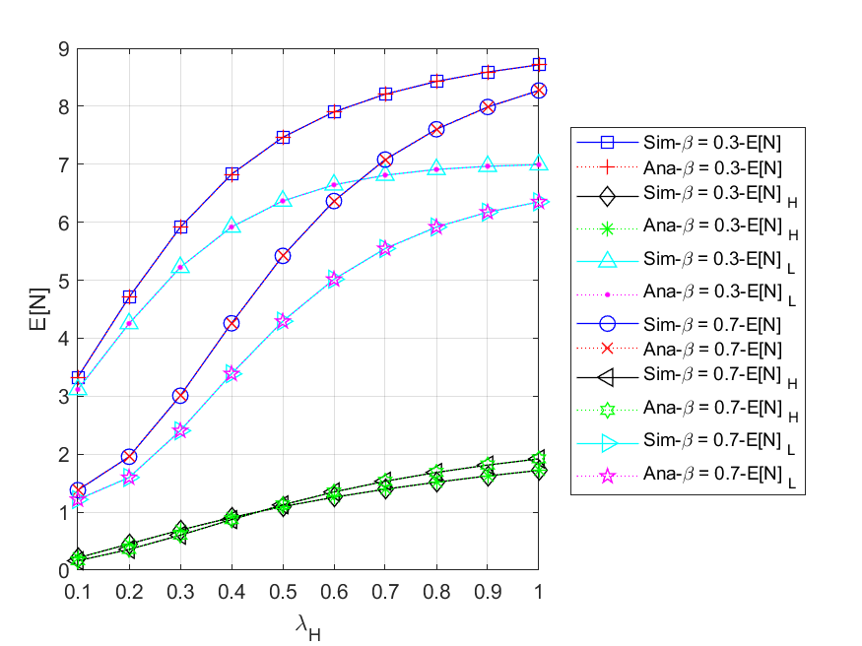

Fig. 5 - 3: The expected number of all ($HP,LP$) packets in the system vs. the HP packet arrival rate

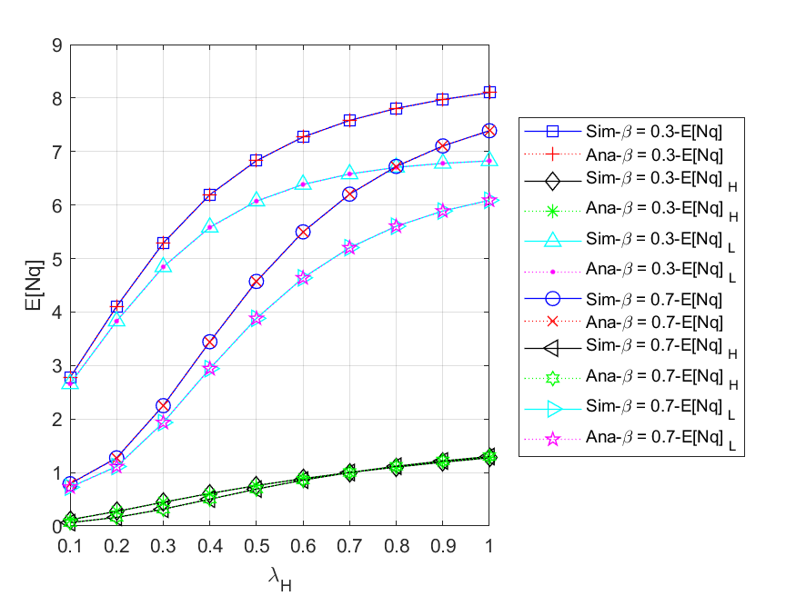

Fig. 5 - 4: The expected number of all ($HP,LP$) packets in the packet queue vs. the HP packet arrival rate

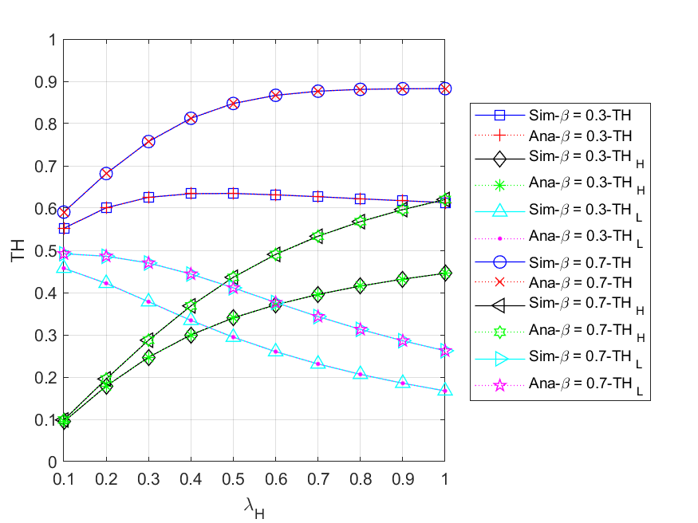

Fig. 5 - 5: The throughput of all ($HP,LP$) packets vs. the HP packet arrival rate

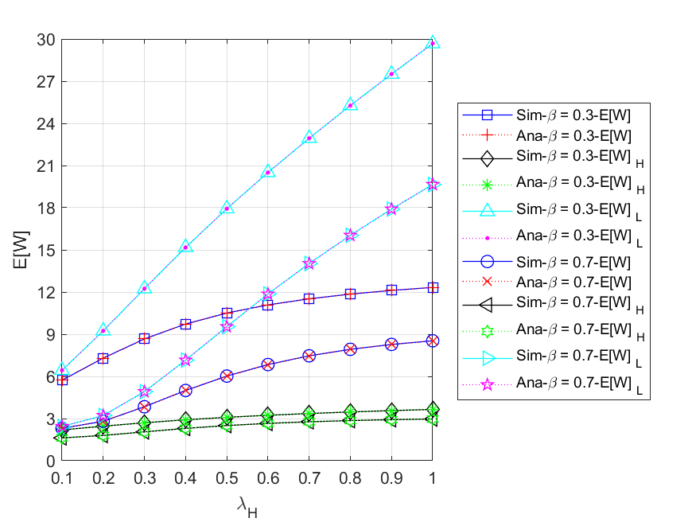

Fig. 5 - 6: The mean waiting time of all ($HP,LP$) packets in the system vs. the HP packet arrival rate

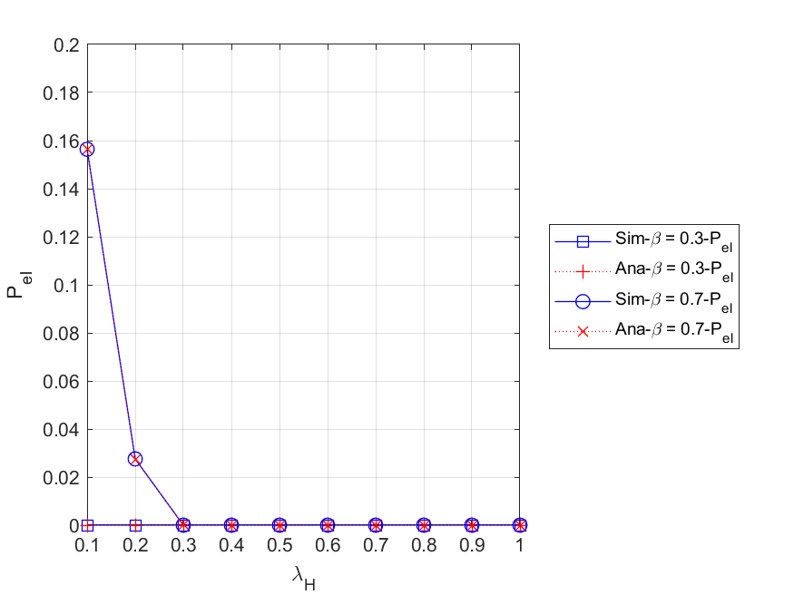

Fig. 5 - 7: The energy loss probability vs. the HP packet arrival rate

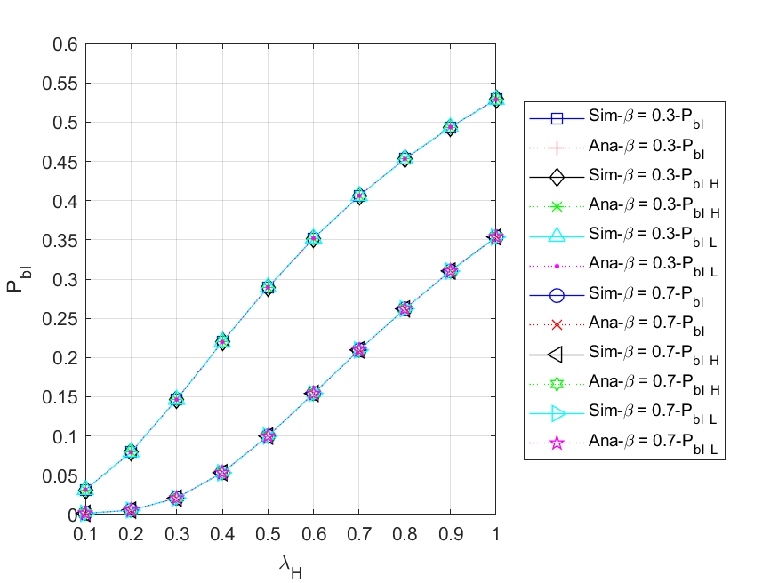

Fig. 5 - 8: The blocking probability of all ($HP,LP$) arrived packets vs. the HP packet arrival rate

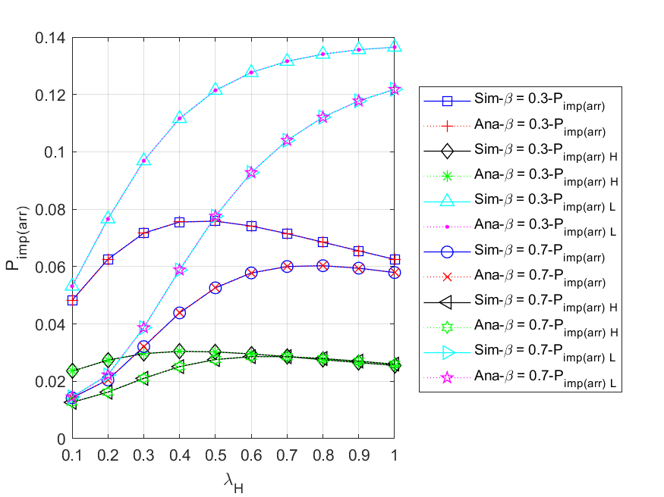

Fig. 5 - 9: The impatient loss probability of all ($HP,LP$) arrived packets vs. the HP packet arrival rate

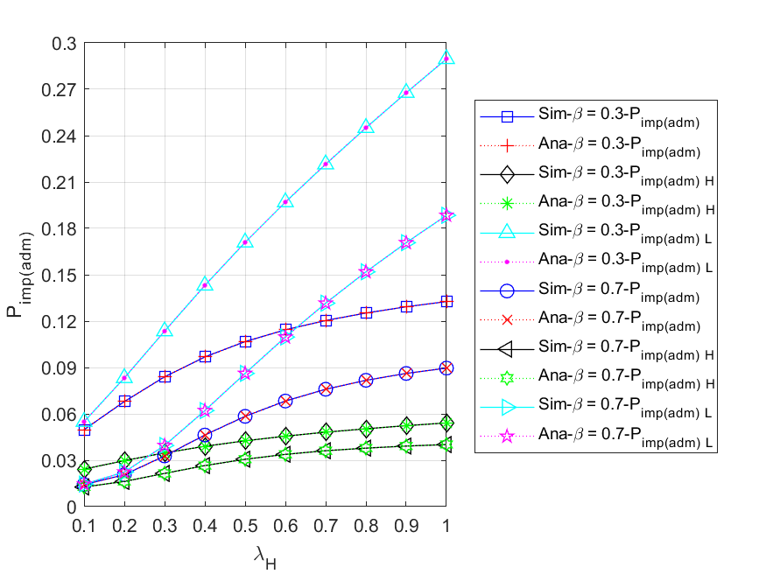

Fig. 5 - 10: The impatient loss probability of all ($HP,LP$) admitted packets vs. the HP packet arrival rate

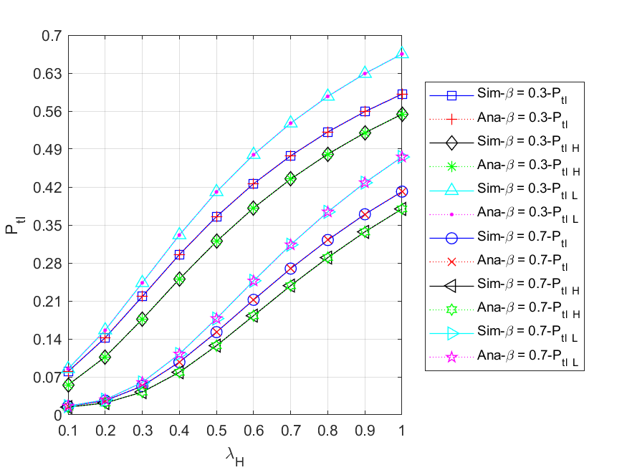

Fig. 5 - 11: The total loss probability of all ($HP,LP$) arrived packets vs. the HP packet arrival rate

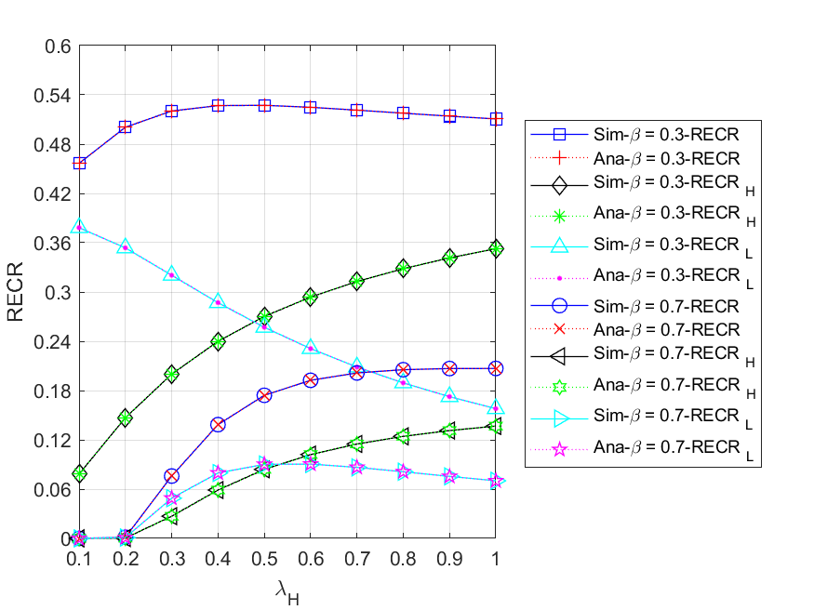

Fig. 5 - 12: The regular energy consumption ratio for serving all ($HP,LP$) packets vs. the HP packet arrival rate

* + 1. **Regular battery usage probabilities**

This subsection compares the scenario without regular battery with the default values. More specifically, we study the impacts of HP packet arrival rate on various performance measures for different regular battery usage probabilities, i.e., ${θ_{H}}/{θ_{L}}=0.0$ and $0.5$, and the results are shown in Fig. 5 - 13 to Fig. 5 - 20.

Fig. 5 - 13 shows the relationship between the expected number of all $(HP,LP)$ packets in the system $E[N]$ $\left({E[N]}_{H},{E[N]}_{L}\right)$ and HP packet arrival rate $λ_{H}$ for different regular battery usage probabilities ${θ_{H}}/{θ_{L}}$. First, we compare the curves of ${θ_{H}}/{θ_{L}}=0.0$ and $0.5$ for $E\left[N\right]$, ${E[N]}_{H}$, and ${E[N]}_{L}$, respectively. It is obvious to find the curve of ${θ_{H}}/{θ_{L}}=0.5$ is lower than that of ${θ_{H}}/{θ_{L}}=0.0$ for both $E\left[N\right]$ and ${E[N]}_{L}$. This is because the higher the regular battery usage probabilities, the more likely it is that a packet can be served by using the regular battery, and the less packets need to wait in the system. Additionally, it is worth pointing out that in the case of ${E[N]}_{H}$, the curve of ${θ_{H}}/{θ_{L}}=0.0$ is initially higher than the curve of ${θ_{H}}/{θ_{L}}=0.5$ and then falls below it. The main reason is that as the load on the system becomes heavier, the energy supply will be insufficient in terms of energy request rate, i.e. $ϕ_{req}>μ_{eff}$. As a result, the lower the probabilities of using regular battery, the longer a packet has to wait in the system, which increases the likelihood of impatience. Second, for ${θ_{H}}/{θ_{L}}=0.0$, we can find that ${E[N]}_{L}$ increases first and then gradually decreases as $λ_{H}$ increases. It is because the higher the arrival rate of HP packets, the longer LP packets need to wait in the queue, which makes LP packets more vulnerable to impatience and priority discipline.

Fig. 5 - 14 shows the relationship between the throughput of all $(HP,LP)$ packets $TH$ $\left({TH}_{H},{TH}_{L}\right)$ and the HP packet arrival rate $λ_{H}$ for different regular battery usage probabilities . For , , and , respectively, it is evident that the curve with is higher than the curve with . This is because the higher the probabilities of regular battery usage, the more likely it is that the packets in the queue can be served. In addition, for ${θ_{H}}/{θ_{L}}=0.0$, we observe that the throughput remains constant at 0.3 with increasing $λ_{H}$. The reason is that in the absence of the regular battery as an auxiliary energy resource, the effective service rate is constrained by the arrival rate of harvested energy.

Fig. 5 - 15 shows the relationship between the mean waiting time of all $(HP,LP)$ packets $E[W]$ $\left({E\left[W\right]}_{H},{E\left[W\right]}_{L}\right)$ and the HP packet arrival rate $λ_{H}$ for different regular battery usage probabilities . First, it is obvious to observe that the curve with is lower than the curve with for , , and . The reason is that the higher the probabilities of regular battery usage, the more likely a packet can be served using the regular battery, and the less time the packets have to wait in the system. Second, due to the fact that HP packets have non-preemptive priority over LP packets, most LP packets are backlogged and waiting in the queue. This results in not only the curve of is always higher than that of for both and , but the difference between the curves of and appears smaller than the difference between the curves. Lastly, we can see from the overall results that the model using the regular battery as an auxiliary energy resource has a significant improvement for both HP and LP packet performance.

Fig. 5 - 16 shows the relationship between the blocking probability of all $(HP,LP)$ arrived packets $P_{bl}$ $(P_{bl_H}, P_{bl_L})$ and the HP packet arrival rate $λ_{H}$ for different regular battery usage probabilities . Since an arrived packet will be blocked regardless of its priority once the packet queue becomes full, , , and are the same for and . In addition, we compare the curves of for different regular battery usage probabilities simultaneously. It is obvious to find that the curve with is higher than the one with . The reason is that the lower the probabilities of regular battery usage, the less likely the packets waiting in the queue can be served, which makes the packet queue easier to become full.

Fig. 5 - 17 shows the relationship between the impatient loss probability of all $(HP,LP)$ arrived packets $P_{imp(arr)}$ $(P_{imp\left(arr\right)_H},P_{imp\left(arr\right)_L})$ and the HP packet arrival rate for different regular battery usage probabilities . According to the figure, we can find that not only the curves with are higher than the curves with in most cases, but as increases, the two lines will become more and more close. The reason is that in the scenario of , the energy supply is relatively insufficient, and even if increases, a large amount of arrived packets are easily blocked. Therefore, the probability of packets getting impatient in the queue becomes smaller instead.

Fig. 5 - 18 shows the relationship between the impatient loss probability of all $(HP,LP)$ admitted packets $P_{imp(adm)}$ $(P_{imp\left(adm\right)_H},P_{imp\left(adm\right)_L})$ and the HP packet arrival rate for different regular battery usage probabilities . First, it is obvious to find that for , , and , the curve with is lower than the curve with . This is because the higher the probabilities of regular battery usage, the more likely a packet will be served immediately using regular battery, and the fewer packets will lose patience in the queue. Second, since HP packets have non-preemptive priority over LP packets, most LP packets are backlogged and waiting in the queue. This results in not only is always higher than for both and , but the difference between the curves of and appears smaller than the difference between the curves. Lastly, we can see from the overall results that the model using the regular battery as an auxiliary energy resource has a significant improvement for both HP and LP packet performance.

Fig. 5 - 19 shows the relationship between the total loss probability of all $(HP,LP)$ arrived packets $P_{tl}$ $(P_{tl_H}, P_{tl_L})$ and the HP packet arrival rate $λ_{H}$ for different regular battery usage probabilities . We can observe from the figure that for $P_{tl}$, $P_{tl_H}$, and , as increases, the values of are always higher than those of ${θ_{H}}/{θ_{L}}=0.5$. This is because the lower the probabilities of regular battery usage, the easier it is for the packet queue to become congested, and the higher the chance of packet loss due to blocking or impatience. In addition, from the overall results, it is evident that using the regular battery as an auxiliary energy resource can improve the performance of both HP and LP packets.

Fig. 5 - 20 shows the relationship between regular energy consumption ratio for serving all $(HP,LP)$ packets $RECR$ $({RECR}_{H},{RECR}_{L})$ and the HP packet arrival rate $λ_{H}$ for different regular battery usage probabilities ${θ_{H}}/{θ_{L}}$. For ${θ_{H}}/{θ_{L}}=0.5$, we observe that with the increase of , will increase first and then decrease, will gradually increase, and will gradually decrease. This is because on the one hand, as increases, the energy supply will become insufficient, which makes the packets in the queue vulnerable to impatience, and the number of served packets is relatively reduced. On the other hand, due to the non-preemption of HP packets over LP packets, the more HP packets enter the server to complete the service, the fewer LP packets can be served. Moreover, since ${θ_{H}}/{θ_{L}}=0.0$ means that the regular battery is never used, the corresponding RECR curves will always remain zero.

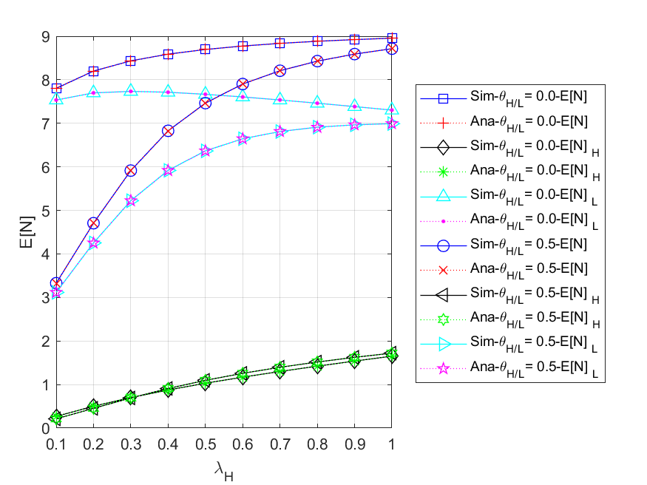

Fig. 5 - 13: The expected number of all ($HP,LP$) packets in the system vs. the HP packet arrival rate for different regular battery usage probabilities

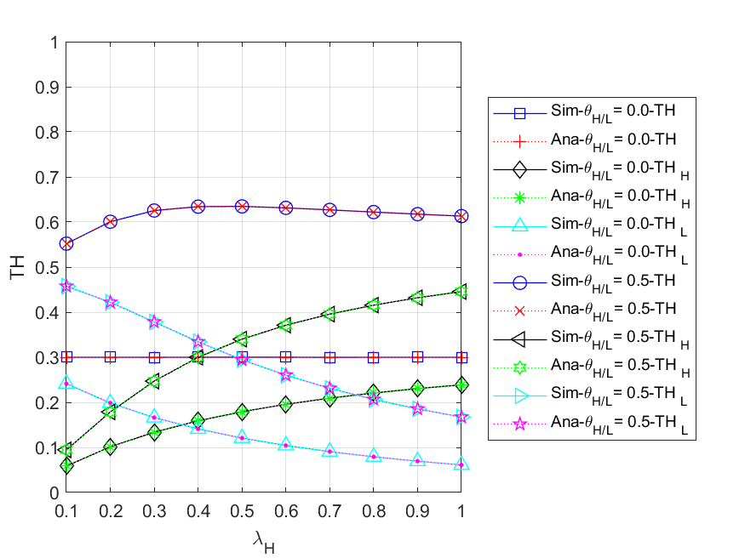

Fig. 5 - 14: The throughput of all ($HP,LP$) packets vs. the HP packet arrival rate for different regular battery usage probabilities

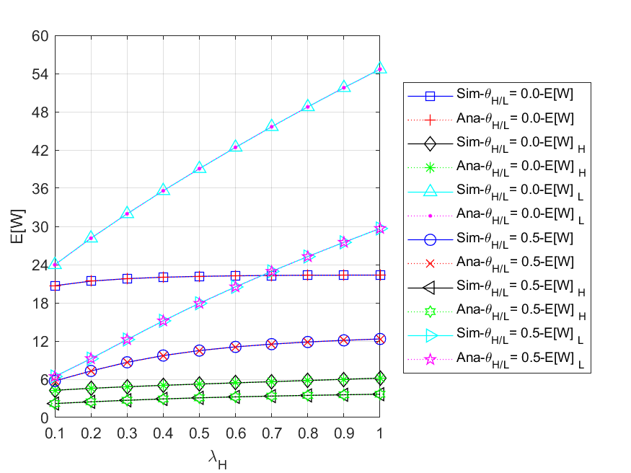

Fig. 5 - 15: The mean waiting time of all ($HP,LP$) packets in the system vs. the HP packet arrival rate for different regular battery usage probabilities

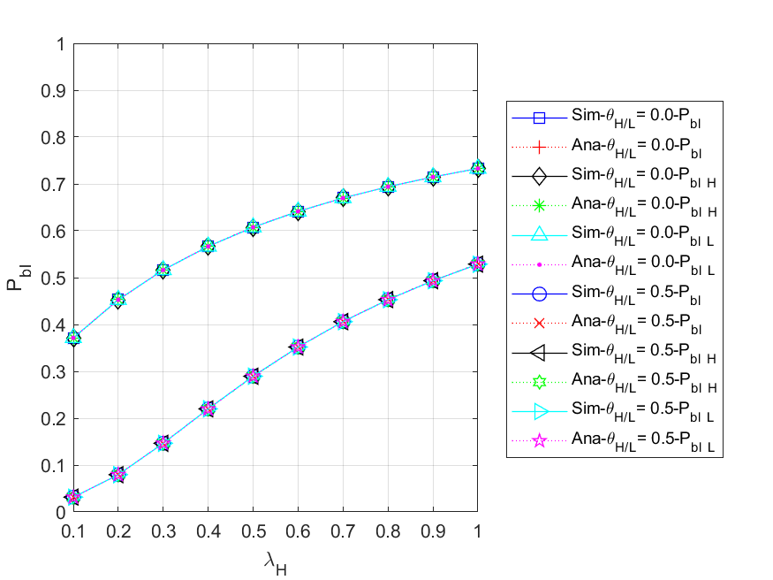

Fig. 5 - 16: The blocking probability of all ($HP,LP$) arrived packets vs. the HP packet arrival rate for different regular battery usage probabilities

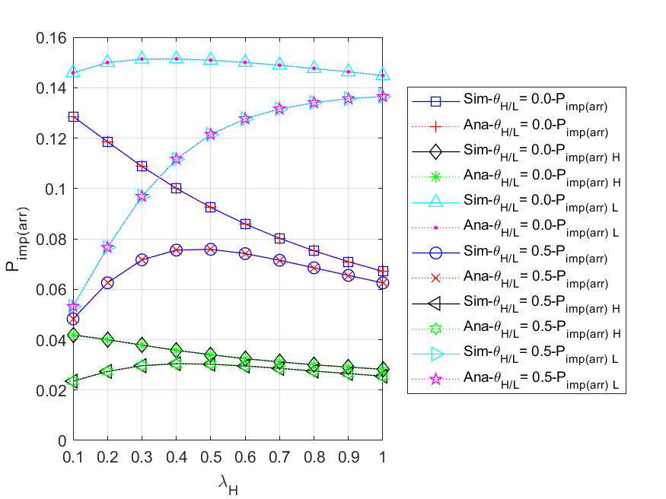

Fig. 5 - 17: The impatient loss probability of all ($HP,LP$) arrived packets vs. the HP packet arrival rate for different regular battery usage probabilities

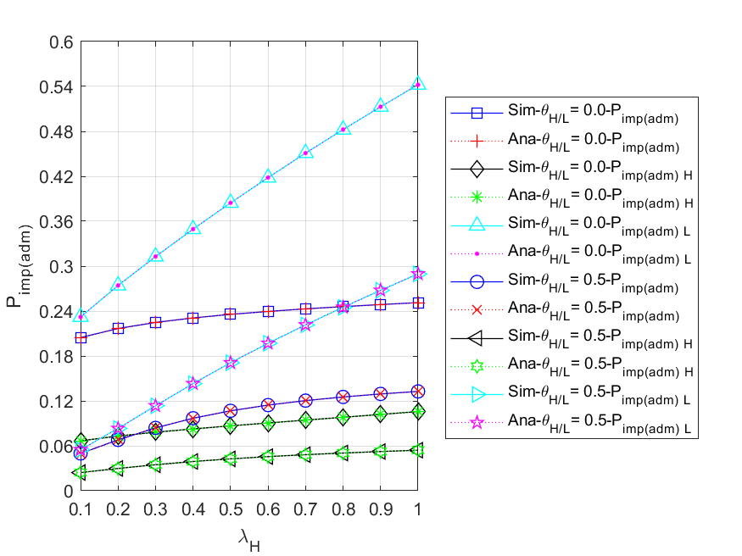

Fig. 5 - 18: The impatient loss probability of all ($HP,LP$) admitted packets vs. the HP packet arrival rate for different regular battery usage probabilities

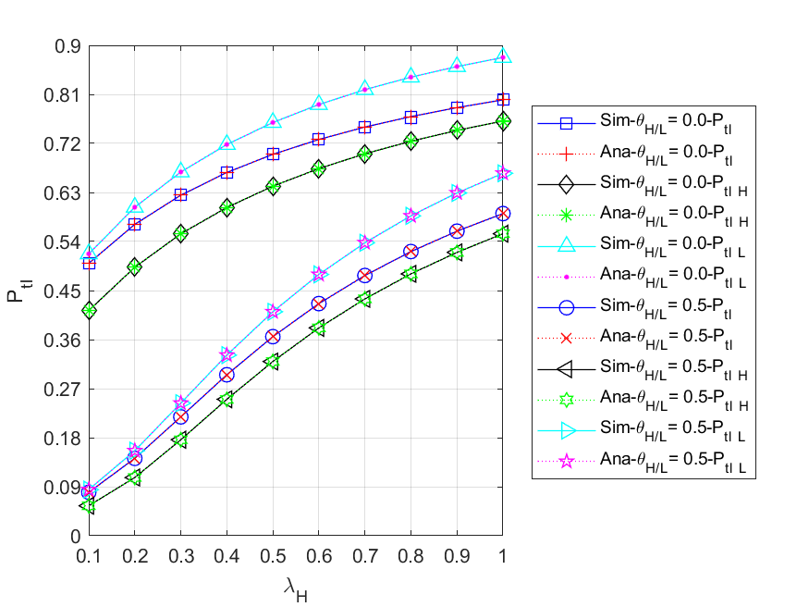

Fig. 5 - 19: The total loss probability of all ($HP,LP$) arrived packets vs. the HP packet arrival rate for different regular battery usage probabilities

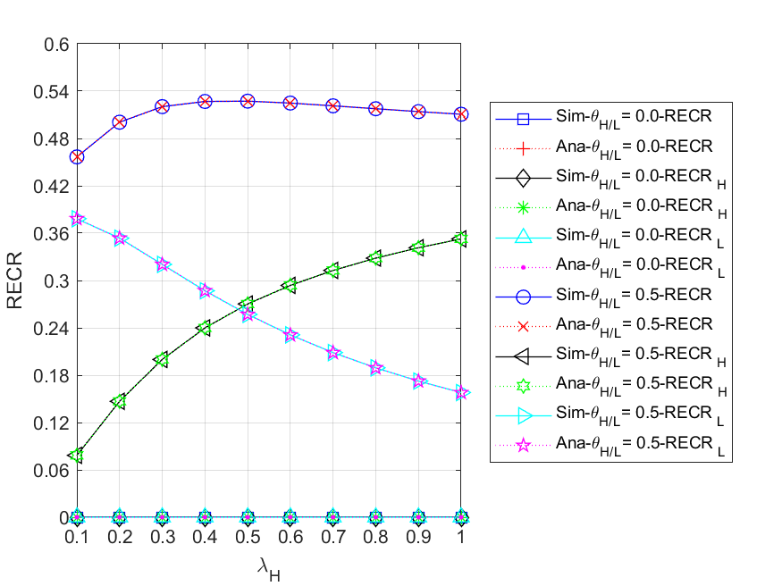

Fig. 5 - 20: The regular energy consumption ratio for serving all ($HP,LP$) packets vs. the HP packet arrival rate for different regular battery usage probabilities

## Scenario 2

Unless otherwise stated, the default values of the various system parameters are as follows: $λ_{H}=0.1$, $λ_{L}=0.5$, $β=0.3$, $α_{H}=0.02$, $α_{L}=0.01$, $μ_{H}=2$, $μ_{L}=1$, the packet queue size $(N)$ is 9, and energy queue size $(K)$ is 100. The energy requirement for HP packets is two units and that for LP packets is one unit, i.e., $e_{H}=2$ and $e_{L}=1$. We assume that the HP and LP packs have the same regular battery usage probability, i.e., $θ_{H}=θ_{L}$, for the convenience of discussion. Moreover, in order to study the impact of different energy arrival rates on the use of the regular battery, a case of is considered simultaneously.

It is noted that the energy request rate is , and the effective service rate is defined as .

In this scenario, we first use the default parameters to determine suitable regular battery usage probabilities $θ_{H}/θ_{L}$. As shown in Fig. 5 - 21 and Fig. 5 - 22, when $β=0.3$, it can be clearly observed that as $θ_{H}/θ_{L}$ gradually increases, $P_{tl}$ decreases and $RECR$ increases accordingly. This is because the larger , the more packets can enter the server immediately by using the regular battery before being blocked or running out of patience. However, this also leads to a shorter lifetime of the regular battery since it drains more energy. For the above reasons, we set as the upper limit, and select the minimum on the curve such that the upper bound is not violated as the suboptimal parameter value, that is, . Afterwards, the influences of HP packet arrival rate on various performance measures are studied as follows, and the results are shown in Fig. 5 - 23 to Fig. 5 - 32.

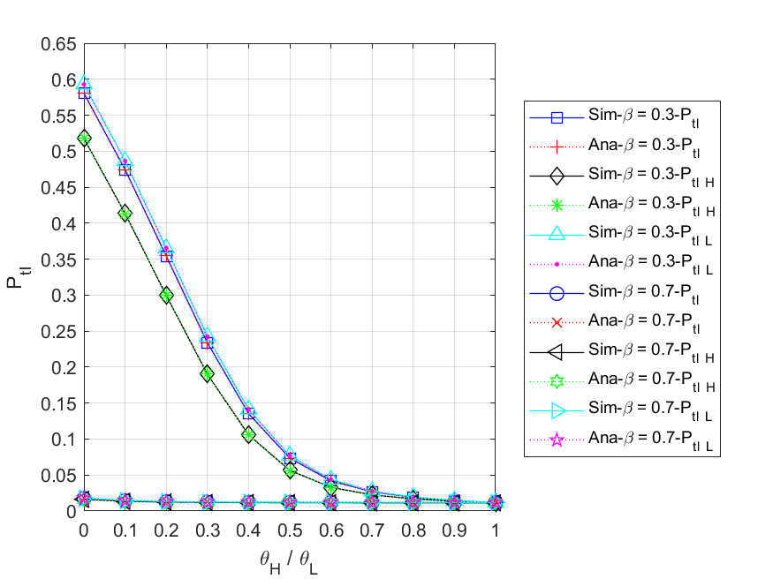

Fig. 5 - 21: The total loss probability of all ($HP,LP$) packets vs. the regular battery usage probabilities

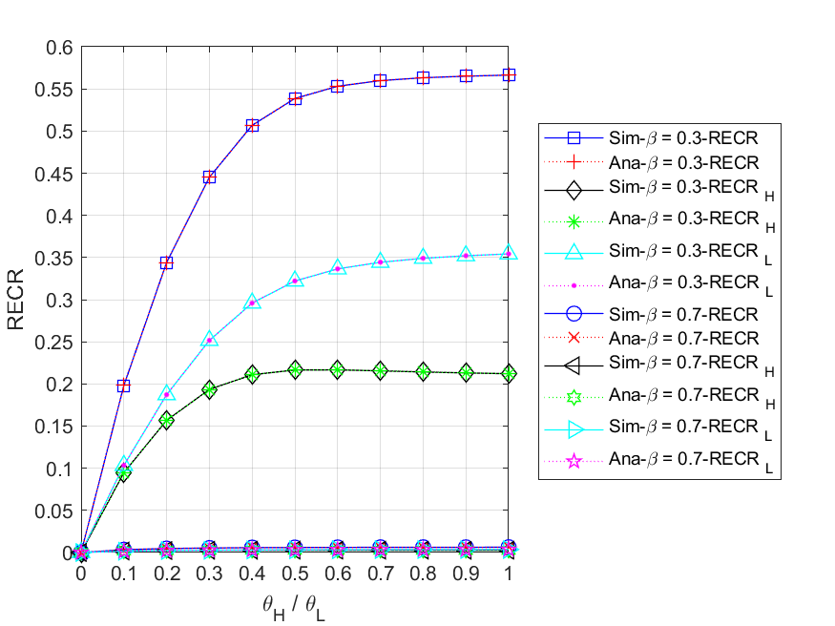

Fig. 5 - 22: The regular energy consumption ratio for serving all ($HP,LP$) packets vs. the regular battery usage probabilities

* + 1. **Energy arrival rate**

Fig. 5 - 23 shows the relationship between the expected number of all $(HP,LP)$ packets in the system and HP packet arrival rate $λ_{H}$ for different energy arrival rates . First, for or , we observe that their respective , , and all increase as increases. This is because the higher the HP packet arrival rate, the more packets are able to enter the system. Second, since HP packets have non-preemptive priority over LP packets, most LP packets are backlogged in the queue. This results in that will always be greater than for both and . Third, we compare the curves of and for , , and , respectively. It can be found that the curve of is higher than that of in all three measures. That is because the higher the energy arrival rate, the more sufficient energy in the energy queue, and the fewer packets need to wait in the system. Additionally, it is worth noting that in the above three cases, the curve of $β=0.3$ and the curve of $β=0.7$ will get closer as $λ_{H}$ increases. The reason is that the lower the energy arrival rate, the longer the packets have to wait in the system and the easier they are to lose patience. Therefore, the upward trend of the curves with $β=0.3$ will gradually slow down and become closer to the curves with $β=0.7$.

Fig. 5 - 24 shows the relationship between the expected number of all $(HP,LP)$ packets in the packet queue $E[N_{q}]$ $\left({E[N_{q}]}_{H},{E[N_{q}]}_{L}\right)$ and HP packet arrival rate $λ_{H}$ for different energy arrival rates . First, for or , we observe that their respective , , and all increase as increases. This is because the higher the HP packet arrival rate, the more packets are able to enter the queue. Second, since HP packets have non-preemptive priority over LP packets, most LP packets are backlogged in the queue. This results in that will always be greater than for both and . Third, we compare the curves of and for , , and , respectively. It can be found that the curve of is higher than that of in all three measures. That is because the higher the energy arrival rate, the more sufficient energy in the energy queue, and the fewer packets need to wait in the queue. Additionally, it is worth noting that in the above three cases, the curve of $β=0.3$ and the curve of $β=0.7$ will get closer as $λ_{H}$ increases. The reason is that the lower the energy arrival rate, the longer the packets have to wait in the queue and the easier they are to lose patience. Therefore, the upward trend of the curves with $β=0.3$ will gradually slow down and become closer to the curves with $β=0.7$.

Fig. 5 - 25 shows the relationship between the throughput of all $(HP,LP)$ packets $TH$ $\left({TH}_{H},{TH}_{L}\right)$ and the HP packet arrival rate $λ_{H}$ for different energy arrival rates . First, we compare the curves of and for , , and , respectively. It is obvious to find that all curves with are lower than those with . This is because the higher the energy arrival rate, the more sufficient energy in the energy queue, and the more packets can be served. Second, for or , we can observe that increases as increases, while gradually decreases. This is because HP packets have a non-preemptive priority over LP packets. Therefore, the higher HP packet arrival rate, the more HP packets enter the server to complete the service, the fewer LP packets can be served. Additionally, since the regular battery acts as an auxiliary energy source, it allows the throughput to increase without being limited by the arrival rate of harvesting energy. Nevertheless, the energy supply will become insufficient as $λ_{H}$ increases, i.e. $ϕ_{req}>μ_{eff}$, which makes the packets in the queue vulnerable to impatience and more difficult to be served. As a result, $TH$ with $β=0.3$ first increases and then decreases slightly, while $TH$ with $β=0.7$ gradually increases and eventually shows a slow upward trend.

Fig. 5 - 26 shows the relationship between the mean waiting time of all $(HP,LP)$ packets $E[W]$ $\left({E\left[W\right]}_{H},{E\left[W\right]}_{L}\right)$ and the HP packet arrival rate $λ_{H}$ for different energy arrival rates . First, for or , we observe that their respective $E[W]$, ${E\left[W\right]}_{H}$, and ${E\left[W\right]}_{L}$ all increase as $λ_{H}$ increases. This is because, the higher the HP packet arrival rate, the more packets can enter the system, and thus the longer a packet must wait. Second, since HP packets have non-preemptive priority over LP packets, most LP packets are backlogged and waiting in the queue. This results in that will always be greater than for both and . In addition, it is worth noting that the difference between the ${E\left[W\right]}_{H}$ curves for $β=0.3$ and $β=0.7$ will appear smaller than the difference between the ${E\left[W\right]}_{L}$ curves. The reason is that under the priority policy, most of the energy will be used to serve HP packets before LP packets. This ensures that HP packets have a lower latency, while LP packets are more likely to be affected by the energy supply and the congestion of the packet queue.

Fig. 5 - 27 shows the relationship between the energy loss probability $P_{el}$ and the HP packet arrival rate $λ_{H}$ for different energy arrival rates . First, for , we can observe that remains zero. This is because energy is always insufficient to provide the service (), so whenever an energy unit arrives, it will be immediately consumed by the packet waiting in the queue. Second, for $β=0.7$, it can be found that $P_{el}$ has a non-zero value at $λ_{H}=0.1$, and then remains zero as $λ_{H}$ increases. The reason is that when $λ_{H}=0.1$, the energy arrival rate can satisfy the packet request rate, i.e., $ϕ_{req}≤β$, which means the harvested energy is not only sufficient, but may even be excessive. However, as HP packet arrival rate continues to increase, more packets need to be served. This causes most of the arriving energy to be consumed immediately, and the energy queue is less likely to become full.

Fig. 5 - 28 shows the relationship between the blocking probability of all $(HP,LP)$ arrived packets $P_{bl}$ $(P_{bl_H}, P_{bl_L})$ and the HP packet arrival rate $λ_{H}$ for different energy arrival rates . First, for and , we can observe that their respective , , and are the same. This is because once the packet queue is full, an arrival packet will be blocked regardless of its priority. Second, since more and more packets enter the system as the HP packet arrival rate increases, it makes the packet queue more likely to become full. Therefore, for both and , their will significantly grow with increasing . Third, we compare the curves of for and simultaneously. It is obvious to find that the curve with is higher than the one with . The reason is that the smaller the energy arrival rate, the longer the packet has to wait in the queue, which makes the packet queue more likely to be full.

Fig. 5 - 29 shows the relationship between the impatient loss probability of all $(HP,LP)$ arrived packets $P_{imp(arr)}$ $(P_{imp\left(arr\right)_H},P_{imp\left(arr\right)_L})$ and the HP packet arrival rate for different energy arrival rates . First, for and 0.7, we can observe that their and curves rise first and then fall with the increase of , while the curves of keep rising. The reason is that with sufficient energy, most packets can enter the system, which results in the number of impatient packets in the queue increasing; however, as the HP packet arrival rate continues to grow until the energy supply gets insufficient, the packet queue will become congested, and a significant number of packets will be blocked out of the system, so the probability of impatience for arrival packets will gradually decrease. On the other hand, for LP packets, where their priority is lower than that of HP packets, the waiting time in the queue is much longer, and impatience is more likely to occur. Second, we compare the curves of and for , , and , respectively. According to the figure, it can be seen that not only the curves with $β=0.3$ are higher than the curves with $β=0.7$ in most cases, but as $λ_{H}$ increases, the pairs of curves will become more and more close. This is because in the case of $β=0.3$, the energy supply being relatively insufficient, an arrived packet has a higher blocking probability and an impatient loss probability, meaning that even if it successfully enters the queue, it is still easy to lose patience while waiting. Furthermore, as increases, the situation described in the preceding paragraph becomes more severe, which leads to an accelerated increase in blocked packets. As a result, the number of impatient packets has decreased rapidly for arrived packets, and the two curves of $P_{imp(arr)}$, $P_{imp\left(arr\right)_H}$, and $P_{imp\left(arr\right)_L}$ will get closer.

Fig. 5 - 30 shows the relationship between the impatient loss probability of all $(HP,LP)$ admitted packets $P_{imp(adm)}$ $(P_{imp\left(adm\right)_H},P_{imp\left(adm\right)_L})$ and the HP packet arrival rate for different energy arrival rates . First, for or , we observe that their respective , , and all increase as increases. This is because the higher the HP packet arrival rate, the more likely the system will be congested, therefore, the longer the packets have to wait in the queue, and the more impatient they will become. Second, since HP packets have non-preemptive priority over LP packets, most LP packets are backlogged and waiting in the queue, which makes impatience more likely to occur. As a result, are always greater than for both and . Third, it is obvious to find the curve of is higher than that of for , , and . The reason is that the higher the energy arrival rate, the less time a packet needs to wait in the queue, and the less likely it will become impatient.

Fig. 5 - 31 shows the relationship between the total loss probability of all $(HP,LP)$ arrived packets $P_{tl}$ $(P_{tl_H}, P_{tl_L})$ and the HP packet arrival rate $λ_{H}$ for different energy arrival rates . First, for or , we observe that their respective , and all increase as increases. The main reason is that the higher the HP packet arrival rate, the more likely the system becomes full, therefore, the number of blocked packets will increase rapidly. Second, since HP packets have non-preemptive priority over LP packets, most LP packets are backlogged and waiting in the queue, which makes impatience more likely to occur. As a result, are always greater than for both and . Third, it is obvious to find the curve of is higher than that of for , , and . This is because the lower the energy arrival rate, the easier the packet queue gets congested, and the more likely the packets are lost due to blocking or impatience. Lastly, it should be noted that $P_{tl}$ is equal to the sum of $P_{bl}$ and $P_{imp(arr)}$.

Fig. 5 - 32 shows the relationship between regular energy consumption ratio for serving all $(HP,LP)$ packets $RECR$ $({RECR}_{H},{RECR}_{L})$ and the HP packet arrival rate $λ_{H}$ for different energy arrival rates $β$. First, for $β=0.3$, we observe that with the increase of $λ_{H}$, $RECR$ and ${RECR}_{H}$ will increase as well, while ${RECR}_{L}$ will gradually decrease. This is because on the one hand, as increases, the energy request rate will become extremely high due to the energy requirement for each HP packet being two units, which makes the regular battery more necessary when the harvesting energy is not sufficient to provide service. On the other hand, since HP packets have non-preemptive priority over LP packets, the more HP packets enter the server to complete the service, the fewer LP packets can be served. Second, for , it is found that with the increase of $λ_{H}$, both $RECR$ and ${RECR}_{H}$ will gradually increase, while ${RECR}_{L}$ will increase first and then decrease. The primary reason for this is that the harvesting energy is about to become insufficient in the former half, and the LP packets has a higher throughput than the HP packets. Therefore, as more HP packets arrive, most of the harvested energy will be consumed by HP packets immediately, and LP packets will be more reliant on the regular battery. However, due to the continuous increase of $λ_{H}$ and the influence of the priority policy, most of the LP packets are backlogged in the queue, so the LP packets that can be served become less and less in the latter half. Third, with the lower energy arrival rate, harvesting energy typically doesn't meet the need for service, and the regular battery is more likely to be used as an alternative energy source. Thus, the curve of $β=0.3$ is higher than that of $β=0.7$ for $RECR$, ${RECR}_{H}$, and ${RECR}_{L}$ as shown.

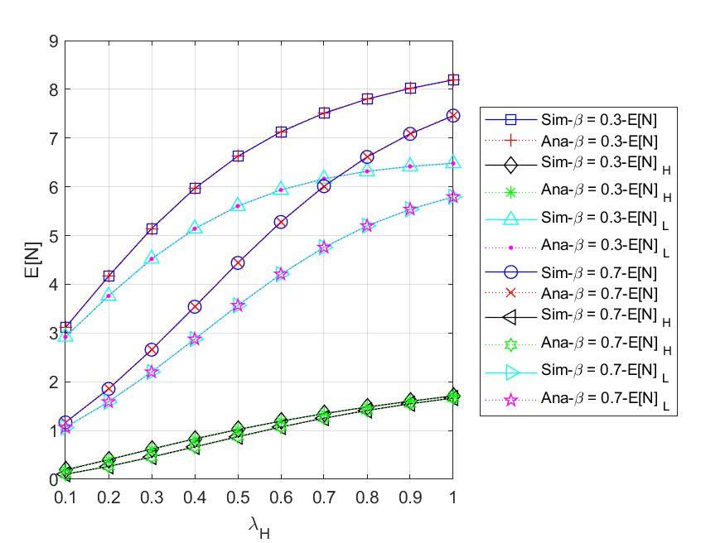

Fig. 5 - 23: The expected number of all ($HP,LP$) packets in the system vs. the HP packet arrival rate

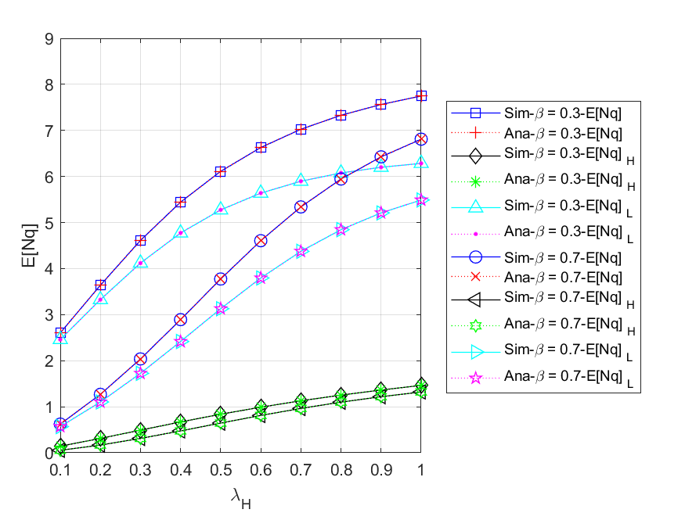

Fig. 5 - 24: The expected number of all ($HP,LP$) packets in the packet queue vs. the HP packet arrival rate

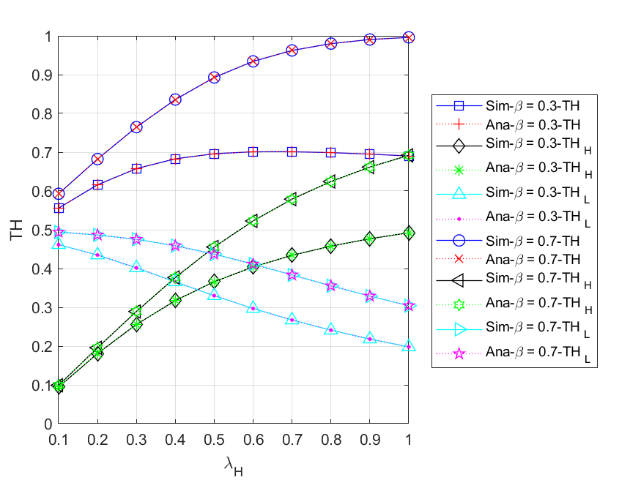

Fig. 5 - 25: The throughput of all ($HP,LP$) packets vs. the HP packet arrival rate

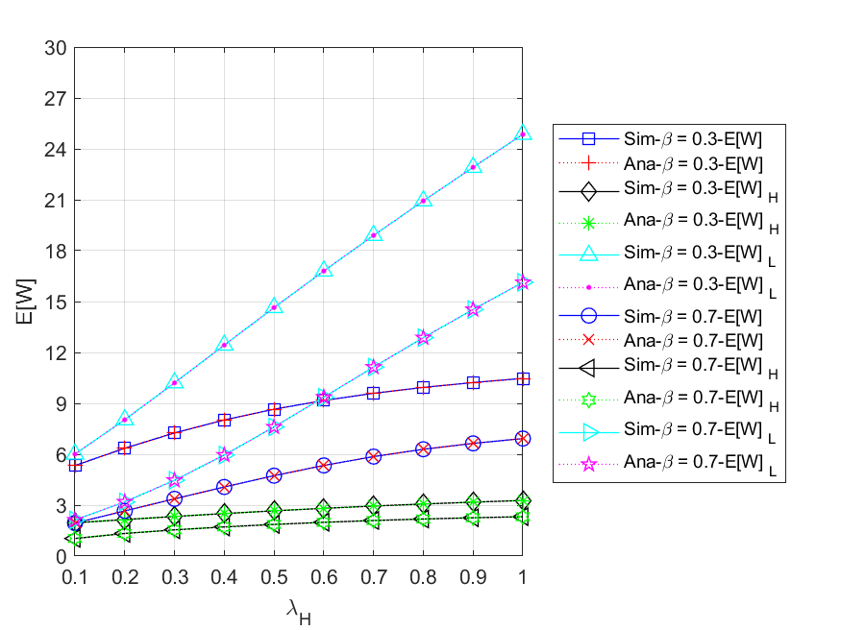

Fig. 5 - 26: The mean waiting time of all ($HP,LP$) packets in the system vs. the HP packet arrival rate

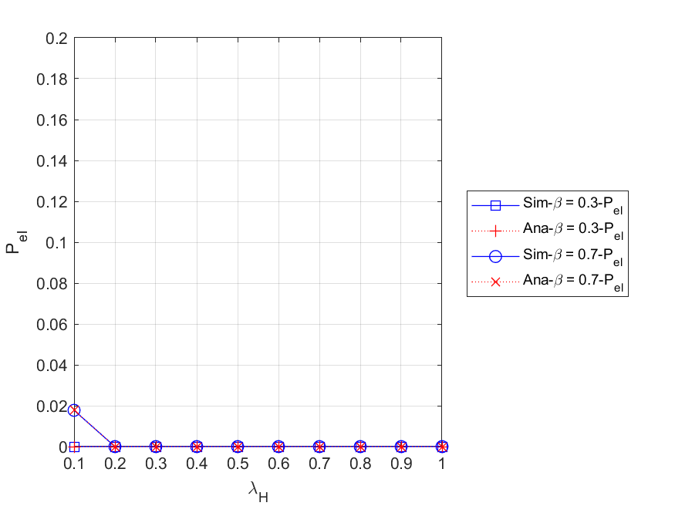

Fig. 5 - 27: The energy loss probability vs. the HP packet arrival rate

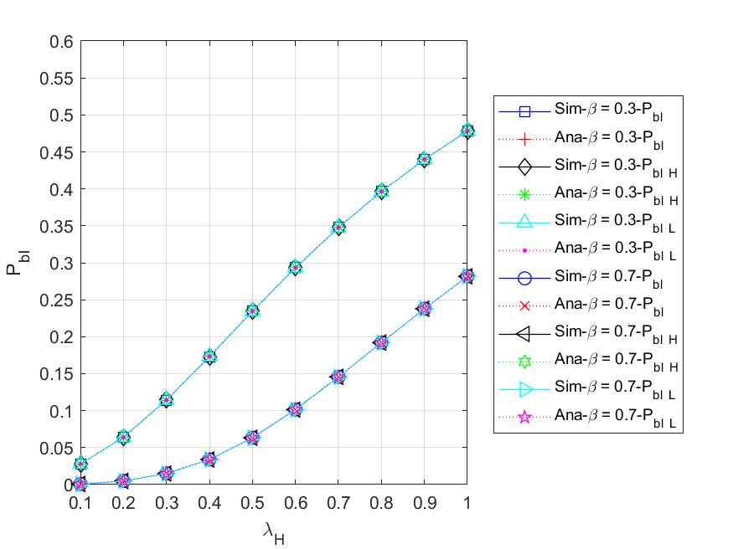

Fig. 5 - 28: The blocking probability of all ($HP,LP$) arrived packets vs. the HP packet arrival rate

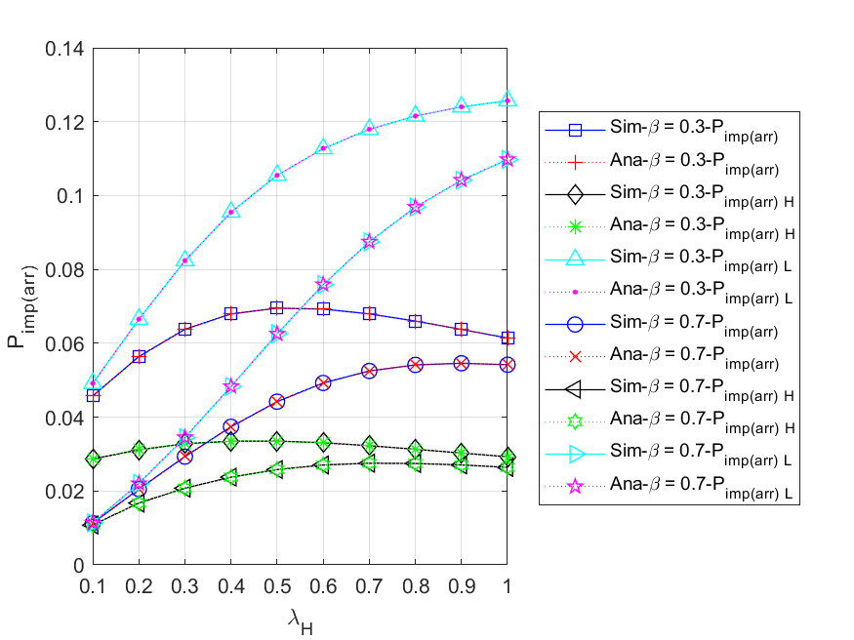

Fig. 5 - 29: The impatient loss probability of all ($HP,LP$) arrived packets vs. the HP packet arrival rate

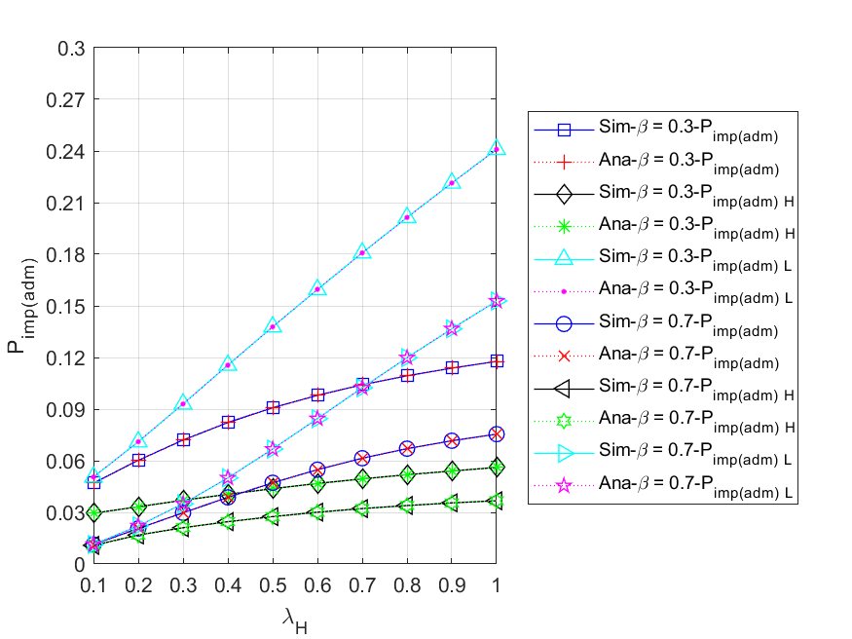

Fig. 5 - 30: The impatient loss probability of all ($HP,LP$) admitted packets vs. the HP packet arrival rate

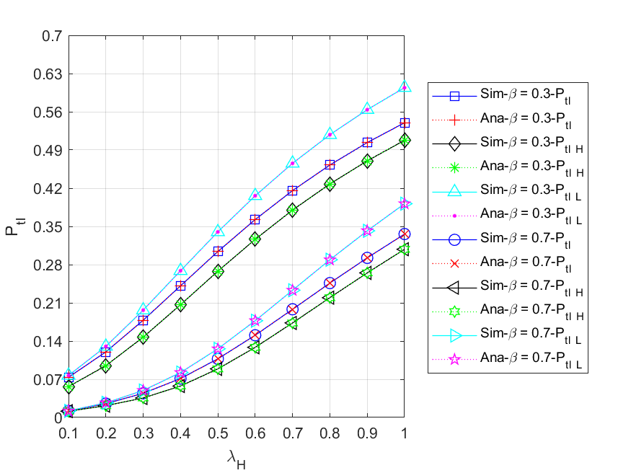

Fig. 5 - 31: The total loss probability of all ($HP,LP$) arrived packets vs. the HP packet arrival rate

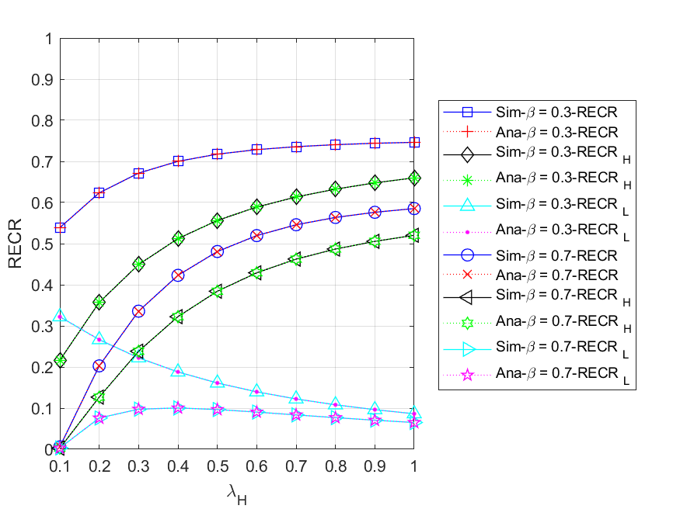

Fig. 5 - 32: The regular energy consumption ratio for serving all ($HP,LP$) packets vs. the HP packet arrival rate

* + 1. **Regular battery usage probabilities**

This subsection compares the scenario without regular battery with the default values. More specifically, we study the impacts of HP packet arrival rate on various performance measures for different regular battery usage probabilities, i.e., ${θ_{H}}/{θ_{L}}=0.0$ and $0.5$, and the results are shown in Fig. 5 - 33 to Fig. 5 - 40.

Fig. 5 - 33 shows the relationship between the expected number of all $(HP,LP)$ packets in the system $E[N]$ $\left({E[N]}_{H},{E[N]}_{L}\right)$ and HP packet arrival rate $λ_{H}$ for different regular battery usage probabilities ${θ_{H}}/{θ_{L}}$. We can observe that the curve of ${θ_{H}}/{θ_{L}}=0.5$ is lower than that of ${θ_{H}}/{θ_{L}}=0.0$ for $E\left[N\right]$, ${E[N]}_{H}$, and ${E[N]}_{L}$. This is because the higher the regular battery usage probabilities, the more likely it is that a packet can be served immediately by using the regular battery, and the less packets need to wait in the system. Additionally, it is notable that, for ${θ_{H}}/{θ_{L}}=0.0$, ${E[N]}_{L}$ increases first and then rapidly decreases as $λ_{H}$ increases. The reason is that the higher the arrival rate of HP packets, the longer LP packets need to wait in the queue, which makes LP packets more vulnerable to impatience and priority discipline.

Fig. 5 - 34 shows the relationship between the throughput of all $(HP,LP)$ packets $TH$ $\left({TH}_{H},{TH}_{L}\right)$ and the HP packet arrival rate $λ_{H}$ for different regular battery usage probabilities . For , , and , respectively, it is evident that the curve with is higher than the curve with . This is because the higher the probabilities of regular battery usage, the more likely it is that the packets in the queue can be served. In addition, for ${θ_{H}}/{θ_{L}}=0.0$, we observe that the throughput gradually decreases with increasing $λ_{H}$. The reason is that, on the one hand, as increases, the energy request rate will become extremely high, since each HP packet requires two units of energy, resulting in insufficient energy supply. On the other hand, as HP packets have a non-preemptive priority over LP packets, the more HP packets enter the server to complete the service, the fewer LP packets can be served.

Fig. 5 - 35 shows the relationship between the mean waiting time of all $(HP,LP)$ packets $E[W]$ $\left({E\left[W\right]}_{H},{E\left[W\right]}_{L}\right)$ and the HP packet arrival rate $λ_{H}$ for different regular battery usage probabilities . First, it is obvious to observe that the curve with is lower than the curve with for , , and . The reason is that the higher the probabilities of regular battery usage, the more likely a packet can be served using the regular battery, and the less time the packets have to wait in the system. Second, due to the fact that HP packets have non-preemptive priority over LP packets, most LP packets are backlogged and waiting in the queue. This results in not only the curve of is always higher than that of for both and , but the difference between the curves of and appears smaller than the difference between the curves. Lastly, we can see from the overall results that the model using the regular battery as an auxiliary energy resource has a significant improvement for both HP and LP packet performance.

Fig. 5 - 36 shows the relationship between the blocking probability of all $(HP,LP)$ arrived packets $P_{bl}$ $(P_{bl_H}, P_{bl_L})$ and the HP packet arrival rate $λ_{H}$ for different regular battery usage probabilities . Since an arrived packet will be blocked regardless of its priority once the packet queue becomes full, , , and are the same for and . In addition, we compare the curves of for different regular battery usage probabilities simultaneously. It is obvious to find that the curve with is higher than the one with . The reason is that the lower the probabilities of regular battery usage, the less likely the packets waiting in the queue can be served, which makes the packet queue easier to become full.

Fig. 5 - 37 shows the relationship between the impatient loss probability of all $(HP,LP)$ arrived packets $P_{imp(arr)}$ $(P_{imp\left(arr\right)_H},P_{imp\left(arr\right)_L})$ and the HP packet arrival rate for different regular battery usage probabilities . According to the figure, we can find that not only the curves with are higher than the curves with in most cases, but as increases, the two lines will become more and more close. The reason is that in the scenario of , the energy supply is relatively insufficient, and even if increases, a large amount of arrived packets are easily blocked. Therefore, the probability of packets getting impatient in the queue becomes smaller instead.

Fig. 5 - 38 shows the relationship between the impatient loss probability of all $(HP,LP)$ admitted packets $P_{imp(adm)}$ $(P_{imp\left(adm\right)_H},P_{imp\left(adm\right)_L})$ and the HP packet arrival rate for different regular battery usage probabilities . First, it is obvious to find that for , , and , the curve with is lower than the curve with . This is because the higher the probabilities of regular battery usage, the more likely a packet will be served immediately using regular battery, and the fewer packets will lose patience in the queue. Second, since HP packets have non-preemptive priority over LP packets, most LP packets are backlogged and waiting in the queue. This results in not only is always higher than for both and , but the difference between the curves of and appears smaller than the difference between the curves. Lastly, we can see from the overall results that the model using the regular battery as an auxiliary energy resource has a significant improvement for both HP and LP packet performance.

Fig. 5 - 39 shows the relationship between the total loss probability of all $(HP,LP)$ arrived packets $P_{tl}$ $(P_{tl_H}, P_{tl_L})$ and the HP packet arrival rate $λ_{H}$ for different regular battery usage probabilities . We can observe from the figure that for $P_{tl}$, $P_{tl_H}$, and $P_{tl_L}$, as $λ_{H}$ increases, the values of ${θ_{H}}/{θ_{L}}=0.0$ are always higher than those of ${θ_{H}}/{θ_{L}}=0.5$. This is because the lower the probability of regular battery usage, the easier it is for the packet queue to become congested, and the higher the chance of packet loss due to blocking or impatience. In addition, from the overall results, it is evident that using the regular battery as an auxiliary energy resource can improve the performance of both HP and LP packets.

Fig. 5 - 40 shows the relationship between regular energy consumption ratio for serving all $(HP,LP)$ packets $RECR$ $({RECR}_{H},{RECR}_{L})$ and the HP packet arrival rate $λ_{H}$ for different regular battery usage probabilities ${θ_{H}}/{θ_{L}}$. For ${θ_{H}}/{θ_{L}}=0.5$, we observe that as $λ_{H}$ increases, $RECR$ and ${RECR}_{H}$ also increase, while ${RECR}_{L}$ gradually decreases. This is because on the one hand, with the increasing of $λ_{H}$, the energy request rate will become extremely high due to the energy requirement for each HP packet being two units. On the other hand, since HP packets have non-preemptive priority over LP packets, the more HP packets enter the server to complete the service, the fewer LP packets can be served. In addition, for the case of , regular battery is never used as an auxiliary energy resource, so the corresponding RECR curves always remain zero.

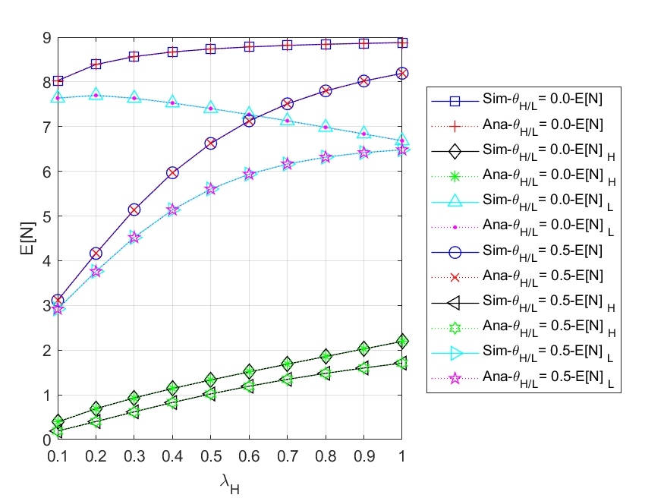

Fig. 5 - 33: The expected number of all ($HP,LP$) packets in the system vs. the HP packet arrival rate for different regular battery usage probabilities

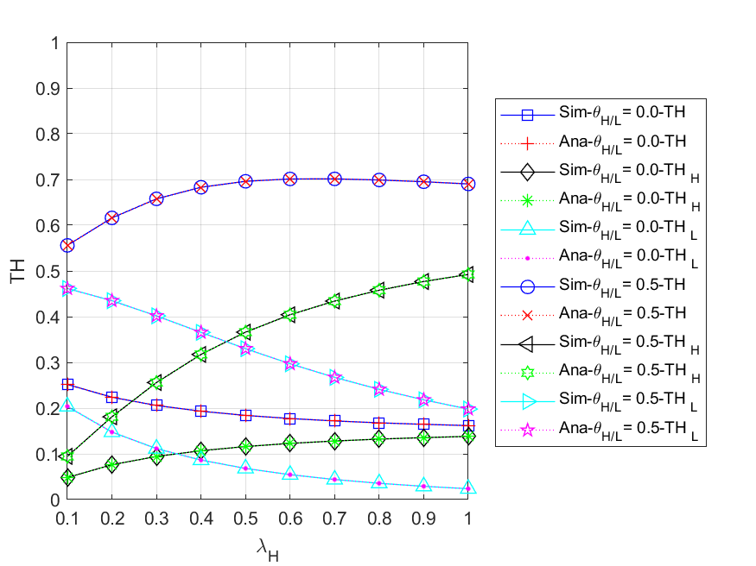

Fig. 5 - 34: The throughput of all ($HP,LP$) packets vs. the HP packet arrival rate for different regular battery usage probabilities

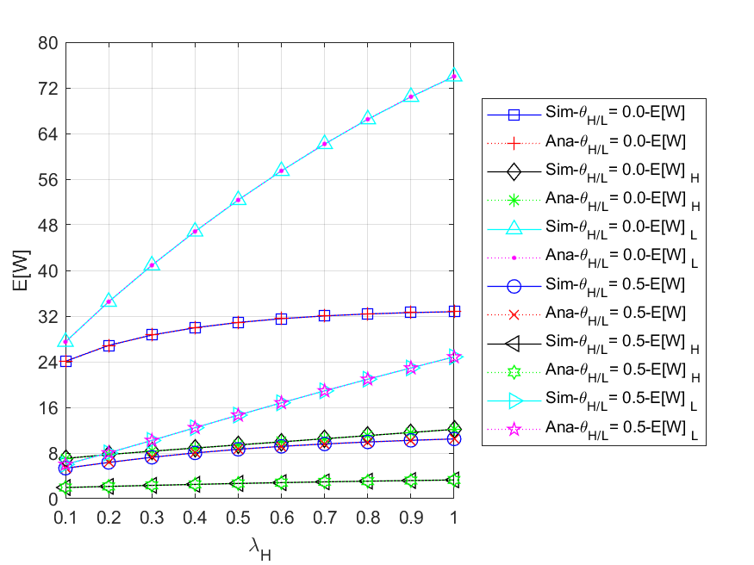

Fig. 5 - 35: The mean waiting time of all ($HP,LP$) packets in the system vs. the HP packet arrival rate for different regular battery usage probabilities

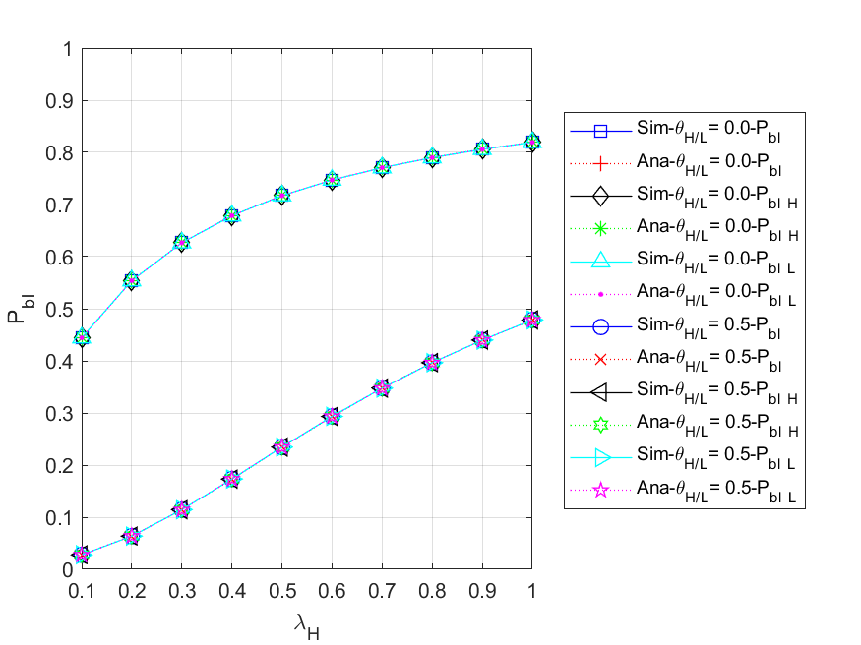

Fig. 5 - 36: The blocking probability of all ($HP,LP$) arrived packets vs. the HP packet arrival rate for different regular battery usage probabilities

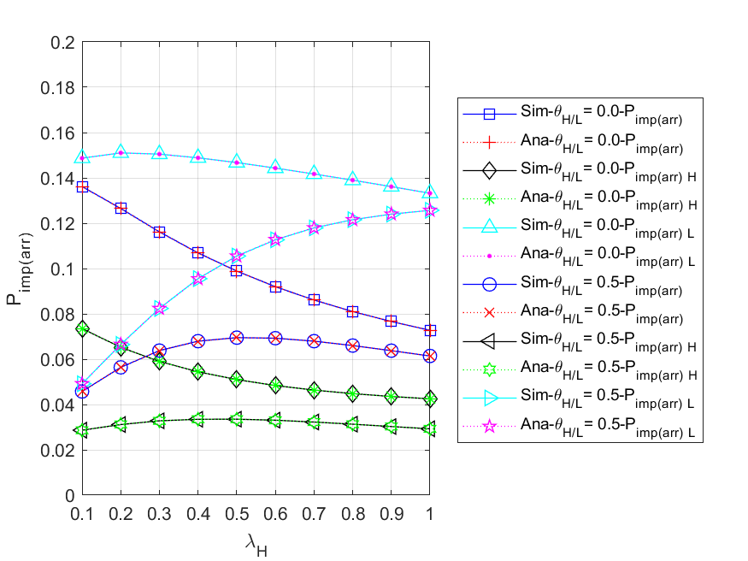

Fig. 5 - 37: The impatient loss probability of all ($HP,LP$) arrived packets vs. the HP packet arrival rate for different regular battery usage probabilities

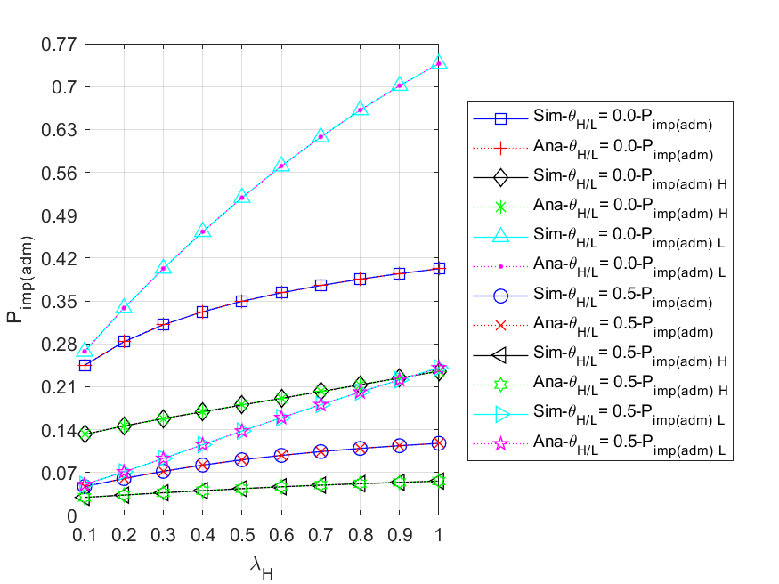

Fig. 5 - 38: The impatient loss probability of all ($HP,LP$) admitted packets vs. the HP packet arrival rate for different regular battery usage probabilities

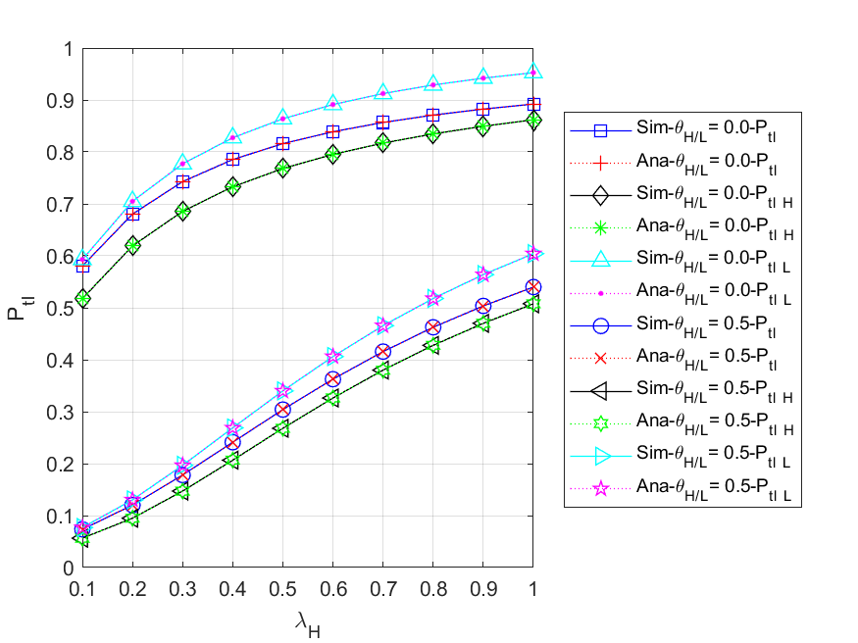

Fig. 5 - 39: The total loss probability of all ($HP,LP$) arrived packets vs. the HP packet arrival rate for different regular battery usage probabilities

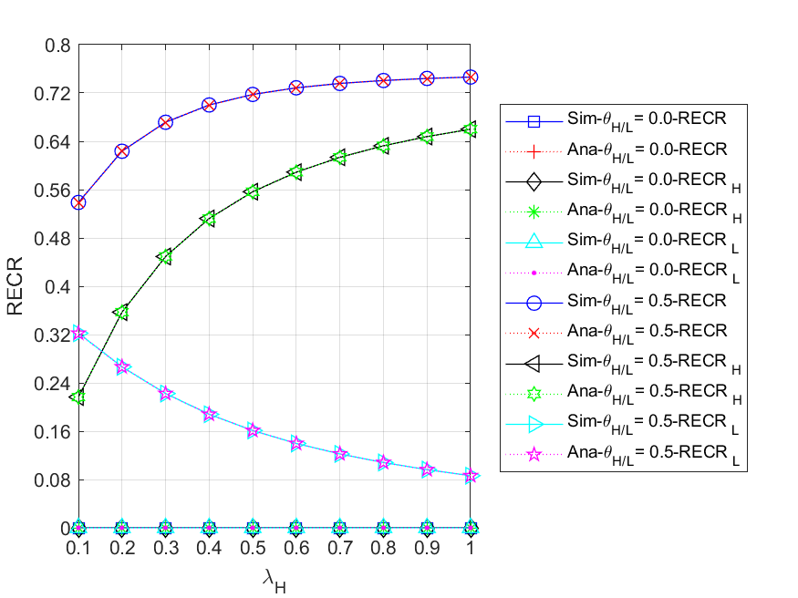

Fig. 5 - 40: The regular energy consumption ratio for serving all ($HP,LP$) packets vs. the HP packet arrival rate for different regular battery usage probabilities

## Scenario 3

In this scenario, the assumptions we make about the three nodes in this network are somewhat different. The nodes in the simulation model are dependent, whereas they are independent in the analytical model. That is, due to blocking, impatience, and routing policy, the internal arrival process in the simulation model is non-Poisson, while it is Poisson in the analytical model.

Unless otherwise stated, the default values of the various parameters are as follows: the external HP and LP packet arrival rates ,, and for each node , , , , the routing probability from the other forwarding nodes to the control node $r_{13}=r_{23}=0.1$, the packet queue size $(N)$ is 9, and energy queue size $(K)$ is 100. The energy requirement for both HP and LP packets is one unit, i.e., $e_{H}=e_{L}=1$. We assume that no matter at which node, all HP and LP packs in the network have the same regular battery usage probability, i.e., , for the convenience of discussion.

It is noted that, for node , the energy request rate is , and the effective service rate is defined as $μ_{eff-n}≤min⁡(\max\left(μ_{Hn}, μ_{Ln}\right), β_{n}+max(θ_{Hn}, θ_{Ln}))$.

We first use the default parameters to determine suitable regular battery usage probabilities $θ_{H}/θ_{L}$. As shown in Fig. 5 - 41, it can be clearly observed that as $θ_{H}/θ_{L}$ gradually increases, the $P_{tl}$ of the network and node 1 will decrease, that of node 2 will increase first and then decrease, and that of node 3 will remain zero. This is because for node 1, the larger , the more packets that can be served immediately by using the regular battery before being blocked or impatient. For node 2, the arrival traffic is related to the rate of packets leaving from node 1, which means that the higher the throughput of node 1, the more likely the energy request rate will be higher than the effective service rate at node 2, so the curve will gradually increase in the former part and decrease as increase in the latter part. For node 3, the arrival traffic is much smaller than those at the other nodes due to the routing probability; therefore, the harvested energy is sufficient to provide the service without using the regular battery as an auxiliary energy source. Considering that each of the above nodes has different characteristics and the energy consumption of the regular battery as shown in Fig. 5 - 42. We choose the average curve of the network as the reference, that is, $P_{tl}$- $Ave$ and $RECR$- $Ave$, and set $P_{tl}=0.1$ as the upper limit, then select the minimum on the curve such that the upper bound is not violated as the suboptimal parameter value, that is, . Afterwards, the influences of external HP packet arrival rate on various performance measures are studied, and the results are shown in Fig. 5 - 43 to Fig. 5 - 61.

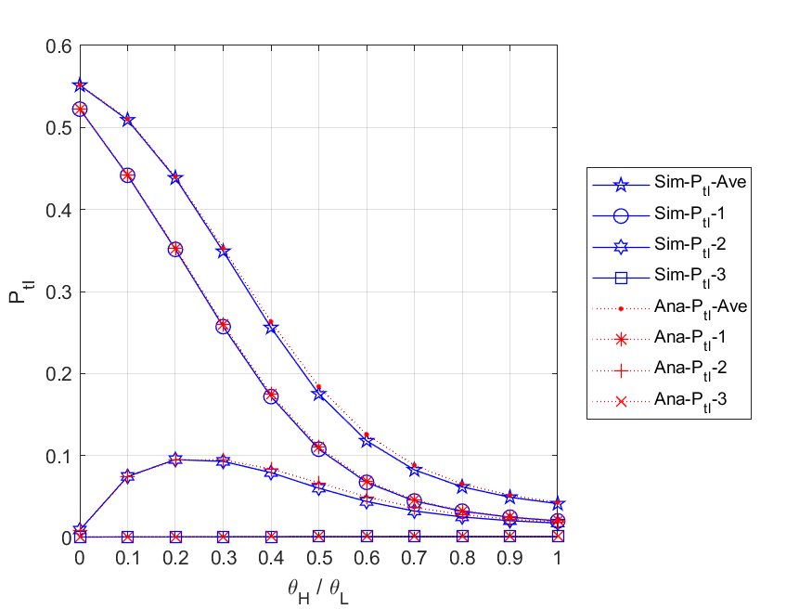

Fig. 5 - 41: The total loss probability of all packets in the network and each node vs. the regular battery usage probabilities

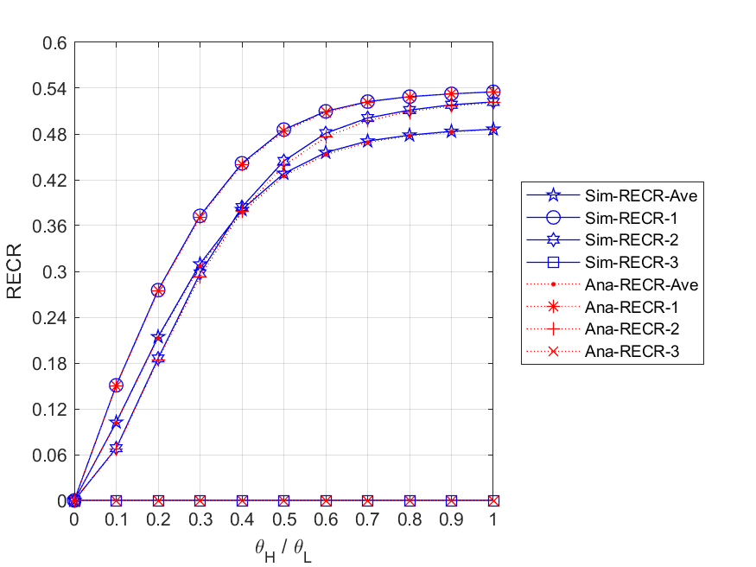

Fig. 5 - 42: The regular energy consumption ratio for serving all packets in the network and each node vs. the regular battery usage probabilities

* + 1. **Energy arrival rate**

Fig. 5 - 43 shows the relationship between the expected number of all packets in the network and each node, and the external HP packet arrival rate . First, we observe that both - and - gradually increase as increases. This is because the higher the external HP packet arrival rate, the more packets are able to enter the network and node 1. Second, it can be found that the curve of - will first rise and then fall. The reason is that the rate of packets leaving node 1 will determine the arrival rate of packets at node 2. This is to say, with the increase of , the queue of node 1 can easily become congested, causing arrived external packets to be blocked or lose patience, thus packets entering node 2 will reduce accordingly. Third, due to the routing probability, the traffic at node 3 is much smaller than those at the other nodes, and most of the arrived packets can be served immediately, therefore - will not change significantly as increases. Fourth, for the same , we can observe that - is higher than -, while - is the lowest. This is because node 1, which is the entry node, has the most packets arrived; node 2 has the second highest number of packets arrived because of blocking and impatience at node 1; and node 3 has the lowest packet arrival rate due to smaller routing probabilities, i.e., $r_{13}$ and $r_{23}$. Additionally, it is worth noting that since the total number of expected packets in the network can be considered as the sum of $E\left[N\right]$- $1$, $E\left[N\right]$- $2$, and $E\left[N\right]$- $3$, the curve of $E\left[N\right]$- $Ave$ must be the highest.

Fig. 5 - 44 shows the relationship between the expected number of HP and LP packets in the network and each node, and the external HP packet arrival rate . First, for node 1, we observe that both - and - increase as increases. This is because the higher the external HP packet arrival rate, the more packets are able to enter node 1. Second, for node 2, it can be found that - increases gradually with the increase of , while - first rises and then falls. The reason is that HP packets have a non-preemptive priority over LP packets. Therefore, the higher HP packet arrival rate, the more likely LP packets can be backlogged in the queue and run out of patience. Third, for node 3, due to the routing probability, the traffic at node 3 is much smaller than those at the other nodes, and most of the arrived packets can be served immediately, therefore - does not change significantly as increases. Fourth, we can find that excluding node 3, (-*n*, *n*=1, 2) is smaller than (-*n*, *n*=1, 2) in most cases. That is because the HP packets can occupy a place in front of any LP packets in the queue, and thus the HP packets can complete the service more quickly. Fifth, for the same , we can observe that - (-) is higher than - (-), while - (-) is the lowest. The reason is that node 1, which is the entry node, has the most packets arrived; node 2 has the second highest number of packets arrived because of blocking and impatience at node 1; and node 3 has the lowest packet arrival rate due to smaller routing probabilities, i.e., $r_{13}$ and $r_{23}$. Additionally, it is worth noting that since the total number of expected HP (LP) packets in the network can be considered as the sum of ${E[N]}_{H}$- $1$ (${E[N]}_{L}$- $1$), ${E[N]}_{H}$- $2$ (${E[N]}_{L}$- $2$), and ${E[N]}_{H}$- $3$ (${E[N]}_{L}$- $3$), the curve of ${E[N]}_{H}$- $Ave$ (${E[N]}_{L}$- $Ave$) must be the highest.

Fig. 5 - 45 shows the relationship between the expected numbers of packets in queue for the network and each node, and the external HP packet arrival rate . First, we observe that both - and - gradually increase as increases. This is because the higher the external HP packet arrival rate, the more packets are able to enter the queue of all nodes and node 1. Second, it can be found that the curve of - will first rise and then fall slightly. The reason is that the rate of packets leaving node 1 will affect the arrival rate of packets at node 2. This is to say, with the increase of , the queue of node 1 can easily become congested, causing arrived external packets to be blocked or lose patience, thus packets entering node 2 will reduce accordingly. Third, due to the routing probability, the traffic at node 3 is much smaller than those at the other nodes, and most of the arrived packets can be served immediately, therefore - does not change significantly as increases. Fourth, for the same , we can observe that - is higher than -, while - is the lowest. This is because node 1, which is the entry node, has the most packets arrived; node 2 has the second highest number of packets arrived because of blocking and impatience at node 1; and node 3 has the lowest packet arrival rate due to smaller routing probabilities, i.e., $r_{13}$ and $r_{23}$. Additionally, it is worth noting that since the total number of expected packets in the queue for the network can be considered as the sum of $E\left[N_{q}\right]$- $1$, $E\left[N_{q}\right]$- $2$, and $E\left[N_{q}\right]$- $3$, the curve of $E\left[N_{q}\right]$- $Ave$ must be the highest.

Fig. 5 - 46 shows the relationship between the expected numbers of HP and LP packets in queue for the network and each node, and the external HP packet arrival rate . First, for node 1, we observe that both - and - increase as increases. This is because the higher the external HP packet arrival rate, the more packets will be backlogged in the queue of node 1. Second, for node 2, it can be found that - increases gradually with the increase of , while - first rises and then falls. The reason is that HP packets have a non-preemptive priority over LP packets. Therefore, the higher HP packet arrival rate, the more likely LP packets can be backlogged in the queue and run out of patience. Third, for node 3, due to the routing probability, the traffic at node 3 is much smaller than those at the other nodes, and most of the arrived packets can be served immediately, therefore - does not change significantly as increases. Fourth, we can find that excluding node 3, (-*n*, *n*=1, 2) is smaller than (-*n*, *n*=1, 2) in most cases. That is because the HP packets can occupy a place in front of any LP packets in the queue, and thus the HP packets can complete the service more quickly. Fifth, for the same , we can observe that - (-) is higher than - (-), while - (-) is the lowest. The reason is that node 1, which is the entry node, has the most packets arrived; node 2 has the second highest number of packets arrived because of blocking and impatience at node 1; and node 3 has the lowest packet arrival due to smaller routing probabilities, i.e., $r_{13}$ and $r_{23}$. Additionally, it is worth noting that since the total number of expected HP (LP) packets in the queue for the network can be considered as the sum of ${E[N_{q}]}_{H}$- $1$ (${E[N_{q}]}_{L}$- $1$), ${E[N_{q}]}_{H}$- $2$ (${E[N_{q}]}_{L}$- $2$), and ${E[N_{q}]}_{H}$- $3$ (${E[N_{q}]}_{L}$- $3$), the curve of ${E[N_{q}]}_{H}$- $Ave$ (${E[N_{q}]}_{L}$- $Ave$) must be the highest.

Fig. 5 - 47 shows the relationship between the throughputs of the network and each node, and the external HP packet arrival rate $λ_{H}$. First, we can observe that as $λ_{H}$ increases, the curves of $TH$- $Ave$, $TH$- $1$, and $TH$- $2$ will first rise and then fall. The main reasons are that, on the one hand, when the energy supply is sufficient with regular batteries acting as auxiliary energy sources, the throughput can be increased without being limited by the arrival rate of harvesting energy. However, the energy supply will gradually become insufficient as $λ_{H}$ increases, causing packets in the queue of node 1 to become impatient and more difficult to be served, i.e., $ϕ_{req-1}>μ_{eff-1}$. On the other hand, since node 1 is an entry node, it has the most traffic and its departure rate determines the arrival rates of the other nodes, so the - and - curves will be lower, but have similar characteristics to the - curve. Second, it can be found that - is not only much lower than the others, but only slightly changes as increases. This is due to the fact that routing probability to node 3 is lower than that to every other node, therefore, traffic to node 3 will be so small that the trend of the curve won't significantly change.

Fig. 5 - 48 shows the relationship between the throughputs of HP and LP packets for the network and each node, and the external HP packet arrival rate . First, it is obvious to find that as increases, - (-*n*, *n*=1, 2, 3) will increase, while - (-*n*, *n*=1, 2, 3) will gradually decrease regardless of the node. This is because HP packets have a non-preemptive priority over LP packets. Therefore, the higher the external HP packet arrival rate, the more HP packets enter the server to complete the service, the fewer LP packets can be served. Second, since node 1 is an entry node, it has the most traffic and its departure rate determines the arrival rates of the other nodes, so the - (-) and - (-) curves will be lower, but have similar characteristics to the - (-) curve. Third, it can be found that - (-) is not only much lower than the others, but changes less with increasing . This is due to the fact that routing probability to node 3 is lower than that to every other node, therefore, traffic to node 3 will be so small that the trend of the curve won't significantly change.

Fig. 5 - 49 shows the relationship between the mean waiting time of all packets in the network and each node, and the external HP packet arrival rate . First, we observe that both - and - gradually increase as increases. This is because, the higher the external HP packet arrival rate, the more packets are able to enter the network and node 1, therefore the longer they have to wait in the queues. Second, it can be found that the curve of $E[W]$- $2$ will first rise and then fall. The reason is that the rate of packets leaving node 1 will affect the arrival rate of packets at node 2. That is to say, with the increase of , the queue of node 1 can easily become congested, causing arrived external packets to be blocked or lose patience, thus packets entering node 2 will reduce accordingly. Third, due to the routing probability, the traffic at node 3 is much smaller than those at the other nodes, and most of the arrived packets can be served immediately without waiting in the queue, hence $E[W]$- $3$ will not change significantly as $λ_{H}$ increases. Fourth, for the same $λ_{H}$, we can observe that $E[W]$- $1$ is higher than $E[W]$- $2$, while $E[W]$- $3$ is the lowest. This is because node 1, which is the entry node, has the most packets arrived; node 2 has the second highest number of packets arrived because of blocking and impatience at node 1; and node 3 has the lowest packet arrival due to smaller routing probabilities, i.e., $r_{13}$ and $r_{23}$.

Fig. 5 - 50 shows the relationship between the mean waiting time of HP and LP packets in the network and each node, and the external HP packet arrival rate . First, we observe that regardless of whether it is node 1, node 2, or the entire network, the corresponding and will gradually increase as the increase of . This is because, the higher the external HP packet arrival rate, the more HP packets are able to enter node 1, node 2 and the network, therefore the longer the HP and LP packets have to wait in the queues. Second, for node 1, node 2, and the entire network, it can also be clearly observed that the curves of  are much lower than those of . The reason is that the non-preemptive priority policy makes HP packets more likely to be served, while most of LP packets are backlogged in the queue. Third, due to the routing probability, the traffic at node 3 is much smaller than those at the other nodes, and most of the arrived packets can be served immediately without waiting in the queue, hence the curve of - and - will not only not change significantly as increases, but will close to the respective mean service time, i.e., and . Fourth, for the same , we can observe that - (-) is higher than - (-2), while - (-3) is the lowest. This is because node 1, which is the entry node, has the most packets arrived; node 2 has the second highest number of packets arrived because of blocking and impatience at node 1; and node 3 has the lowest packet arrival due to smaller routing probabilities, i.e., $r_{13}$ and $r_{23}$.

Fig. 5 - 51 shows the relationship between the energy loss probabilities of the network and each node, and the external HP packet arrival rate . First, we observe that both - and - remain zero as increases. This is because the harvesting energy at nodes 1 and 2 is always insufficient to provide the service (, *n*=1, 2), so whenever an energy unit arrives, it will be immediately consumed by the packets waiting in the queues. Second, for node 3, it is obvious to find that as $λ_{H}$ increases, $P_{el}$- $3$ only decreases slightly and then remains nearly at a constant. The reason is due to the fact that routing probability to node 3 is lower than that to every other node, therefore traffic to node 3 will be so small that the harvested energy can not only satisfy most of the arrived packets, but even be excessive, i.e., $ϕ_{req-3}<β_{3}$. Third, since we assume that each of the three nodes has the same energy arrival rate, $P_{el}$- $Ave$ can be regarded as the average of $P_{el}$- $1$, $P_{el}$- $2$, and $P_{el}$- $3$.

Fig. 5 - 52 shows the relationship between the blocking probabilities for all arrived packets of the network and each node, and the external HP packet arrival rate . First, we observe that both - and - rapidly increase as increases. This is because, the higher the external HP packet arrival rate, the more likely the packet queue will become full. Second, it can be found that the curve of $P_{bl}$- $2$ will first increase and then decrease slightly. The reason is that as $λ_{H}$ increases, node 1 becomes more congested, which leads to fewer packets entering node 2 per unit time, and the chance of being blocked at node 2 is also slightly reduced. Third, due to the routing probability, the traffic at node 3 is much smaller than those at the other nodes, and most of the arrived packets can be served immediately without waiting in the queue, hence $P_{bl}$- $3$ will always remain at zero. Fourth, for the same $λ_{H}$, we can observe that $P_{bl}$- $1$ is higher than $P_{bl}$- $2$, while $P_{bl}$- $3$ is the lowest. This is because node 1, which is the entry node, has the most packets arrived; node 2 has the second highest number of packets arrived because of the congestion at node 1; and node 3 has the lowest packet arrival due to smaller routing probabilities, i.e., $r_{13}$ and $r_{23}$.

Fig. 5 - 53 shows the relationship between the blocking probabilities for arrived HP and LP packets of the network and each node, and the external HP packet arrival rate . First, for each node, we can observe that their respective and are the same. This is because once the packet queue is full, an arrived packet will be blocked regardless of its priority. Second, since more and more packets enter the network as the external HP packet arrival rate increases, it makes the packet queue more likely to become full. Therefore, for both node 1 and the entire network, their $P_{bl_H}$ and $P_{bl_L}$ will significantly grow with increasing $λ_{H}$. Third, it can be found that both the curves of $P_{bl_H}$- $2$ and $P_{bl_L}$- $2$ will first increase and then decrease slightly. The reason is that as $λ_{H}$ increases, node 1 becomes more congested, which leads to fewer packets entering node 2 per unit time, and the chance of being blocked at node 2 is also slightly reduced. Fourth, due to the routing probability, the traffic at node 3 is much smaller than those at the other nodes, and most of the arrived HP and LP packets can be served immediately without waiting in the queue, hence $P_{bl_H}$- $3$ and $P_{bl_L}$- $3$ will always remain at zero. Fifth, for the same $λ_{H}$, we can observe that $P_{bl_H}$- $1$ ($P_{bl_L}$- $1$) is higher than $P_{bl_H}$- $2$ ($P_{bl_L}$- $2$), while $P_{bl_H}$- $3$ ($P_{bl_L}$-3) is the lowest. This is because node 1, which is the entry node, has the most packets arrived; node 2 has the second highest number of packets arrived because of the congestion at node 1; and node 3 has the lowest packet arrival due to smaller routing probabilities, i.e., $r_{13}$ and $r_{23}$.

Fig. 5 - 54 shows the relationship between the impatient loss probability for all arrived packets of the network and each node, and the external HP packet arrival rate . First, for the entire network and node 1, we can observe that their corresponding - and - curves rise first and then fall with the increase of . The reason is that with sufficient energy, most packets can enter the network and node 1, which results in the number of impatient packets in the queue increasing; however, as the external HP packet arrival rate continues to grow until the energy supply gets insufficient, the packet queue will become congested, and a significant number of packets will be blocked out of the network, so the probability of impatience for arrived packets will gradually decrease. Second, for node 2, it can be found that $P_{imp(arr)}$- $2$ gradually increases as $λ_{H}$ increases. This is because node 2 has a lower packet arrival rate than node 1, which means most arrived packets are less likely to be blocked and may enter the queue waiting for service. Third, due to the routing probability, the traffic at node 3 is much smaller than those at the other nodes, and most of the arrived packets can be served immediately without waiting in the queue, hence $P_{imp(arr)}$- $3$ will not make a significant change as $λ_{H}$ increases.

Fig. 5 - 55 shows the relationship between the impatient loss probabilities for arrived HP and LP packets of the network and each node, and the external HP packet arrival rate $λ_{H}$. First, for $P_{imp\left(arr\right)_L}$, it is clearly observed that $P_{imp\left(arr\right)_L}$- $Ave$, $P_{imp\left(arr\right)_L}$- $1$, and $P_{imp\left(arr\right)_L}$- $2$ all increase with the increase of $λ_{H}$. The reason is that the higher the external HP packet arrival rate, the more HP packets are able to enter the network, node 1 and node 2. This causes the LP packets backlogged in the queue to wait longer and are more likely to become impatient. Second, for , we find that as increases, - and - increase first and then decrease, while - keeps increasing. This is because as the external HP packet arrival rate keeps growing, the packet queue of node 1 will become congested, and a significant number of packets will be blocked, therefore the probability of impatience for arrived packets will gradually decrease. On the contrary, since node 2 has a lower packet arrival rate than node 1, most arrived packets are less likely to be blocked and can be queued for service. Third, due to the routing probability, the traffic at node 3 is much smaller than those at the other nodes, and most of the arrived packets can be served immediately without waiting in the queue, hence $P_{imp\left(arr\right)_H}$- $3$ and $P_{imp\left(arr\right)_L}$- $3$ will not only be very low, but will not change significantly as $λ_{H}$ increases. Lastly, for node 1, node 2, and the entire network, we can observe that the curves of $P_{imp\left(arr\right)_H}$ are much lower than those of $P_{imp\left(arr\right)_L}$. The reason is that the non-preemptive priority policy makes HP packets more likely to be served, while most of LP packets are backlogged in the queue.

Fig. 5 - 56 shows the relationship between the impatient loss probabilities for all admitted packets of the network and each node, and the external HP packet arrival rate $λ_{H}$. First, for the entire network and each node, we can observe that their corresponding - and -, *n*=1, 2, 3, all increase as increases. This is because the higher the external HP packet arrival rate, the more packets will enter the network and each node, which results in the packets having to wait in the queue longer and becoming more vulnerable to impatience. Second, for the same , it can be found that - is higher than -, while - is the lowest. This is because node 1, which is the entry node, has the most packets arrived; node 2 has the second highest number of packets arrived because of blocking and impatience at node 1; and node 3 has the lowest packet arrival due to smaller routing probabilities, i.e., $r_{13}$ and $r_{23}$.

Fig. 5 - 57 shows the relationship between the impatient loss probabilities for admitted HP and LP packets of the network and each node, and the external HP packet arrival rate . First, for the entire network and each node, we can observe that their respective and all increase as increases. This is because the higher the external HP packet arrival rate, the more packets will enter the network and each node, which results in the packets having to wait in the queue longer and becoming more vulnerable to impatience. Second, for the entire network, node 1, and node 2, we can observe that the curves of  are much lower than those of . The reason is that the non-preemptive priority policy makes HP packets more likely to be served, while most of LP packets are backlogged in the queue. Third, due to the routing probability, the traffic at node 3 is much smaller than those at the other nodes, and most of the admitted packets can be served immediately without waiting in the queue, hence $P_{imp\left(adm\right)_H}$- $3$ and $P_{imp\left(adm\right)_L}$- $3$ will not only be very low, but will not change significantly as increases. Lastly, for the same , we can observe that - (-) is higher than - (-), while - (-) is the lowest. This is because node 1, which is the entry node, has the most packets arrived; node 2 has the second highest number of packets arrived because of blocking and impatience at node 1; and node 3 has the lowest packet arrival due to smaller routing probabilities, i.e., $r_{13}$ and $r_{23}$.

Fig. 5 - 58 shows the relationship between the total loss probabilities for all arrived packets of the network and each node, and the external HP packet arrival rate . First, for the entire network, node 1, and node 2, we observe that their corresponding -, - and - all increase as increases. The main reasons are that, on the one hand, the higher the external HP packet arrival rate, the more likely the queue in each node will become full, therefore the number of blocked packets will increase rapidly. On the other hand, as the packet queues become congested, there is a much higher chance of losing packets due to impatience. Second, it can be found that the curve of - will first increase and then remain constant. This is because, when the total external packet arrival rate exceeds the effective service rate of node 1, the packet arrival rate of node 2 will be affected by the departure rate of node 1 and approaches the limit. Third, due to the routing probability, the traffic at node 3 is much smaller than those at the other nodes, hence - will not only be very low, but will not change significantly as increases. Fourth, for the same , we can observe that - is higher than -, while - is the lowest. This is because node 1, which is the entry node, has the most packets arrived; node 2 has the second highest number of packets arrived because of blocking and impatience at node 1; and node 3 has the lowest packet arrival due to smaller routing probabilities, i.e., $r_{13}$ and $r_{23}$. Lastly, it should be noted that for the entire network and for each node, $P_{tl}$ is actually the sum of $P_{bl}$ and $P_{imp(arr)}$.

Fig. 5 - 59 shows the relationship between the total loss probabilities for arrived HP and LP packets of the network and each node, and the external HP packet arrival rate . First, for the entire network and each node, we can observe that their respective and all increase as increases. This is because the higher the external HP packet arrival rate, the more packets are expected to enter the network and nodes. This results in the packet queue becoming full more quickly and the packets having to wait longer, making them more vulnerable to impatience. Second, for the entire network, node 1, and node 2, we can observe that the curves of $P_{tl_H}$ are much lower than those of . The reason is that the non-preemptive priority policy makes HP packets more likely to be served, while most of LP packets are backlogged and waiting in the queue. Third, due to the routing probability, the traffic at node 3 is much smaller than those at the other nodes, and most of the arrived packets can be served immediately without waiting in the queue, hence $P_{tl_H}$- $3$ and $P_{tl_L}$- $3$ will not only be very low, but will not change significantly as increases. Lastly, for the same , we can observe that - (-) is higher than - (-), while - (-) is the lowest. This is because node 1, which is the entry node, has the most packets arrived; node 2 has the second highest number of packets arrived because of blocking and impatience at node 1; and node 3 has the lowest packet arrival due to smaller routing probabilities, i.e., $r_{13}$ and $r_{23}$.

Fig. 5 - 60 shows the relationship between the regular energy consumption ratio for serving all packets of the network and each node, and the external HP packet arrival rate $λ_{H}$. First, we can observe that as $λ_{H}$ increases, the curves of $RECR$- $1$, $RECR$- $2$, and $RECR$- $Ave$ will first rise and then fall. This is because, in the former half, the effective service rate is higher than the energy request rate, i.e., $ϕ_{req}<μ_{eff}$, therefore, the more packets are served, the more likely the regular battery in node 1 is to be used. However, as $λ_{H}$ increases, the energy supply will gradually become insufficient in the latter half, which makes the packets in the queue of node 1 vulnerable to impatience, and the number of served packets is relatively reduced. Furthermore, since node 1 is an entry node, it has the most traffic and its departure rate determines the arrival rates of the other nodes, so $RECR$- $Ave$ and $RECR$- $2$ curves will be lower, but have similar characteristics to the curve of $RECR$- $1$. Second, due to the fact that routing probability to node 3 is lower than that to every other node, therefore, traffic to node 3 will be so small that the harvesting energy is sufficient to provide service without acting on the regular battery as auxiliary energy sources.

Fig. 5 - 61 shows the relationship between the regular energy consumption ratio for serving HP and LP packets of the network and each node, and the external HP packet arrival rate . First, it is obvious to find that as increases, - (-*n*, *n*=1, 2) will increase, while - (-*n*, *n*=1, 2) will gradually decrease. This is because HP packets have a non-preemptive priority over LP packets. Thus, the higher the external HP packet arrival rate, the more HP packets enter the server to complete the service, the fewer LP packets can be served. Second, since node 1 is an entry node, it has the most traffic and its departure rate determines the arrival rates of the other nodes, so the ${RECR}_{H}$- $Ave$ (${RECR}_{L}$- $Ave$) and ${RECR}_{H}$- $2$ (${RECR}_{L}$- $2$) curves will be lower, but have similar characteristics to the ${RECR}_{H}$- $1$ (${RECR}_{L}$- $1$) curve. Third, due to the fact that routing probability to node 3 is lower than that to every other node, therefore, traffic to node 3 will be so small that the harvesting energy is sufficient to provide service without acting on the regular battery as auxiliary energy sources. As a result, both ${RECR}_{H}$- $3$ and ${RECR}_{L}$- $3$ are always remain at zero with the increase of $λ_{H}$.

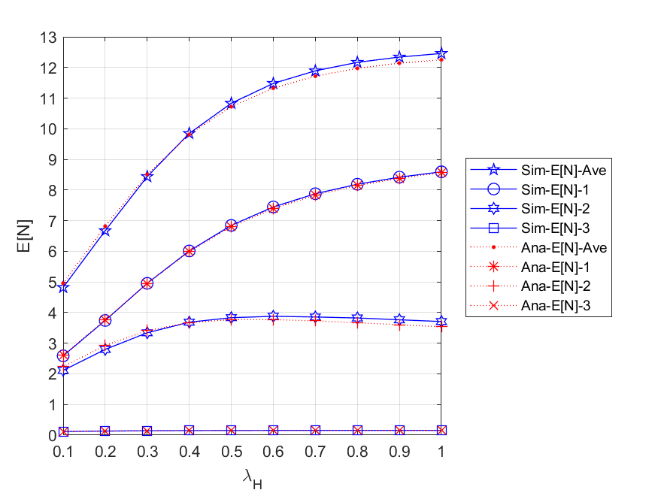

Fig. 5 - 43: The expected number of all packets in the network and each node vs. the external HP packet arrival rate

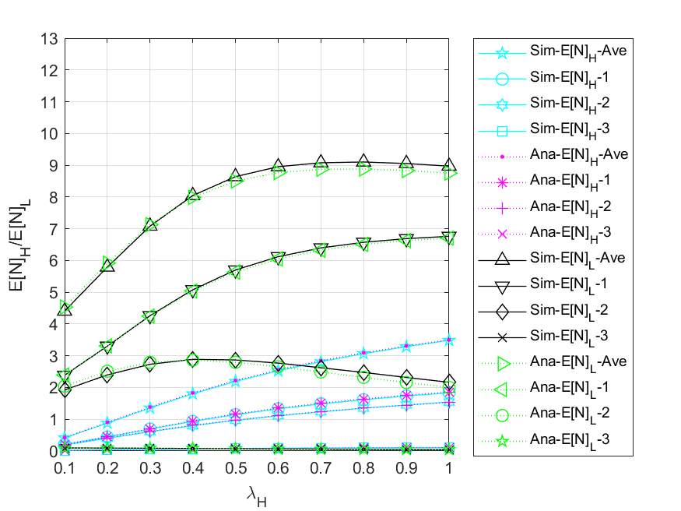

Fig. 5 - 44: The expected number of HP and LP packets in the network and each node vs. the external HP packet arrival rate

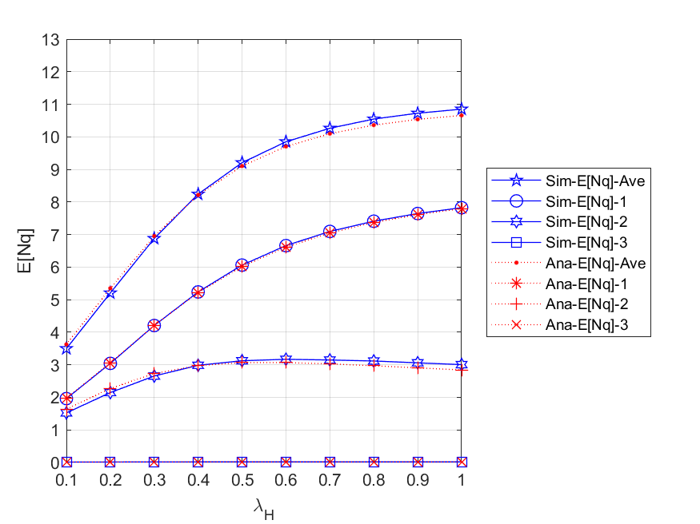

Fig. 5 - 45: The expected number of packets in queue for all nodes and each node vs. the external HP packet arrival rate

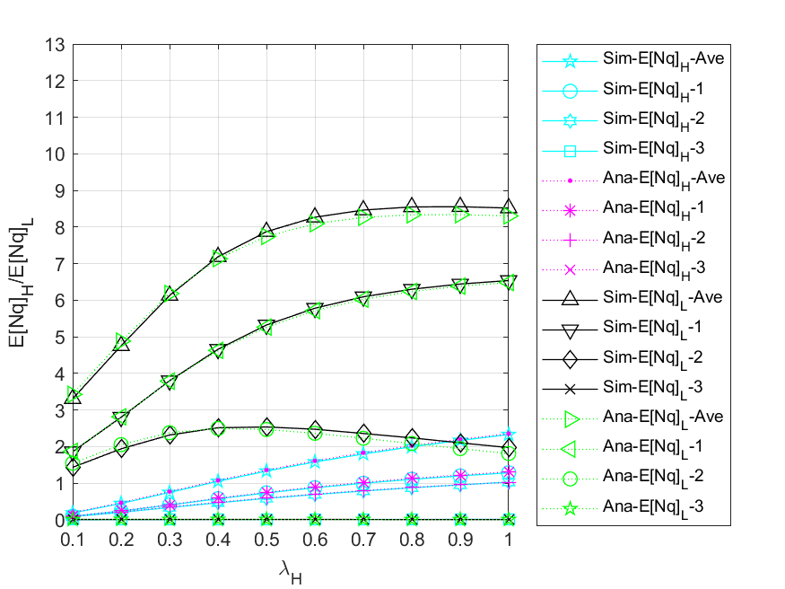

Fig. 5 - 46: The expected number of HP and LP packets in queue for all nodes and each node vs. the external HP packet arrival rate

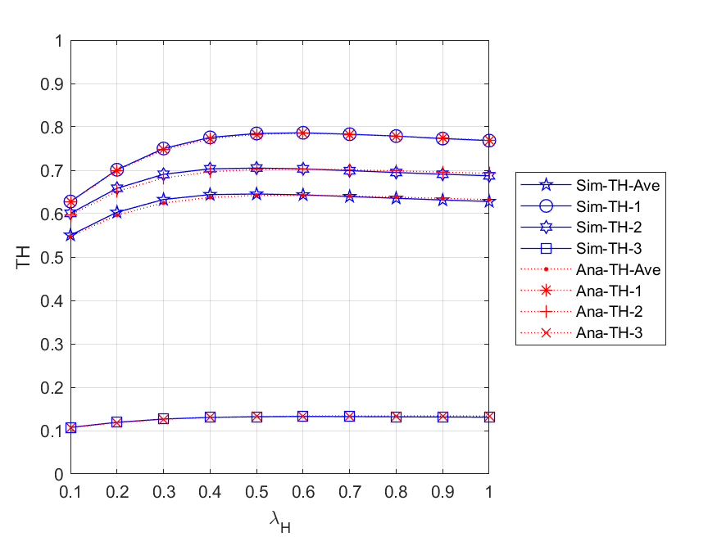

Fig. 5 - 47: The throughputs of the network and each node vs. the external HP packet arrival rate

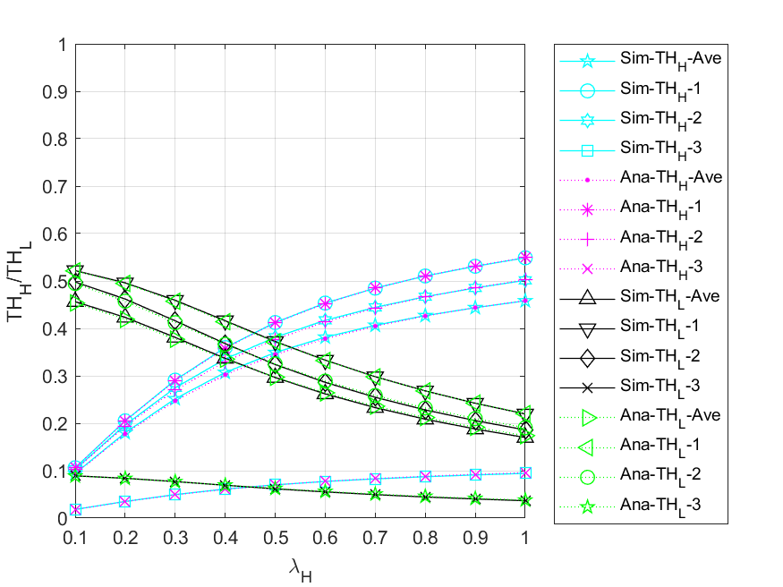

Fig. 5 - 48: The throughputs of HP and LP packets for the network and each node vs. the external HP packet arrival rate

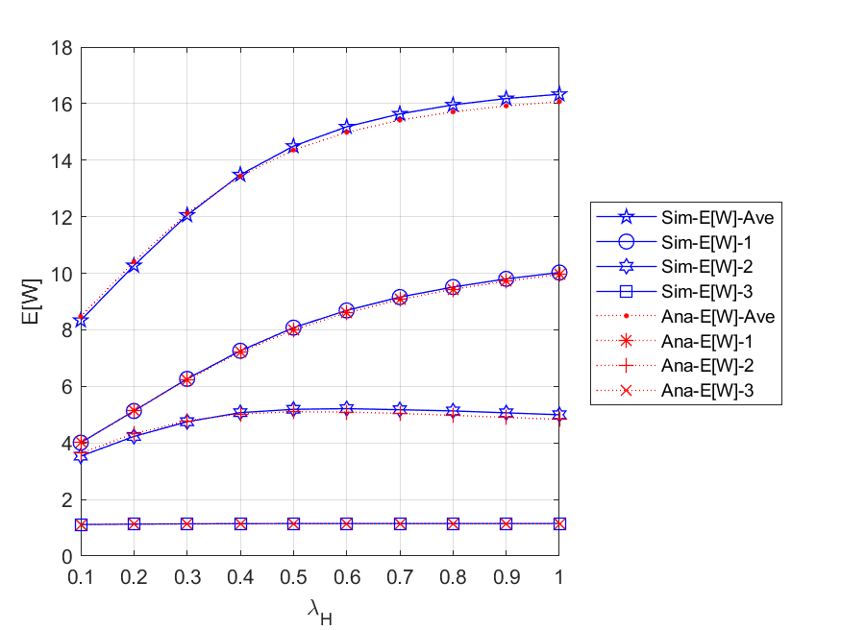

Fig. 5 - 49: The mean waiting time of all packets in the network and each node vs. the external HP packet arrival rate

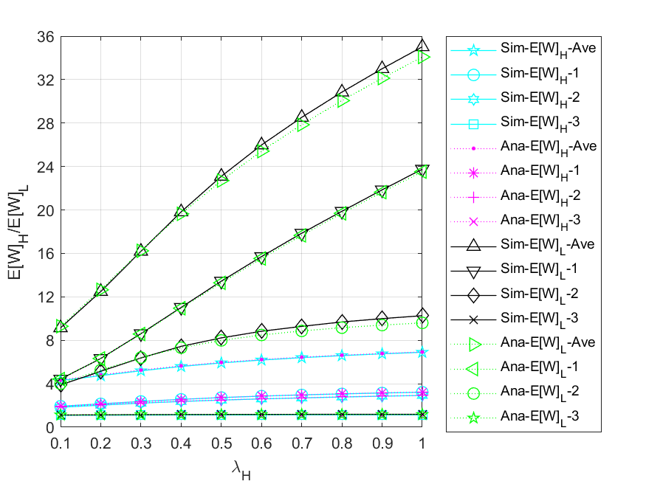

Fig. 5 - 50: The mean waiting time of HP and LP packets in the network and each node vs. the external HP packet arrival rate

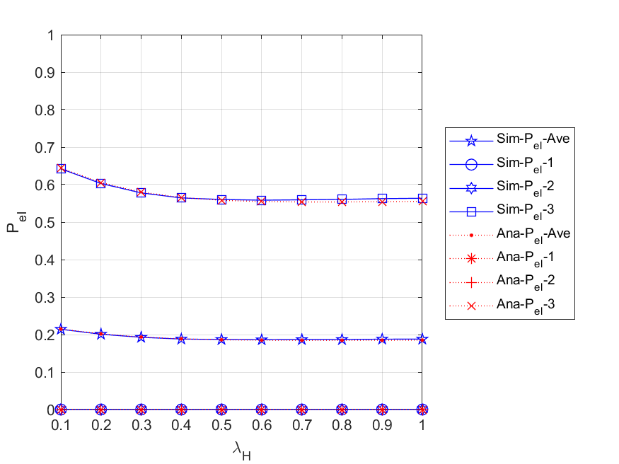

Fig. 5 - 51: The energy loss probabilities of the network and each node vs. the external HP packet arrival rate

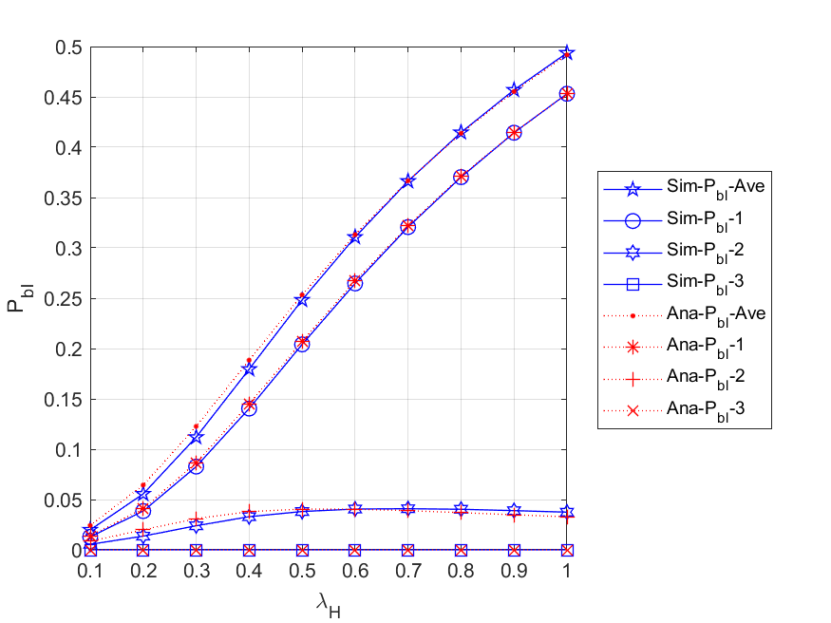

Fig. 5 - 52: The blocking probabilities for all arrived packets of the network and each node vs. the external HP packet arrival rate

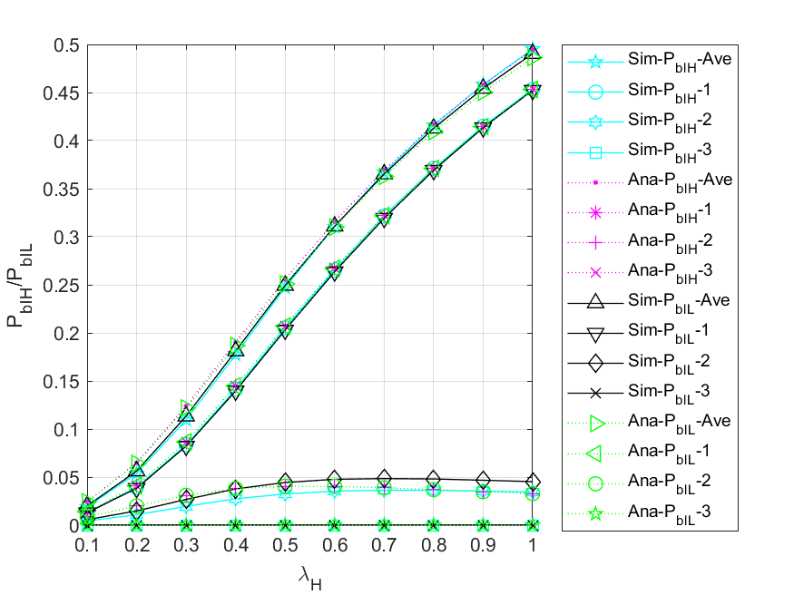

Fig. 5 - 53: The blocking probabilities for arrived HP and LP packets of the network and each node vs. the external HP packet arrival rate

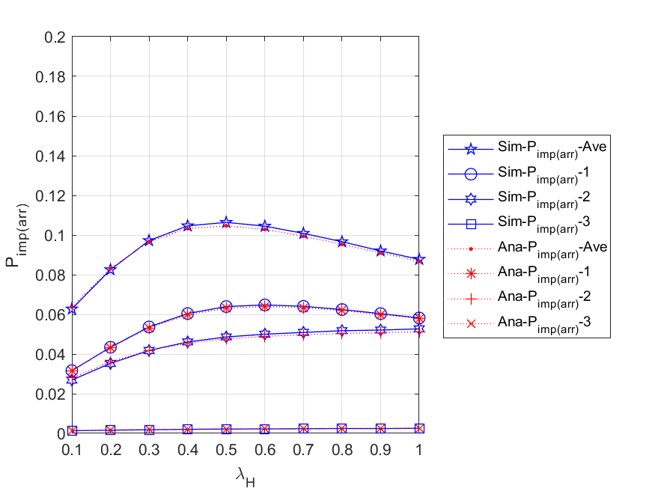

Fig. 5 - 54: The impatient loss probabilities for all arrived packets of the network and each node vs. the external HP packet arrival rate

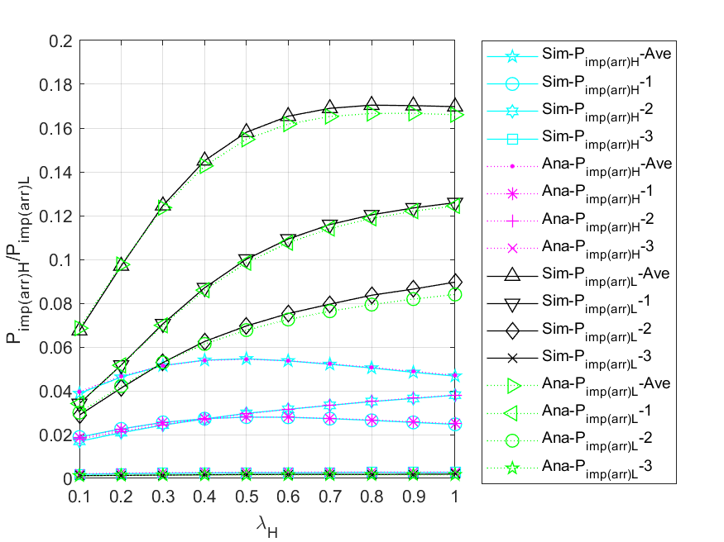

Fig. 5 - 55: The impatient loss probabilities for all arrived HP and LP packets of the network and each node vs. the external HP packet arrival rate

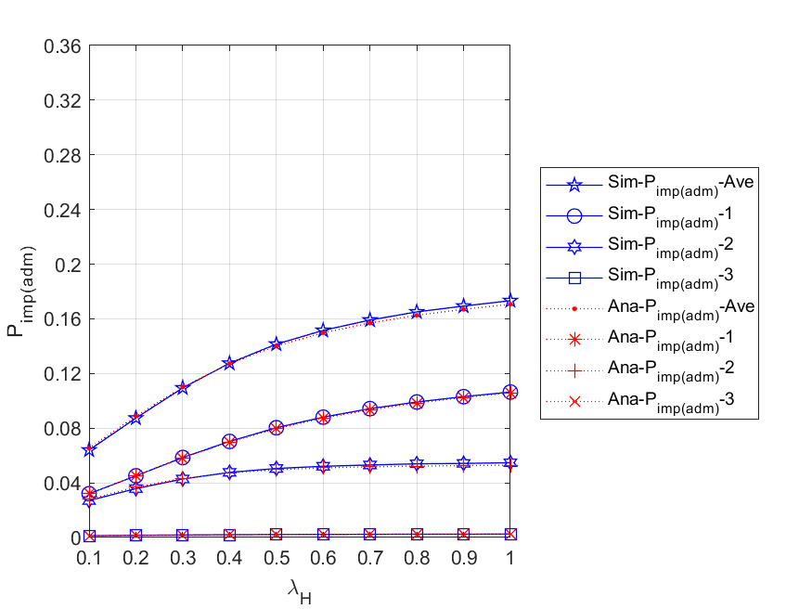

Fig. 5 - 56: The impatient loss probabilities for all admitted packets of the network and each node vs. the external HP packet arrival rate

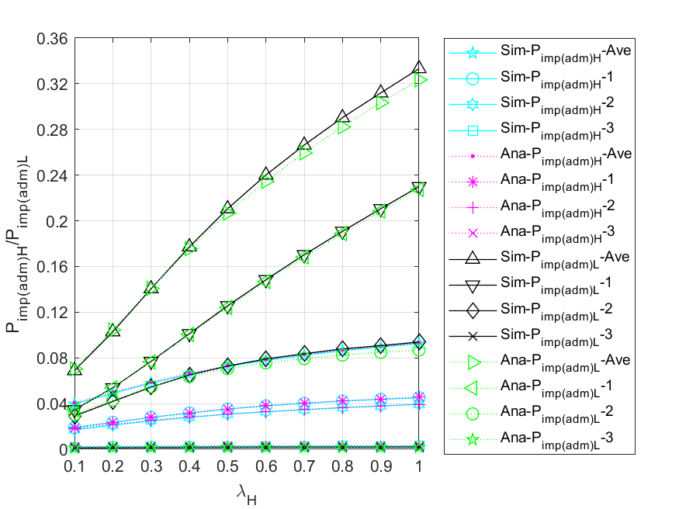

Fig. 5 - 57: The impatient loss probabilities for all admitted HP and LP packets of the network and each node vs. the external HP packet arrival rate

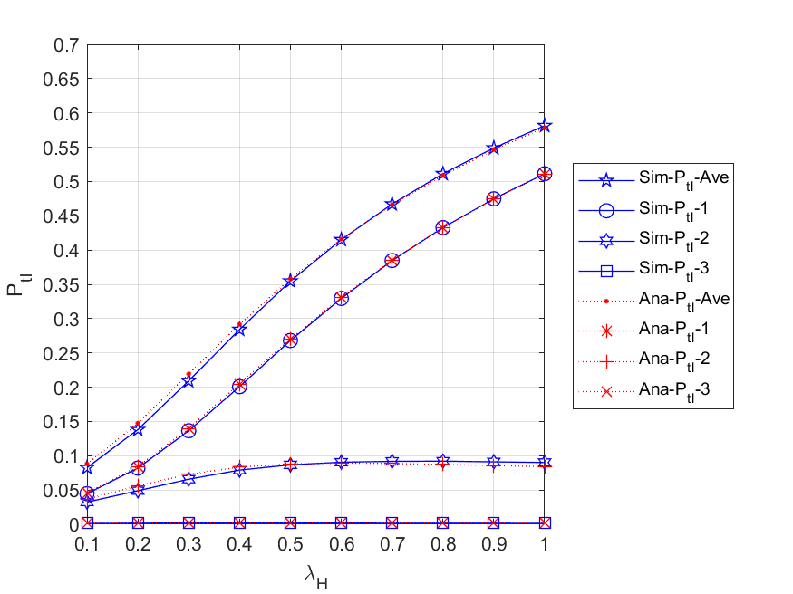

Fig. 5 - 58: The total loss probabilities for all arrived packets of the network and each node vs. the external HP packet arrival rate

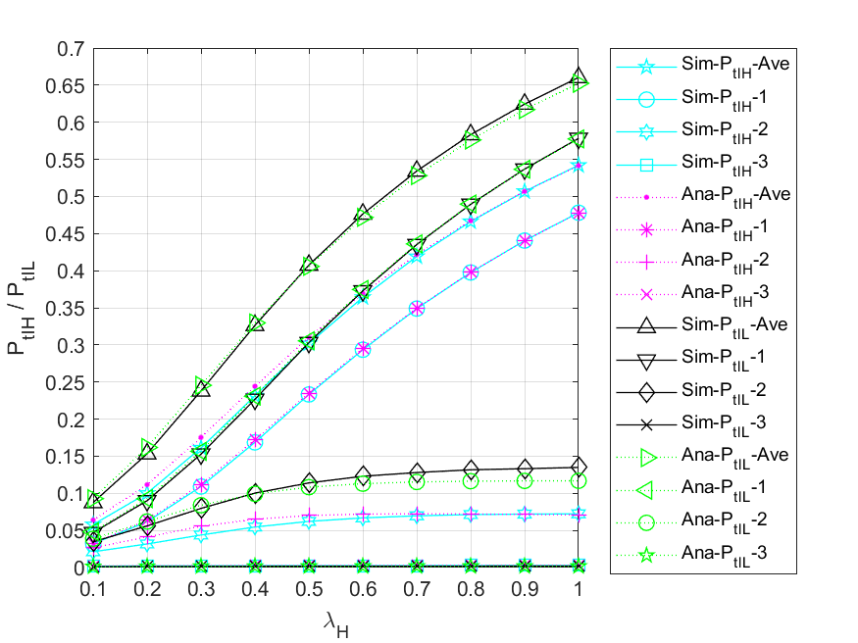

Fig. 5 - 59: The total loss probabilities for all arrived packets of the network and each node vs. the external HP packet arrival rate

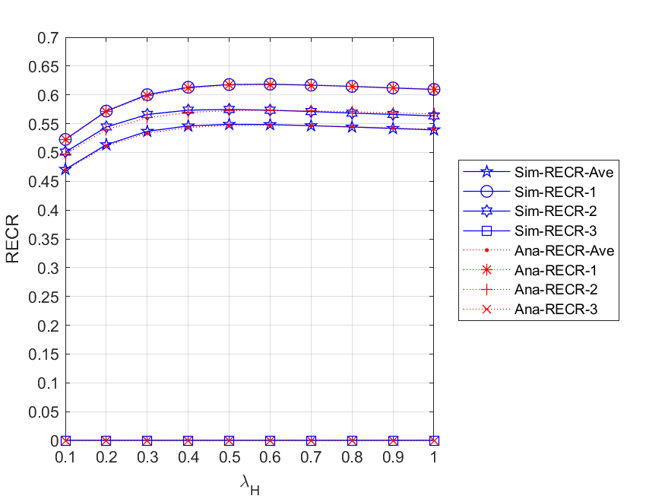

Fig. 5 - 60: The regular energy consumption ratio for serving all packets of the network and each node vs. the external HP packet arrival rate

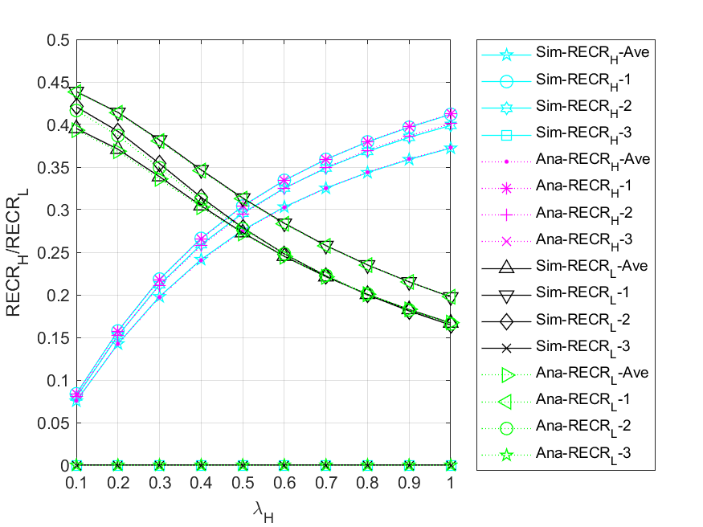

Fig. 5 - 61: The regular energy consumption ratio for serving HP and LP packets of the network and each node vs. the external HP packet arrival rate

* + 1. **Regular battery usage probabilities**

This subsection compares the scenario without regular battery with the default values. More specifically, we study the impacts of the external HP packet arrival rate on various performance measures for different regular battery usage probabilities, i.e., ${θ_{H}}/{θ_{L}}=0.0$ and $0.7$, and the results are shown in Fig. 5 - 62 to Fig. 5 - 69. Further, since our main concern is the overall network performance, only average values of network models are considered.

Fig. 5 - 62 shows the relationship between the expected number of all $(HP,LP)$ packets in the network $E[N]$ $\left({E[N]}_{H},{E[N]}_{L}\right)$ and the external HP packet arrival rate for different regular battery usage probabilities . First, for and , we can observe that the curve with is lower than the curve with at the beginning, but gradually exceeds it as increases. This is because the higher the regular battery usage probabilities, the more packets can be immediately served and routed to the other nodes rather than backlogged in the entry node. Second, for , due to the same reason as mentioned above and the discipline of non-preemptive priority, HP packets can be routed to the other nodes more easily, so the values of are higher than those of . Lastly, for , we can find that gradually decreases as increases. It is because the higher the arrival rate of the external HP packets, the longer LP packets need to wait in the queues, which makes LP packets more vulnerable to impatience and priority discipline.

Fig. 5 - 63 shows the relationship between the throughput of the network $TH$ $\left({TH}_{H},{TH}_{L}\right)$ and the external HP packet arrival rate $λ_{H}$ for different regular battery usage probabilities . For , , and , respectively, it is evident that the curve with is higher than the curve with . This is because the higher the probabilities of regular battery usage, the more likely the packets in each node can be served. In addition, for ${θ_{H}}/{θ_{L}}=0.0$, we observe that the throughput remains at a constant value below 0.3 with increasing $λ_{H}$. The reason is that in the absence of the regular battery as an auxiliary energy resource, the effective service rate is constrained by the arrival rate of harvested energy.

Fig. 5 - 64 shows the relationship between the mean waiting time of all $(HP,LP)$ packets in the network $E[W]$ $\left({E\left[W\right]}_{H},{E\left[W\right]}_{L}\right)$ and the external HP packet arrival rate for different regular battery usage probabilities . First, it is obvious to observe that the curve with is lower than the curve with for , , and . The reason is that the higher the probabilities of regular battery usage, the more likely a packet can be served immediately in each node, and the shorter the delay time the packet has in the network. Second, due to the fact that HP packets have non-preemptive priority over LP packets, most LP packets are backlogged and waiting in queues. This results in not only the curve of is always higher than that of for both and , but the difference between the curves of and appears smaller than the difference between the curves. Lastly, we can see from the overall results that the model using the regular battery as an auxiliary energy resource has a significant improvement for both HP and LP packet performance.

Fig. 5 - 65 shows the relationship between the blocking probability for all $(HP,LP)$ arrived packets of the network $P_{bl}$ $(P_{bl_H}, P_{bl_L})$ and the external HP packet arrival rate for different regular battery usage probabilities . Since an arrived packet will be blocked regardless of its priority once the packet queue in the entry node becomes full, , , and are the same for and . In addition, we compare the curves of for different regular battery usage probabilities simultaneously. It is obvious to find that the curve with is higher than the one with . The reason is that the lower the probabilities of regular battery usage, the less likely the packets waiting in the queue can be served, which makes the entry node easier to become full.

Fig. 5 - 66 shows the relationship between the impatient loss probability for all $(HP,LP)$ arrived packets of the network $P_{imp(arr)}$ $(P_{imp\left(arr\right)_H},P_{imp\left(arr\right)_L})$ and the external HP packet arrival rate for different regular battery usage probabilities . According to the figure, no matter for , , and , we can find that the curve with is lower than the curve with at the beginning, but gradually exceeds it as increases. This is because the higher the regular battery usage probabilities, the more packets can be immediately served and routed to the other nodes rather than backlogged in the entry node. However, as the number of arrived packets increases, the other nodes in the network will gradually become congested, so as $λ_{H}$ increases, the impatient loss probability of arrived packets with ${θ_{H}}/{θ_{L}}=0.7$ will become larger than that with ${θ_{H}}/{θ_{L}}=0.0$.

Fig. 5 - 67 shows the relationship between the impatient loss probability for all $(HP,LP)$ admitted packets of the network $P_{imp(adm)}$ $(P_{imp\left(adm\right)_H},P_{imp\left(adm\right)_L})$ and the external HP packet arrival rate for different regular battery usage probabilities . First, it is obvious to find that for , , and , the curve with is lower than the curve with . This is because the higher the probabilities of regular battery usage, the more likely it is that a packet will be served immediately, and the fewer packets will lose patience in the network. Second, since HP packets have non-preemptive priority over LP packets, most LP packets are backlogged and waiting in nodes’ queues. This results in not only is always higher than for both and , but the difference between the curves of and appears smaller than the difference between the curves. Lastly, we can see from the overall results that the model using the regular battery as an auxiliary energy resource has a significant improvement for both HP and LP packet performance.

Fig. 5 - 68 shows the relationship between the total loss probability for all $(HP,LP)$ arrived packets of the network $P_{tl}$ $(P_{tl_H}, P_{tl_L})$ and the external HP packet arrival rate for different regular battery usage probabilities . We can observe from the figure that for , , and , as increases, the values of are always higher than those of . This is because the lower the probabilities of regular battery usage, the easier it is for the network to become congested, and the higher the chance of packet loss due to blocking or impatience. In addition, from the overall results, it is evident that using the regular battery as an auxiliary energy resource can improve the performance of both HP and LP packets.

Fig. 5 - 69 shows the relationship between regular energy consumption ratio for serving all $(HP,LP)$ packets of the network $RECR$ $({RECR}_{H},{RECR}_{L})$ and the external HP packet arrival rate $λ_{H}$ for different regular battery usage probabilities ${θ_{H}}/{θ_{L}}$. For ${θ_{H}}/{θ_{L}}=0.7$, we observe that with the increase of , will increase first and then decrease, will gradually increase, and will gradually decrease. This is because on the one hand, as $λ_{H}$ increases, the energy supply will become insufficient, which makes the packets in the network vulnerable to impatience, and the number of served packets is relatively reduced. On the other hand, due to the non-preemption of HP packets over LP packets, the more HP packets entering the server to complete the service, the fewer LP packets can be served. Moreover, since ${θ_{H}}/{θ_{L}}=0.0$ means that the regular battery is never used, the corresponding RECR curves will always remain zero.

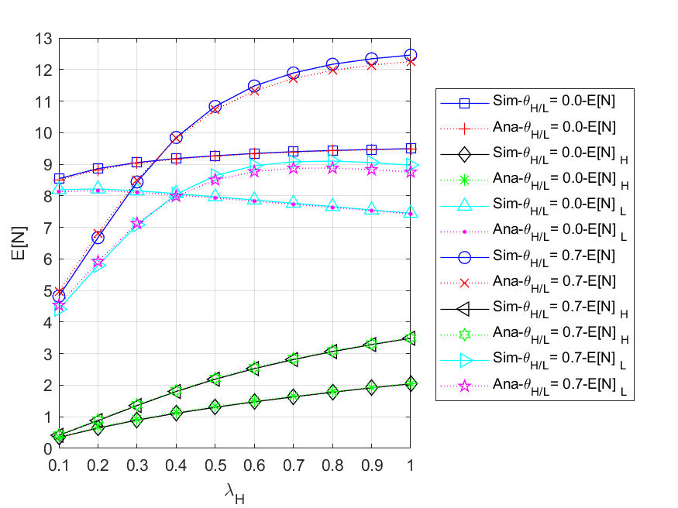

Fig. 5 - 62: The expected number of all ($HP,LP$) packets in the network vs. the external HP packet arrival rate for different regular battery usage probabilities

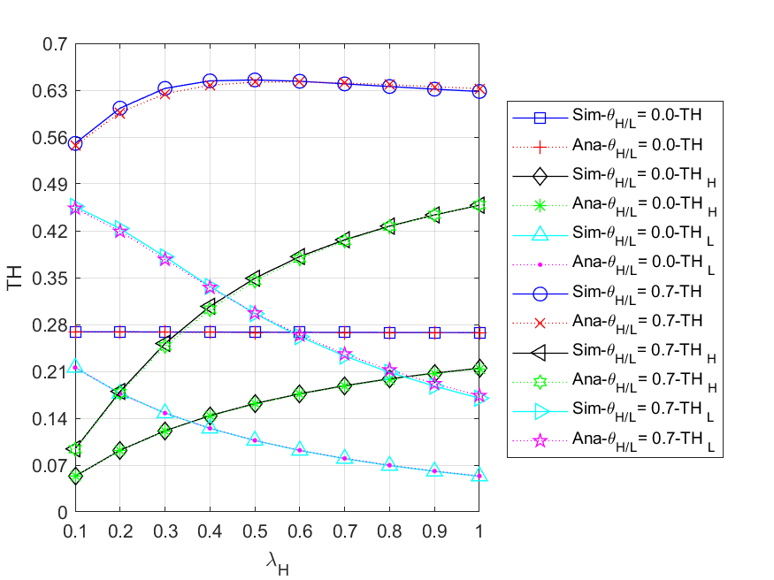

Fig. 5 - 63: The throughput of the network vs. the external HP packet arrival rate for different regular battery usage probabilities

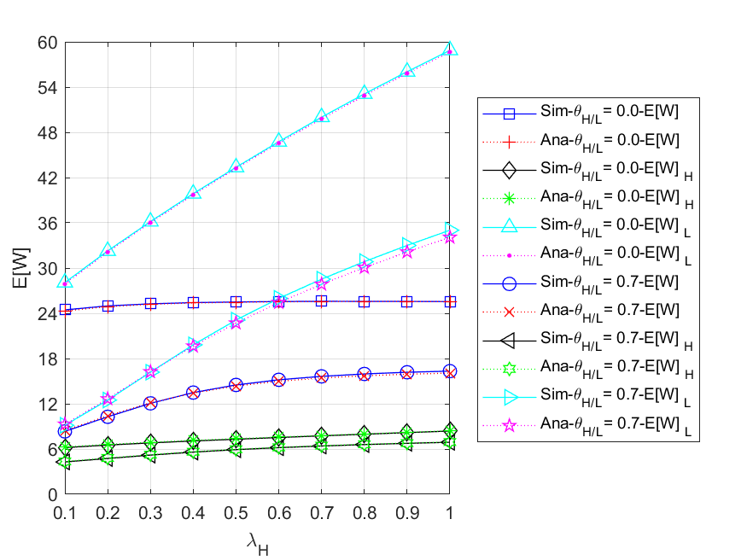

Fig. 5 - 64: The mean waiting time of all ($HP,LP$) packets in the network vs. the external HP packet arrival rate for different regular battery usage probabilities

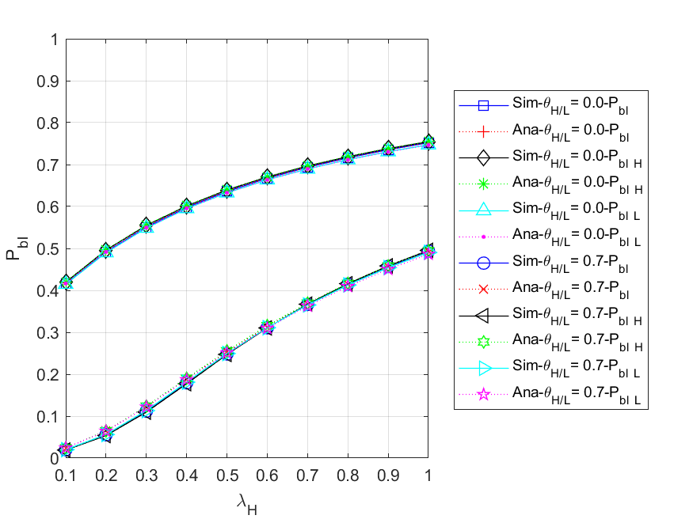

Fig. 5 - 65: The blocking probability for all ($HP,LP$) arrived packets of the network vs. the external HP packet arrival rate for different regular battery usage probabilities

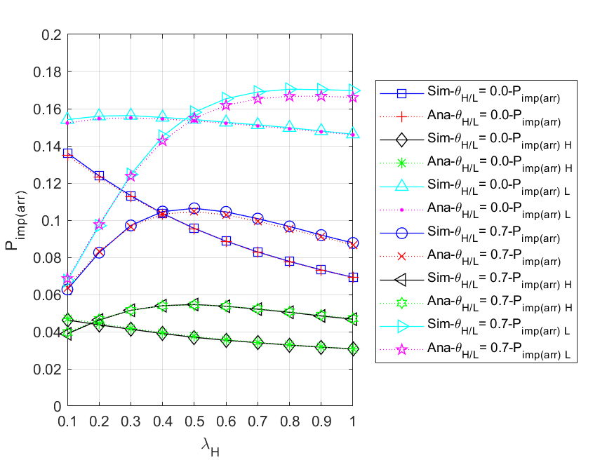

Fig. 5 - 66: The impatient loss probability for all ($HP,LP$) arrived packets of the network

vs. the external HP packet arrival rate for different regular battery usage probabilities

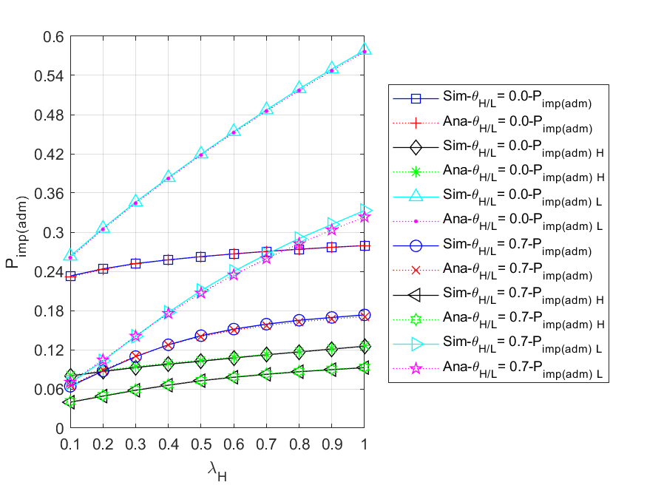

Fig. 5 - 67: The impatient loss probability for all ($HP,LP$) admitted packets of the network vs. the external HP packet arrival rate for different regular battery usage probabilities

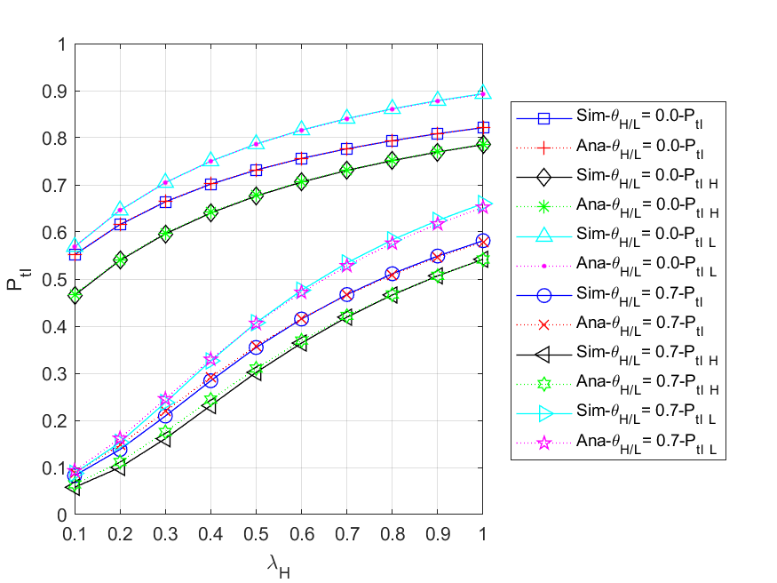

Fig. 5 - 68: The total loss probability for all ($HP,LP$) arrived packets of the network vs. the external HP packet arrival rate for different regular battery usage probabilities

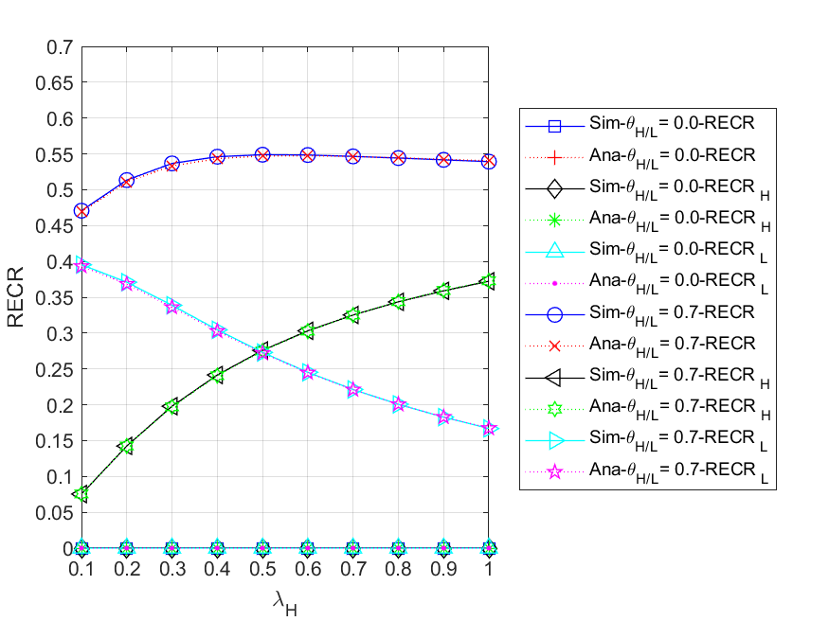

Fig. 5 - 69: The regular energy consumption ratio for serving all packets of the network

vs. the external HP packet arrival rate for different regular battery usage probabilities

## Scenario 4

In this scenario, the assumptions we make about the three nodes in this network are somewhat different. The nodes in the simulation model are dependent, whereas they are independent in the analytical model. That is, due to blocking, impatience, and routing policy, the internal arrival process in the simulation model is non-Poisson, while it is Poisson in the analytical model.

Unless otherwise stated, the default values of the various parameters are as follows: the external HP and LP packet arrival rates ,, and for each node , , , , , the routing probability from the other forwarding nodes to the control node $r_{13}=r_{23}=0.1$, the packet queue size $(N)$ is 9, and energy queue size $(K)$ is 100. The energy requirement for HP packets is two units and that for LP packets is one unit, i.e., $e_{H}=2$ and $e_{L}=1$. We assume that no matter at which node, all HP and LP packs in the network have the same regular battery usage probability, i.e., , for the convenience of discussion.

It is noted that, for node , the energy request rate is , and the effective service rate is defined as $μ_{eff-n}≤min⁡(\max\left(μ_{Hn}, μ_{Ln}\right), β_{n}+max(θ_{Hn}, θ_{Ln}))$.

We first use the default parameters to determine suitable regular battery usage probabilities $θ_{H}/θ_{L}$. As shown in Fig. 5 - 70, it can be clearly observed that as $θ_{H}/θ_{L}$ gradually increases, the $P_{tl}$ of the network and node 1 will decrease, that of node 2 will increase first and then decrease, and that of node 3 will remain zero. This is because for node 1, the larger , the more packets that can be served immediately by using the regular battery before being blocked or impatient. For node 2, the arrival traffic is related to the rate of packets leaving from node 1, which means that the higher the throughput of node 1, the more likely the energy request rate will be higher than the effective service rate at node 2, so the curve will gradually increase in the former part and decrease as increase in the latter part. For node 3, the arrival traffic is much smaller than those at the other nodes due to the routing probability; therefore, the harvested energy is sufficient to provide the service without using the regular battery as an auxiliary energy source. Considering that each of the above nodes has different characteristics and the energy consumption of the regular battery as shown in Fig. 5 - 71. We choose the average curve of the network as the reference, that is, $P_{tl}$- $Ave$ and $RECR$- $Ave$, and set $P_{tl}=0.1$ as the upper limit, then select the minimum on the curve such that the upper bound is not violated as the suboptimal parameter value, that is, . Afterwards, the influences of external HP packet arrival rate on various performance measures are studied, and the results are shown in Fig. 5 - 72 to Fig. 5 - 90.

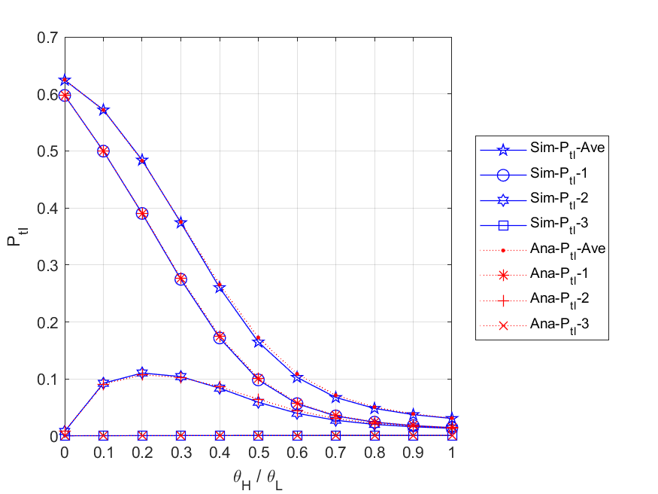

Fig. 5 - 70: The total loss probability of all packets in the network and each node vs. the regular battery usage probabilities

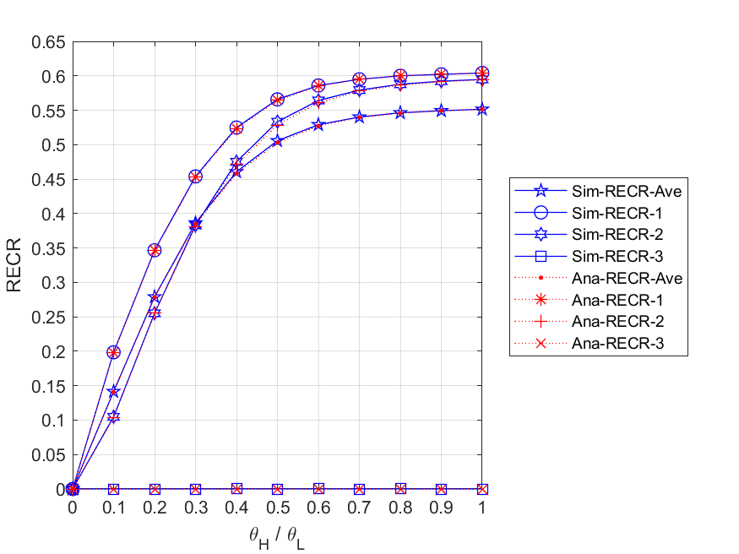

Fig. 5 - 71: The regular energy consumption ratio for serving all packets in the network and each node vs. the regular battery usage probabilities

* + 1. **Energy arrival rate**

Fig. 5 - 72 shows the relationship between the expected number of all packets in the network and each node, and the external HP packet arrival rate . First, we observe that both - and - gradually increase as increases. This is because the higher the external HP packet arrival rate, the more packets are able to enter the network and node 1. Second, it can be found that the curve of - will first rise and then fall. The reason is that the rate of packets leaving node 1 will determine the arrival rate of packets at node 2. This is to say, with the increase of , the queue of node 1 can easily become congested, causing arrived external packets to be blocked or lose patience, thus packets entering node 2 will reduce accordingly. Third, due to the routing probability, the traffic at node 3 is much smaller than those at the other nodes, and most of the arrived packets can be served immediately, therefore - will not change significantly as increases. Fourth, for the same , we can observe that - is higher than -, while - is the lowest. This is because node 1, which is the entry node, has the most packets arrived; node 2 has the second highest number of packets arrived because of blocking and impatience at node 1; and node 3 has the lowest packet arrival due to smaller routing probabilities, i.e., $r_{13}$ and $r_{23}$. In addition, it is worth noting that since the total number of expected packets in the network can be considered as the sum of $E\left[N\right]$- $1$, $E\left[N\right]$- $2$ and $E\left[N\right]$- $3$, the curve of $E\left[N\right]$- $Ave$ must be the highest. Lastly, because of the fact that blocking and impatience will occur more frequently in the case of the energy supply being insufficient, the packet delivery between three nodes is no longer close to a Poisson process. Consequently, the simulation and analytical results are slightly different, but their trends are still similar.

Fig. 5 - 73 shows the relationship between the expected number of HP and LP packets in the network and each node, and the external HP packet arrival rate . First, for node 1, we observe that both - and - increase as increases. This is because the higher the external HP packet arrival rate, the more packets are able to enter node 1. Second, for node 2, it can be found that - increases gradually with the increase of , while - first rises and then falls. The reason is that HP packets have a non-preemptive priority over LP packets. Therefore, the higher HP packet arrival rate, the more likely LP packets can be backlogged in the queue and run out of patience. Third, for node 3, due to the routing probability, the traffic at node 3 is much smaller than those at the other nodes, and most of the arrived packets can be served immediately, therefore ${E[N]}_{L}$- $3$ will not change significantly as $λ_{H}$ increases. Fourth, we can find that excluding node 3, ${E[N]}_{H}$ (${E[N]}_{H}$-*n*, *n*=1, 2) is smaller than ${E[N]}_{L}$ (${E[N]}_{L}$-*n*, *n*=1, 2) in most cases. That is because the HP packets can occupy a place in front of any LP packets in the queue, and thus the HP packets can complete the service more quickly. Fifth, for the same , we can observe that - (-) is higher than - (-), while - (-) is the lowest. The reason is that node 1, which is the entry node, has the most packets arrived; node 2 has the second highest number of packets arrived because of blocking and impatience at node 1; and node 3 has the lowest packet arrival due to smaller routing probabilities, i.e., $r_{13}$ and $r_{23}$. In addition, it is worth noting that since the total number of expected HP (LP) packets in the network can be considered as the sum of ${E[N]}_{H}$- $1$ (${E[N]}_{L}$- $1$), ${E[N]}_{H}$- $2$ (${E[N]}_{L}$- $2$) and ${E[N]}_{H}$- $3$ (${E[N]}_{L}$- $3$), the curve of ${E[N]}_{H}$- $Ave$ (${E[N]}_{L}$- $Ave$) must be the highest. Lastly, because of the fact that blocking and impatience will occur more frequently in the case of the energy supply being insufficient, the packet delivery between three nodes is no longer close to a Poisson process. Consequently, the simulation and analytical results are slightly different, but their trends are still similar.

Fig. 5 - 74 shows the relationship between the expected numbers of packets in queue for the network and each node, and the external HP packet arrival rate . First, we observe that both - and - gradually increase as increases. This is because the higher the external HP packet arrival rate, the more packets are able to enter the queue of all nodes and node 1. Second, it can be found that the curve of - will first rise and then fall slightly. The reason is that the rate of packets leaving node 1 will affect the arrival rate of packets at node 2. This is to say, with the increase of , the queue of node 1 can easily become congested, causing arrived external packets to be blocked or lose patience, thus packets entering node 2 will reduce accordingly. Third, due to the routing probability, the traffic at node 3 is much smaller than those at the other nodes, and most of the arrived packets can be served immediately, therefore - does not change significantly as increases. Fourth, for the same , we can observe that - is higher than -, while - is the lowest. This is because node 1, which is the entry node, has the most packets arrived; node 2 has the second highest number of packets arrived because of blocking and impatience at node 1; and node 3 has the lowest packet arrival due to smaller routing probabilities, i.e., $r_{13}$ and $r_{23}$. In addition, it is worth noting that since the total number of expected packets in the queue for the network can be considered as the sum of $E\left[N_{q}\right]$- $1$, $E\left[N_{q}\right]$- $2$ and $E\left[N_{q}\right]$- $3$, the curve of $E\left[N_{q}\right]$- $Ave$ must be the highest. Lastly, because of the fact that blocking and impatience will occur more frequently in the case of the energy supply being insufficient, the packet delivery between three nodes is no longer close to a Poisson process. Consequently, the simulation and analytical results are slightly different, but their trends are still similar.

Fig. 5 - 75 shows the relationship between the expected numbers of HP and LP packets in queue for the network and each node, and the external HP packet arrival rate . First, for node 1, we observe that both - and - increase as increases. This is because the higher the external HP packet arrival rate, the more packets will be backlogged in the queue of node 1. Second, for node 2, it can be found that - increases gradually with the increase of , while - first rises and then falls. The reason is that HP packets have a non-preemptive priority over LP packets. Therefore, the higher HP packet arrival rate, the more likely LP packets can be backlogged in the queue and run out of patience. Third, for node 3, due to the routing probability, the traffic at node 3 is much smaller than those at the other nodes, and most of the arrived packets can be served immediately, therefore - does not change significantly as increases. Fourth, we can find that excluding node 3, (-*n*, *n*=1, 2) is smaller than (-*n*, *n*=1, 2) in most cases. That is because the HP packets can occupy a place in front of any LP packets in the queue, and thus the HP packets can complete the service more quickly. Fifth, for the same , we can observe that - (-) is higher than - (-), while - (-) is the lowest. The reason is that node 1, which is the entry node, has the most packets arrived; node 2 has the second highest number of packets arrived because of blocking and impatience at node 1; and node 3 has the lowest packet arrival due to smaller routing probabilities, i.e., $r_{13}$ and $r_{23}$. In addition, it is worth noting that since the total number of expected HP (LP) packets in the queue for the network can be considered as the sum of ${E[N_{q}]}_{H}$- $1$ (${E[N_{q}]}_{L}$- $1$), ${E[N_{q}]}_{H}$- $2$ (${E[N_{q}]}_{L}$- $2$) and ${E[N_{q}]}_{H}$- $3$ (${E[N_{q}]}_{L}$- $3$), the curve of ${E[N_{q}]}_{H}$- $Ave$ (${E[N_{q}]}_{L}$- $Ave$) must be the highest. Lastly, because of the fact that blocking and impatience will occur more frequently in the case of the energy supply being insufficient, the packet delivery between three nodes is no longer close to a Poisson process. Consequently, the simulation and analytical results are slightly different, but their trends are still similar.

Fig. 5 - 76 shows the relationship between the throughputs of the network and each node, and the external HP packet arrival rate $λ_{H}$. First, we can observe that as $λ_{H}$ increases, the $TH$- $Ave$, $TH$- $1$ and $TH$- $2$ all increase as well. The reasons are that, on the one hand, when the energy supply is sufficient with regular batteries acting as auxiliary energy sources, the throughput can be increased without being limited by the arrival rate of harvesting energy. On the other hand, since node 1 is an entry node, it has the most traffic and its departure rate determines the arrival rates of the other nodes, so the - and - curves will be lower, but have similar characteristics to the - curve. Second, it can be found that - is not only much lower than the others, but only slightly changes as increases. This is due to the fact that routing probability to node 3 is lower than that to every other node, therefore, traffic to node 3 will be so small that the trend of the curve won't significantly change. Lastly, because blocking and impatience will occur more frequently in the case of the energy supply being insufficient, the packet delivery between three nodes is no longer close to a Poisson process. Consequently, the simulation and analytical results are slightly different, but their trends are still similar.

Fig. 5 - 77 shows the relationship between the throughputs of HP and LP packets for the network and each node, and the external HP packet arrival rate . First, it is obvious to find that as increases, - (-*n*, *n*=1, 2, 3) will increase, while - (-*n*, *n*=1, 2, 3) will gradually decrease regardless of the node. This is because HP packets have a non-preemptive priority over LP packets. Therefore, the higher the external HP packet arrival rate, the more HP packets enter the server to complete the service, the fewer LP packets can be served. Second, since node 1 is an entry node, it has the most traffic and its departure rate determines the arrival rates of the other nodes, so the - (-) and - (-) curves will be lower, but have similar characteristics to the - (-) curve. Third, it can be found that - (-) is not only much lower than the others, but changes less with increasing . This is due to the fact that routing probability to node 3 is lower than that to every other node, therefore, traffic to node 3 will be so small that the trend of the curve won't significantly change. Lastly, because blocking and impatience will occur more frequently in the case of the energy supply being insufficient, the packet delivery between three nodes is no longer close to a Poisson process. Consequently, the simulation and analytical results are slightly different, but their trends are still similar.

Fig. 5 - 78 shows the relationship between the mean waiting time of all packets in the network and each node, and the external HP packet arrival rate . First, we observe that both - and - gradually increase as increases. This is because, the higher the external HP packet arrival rate, the more packets are able to enter the network and node 1, therefore the longer they have to wait in the queues. Second, it can be found that the curve of $E[W]$- $2$ will first rise and then drop slightly. The reason is that the rate of packets leaving node 1 will affect the arrival rate of packets at node 2. That is to say, with the increase of , the queue of node 1 can easily become congested, causing arrived external packets to be blocked or lose patience, thus packets entering node 2 will reduce accordingly. Third, on the one hand, since the traffic of node 3 is much smaller than that of other nodes, and the number of arrived LP packets becomes very small as $λ_{H}$ increases, most of the arrived HP packets are more likely to be served immediately; on the other hand, because of the high service rate of HP packets, the average service time of node 3 will decrease slightly with the increase of $λ_{H}$. Fourth, for the same $λ_{H}$, we can observe that $E[W]$- $1$ is higher than $E[W]$- $2$, while $E[W]$- $3$ is the lowest. This is because node 1, which is the entry node, has the most packets arrived; node 2 has the second highest number of packets arrived because of blocking and impatience at node 1; and node 3 has the lowest packet arrival due to smaller routing probabilities, i.e., and . Lastly, because blocking and impatience will occur more frequently in the case of the energy supply being insufficient, the packet delivery between three nodes is no longer close to a Poisson process. Consequently, the simulation and analytical results are slightly different, but their trends are still similar.

Fig. 5 - 79 shows the relationship between the mean waiting time of HP and LP packets in the network and each node, and the external HP packet arrival rate . First, we observe that regardless of whether it is node 1, node 2, or the entire network, the corresponding and will gradually increase as the increase of . This is because, the higher the external HP packet arrival rate, the more HP packets are able to enter node 1, node 2 and the network, therefore the longer the HP and LP packets have to wait in the queues. Second, for node 1, node 2, and the entire network, it can also be clearly observed that the curves of  are much lower than those of . The reason is that the non-preemptive priority policy makes HP packets more likely to be served, while most of LP packets are backlogged in the queue. Third, due to the routing probability, the traffic at node 3 is much smaller than those at the other nodes, and most of the arrived packets can be served immediately without waiting in the queue, hence the curve of - and - will not only not change significantly as increases, but will close to the respective mean service time, i.e., and . Fourth, for the same , we can observe that - (-) is higher than - (-2), while - (-3) is the lowest. This is because node 1, which is the entry node, has the most packets arrived; node 2 has the second highest number of packets arrived because of blocking and impatience at node 1; and node 3 has the lowest packet arrival due to smaller routing probabilities, i.e., and . Lastly, because blocking and impatience will occur more frequently in the case of the energy supply being insufficient, the packet delivery between three nodes is no longer close to a Poisson process. Consequently, the simulation and analytical results are slightly different, but their trends are still similar.

Fig. 5 - 80 shows the relationship between the energy loss probabilities of the network and each node, and the external HP packet arrival rate . First, we observe that both - and - remain zero as increases. This is because the harvesting energy at nodes 1 and 2 is always insufficient to provide the service (, *n*=1, 2), so whenever an energy unit arrives, it will be immediately consumed by the packets waiting in the queues. Second, for node 3, it is obvious that as $λ_{H}$ increases, P_el-3 also decreases rapidly. The reason is that, on the one hand, the more HP packets entering node 3, the more energy will be consumed, so the remaining harvested energy will be less; on the other hand, HP packets have higher energy requirements and therefore energy requests will be more severe. Third, since we assume that each of the three nodes has the same energy arrival rate, $P_{el}$- $Ave$ can be regarded as the average of $P_{el}$- $1$, $P_{el}$- $2$, and $P_{el}$- $3$. Lastly, because blocking and impatience will occur more frequently in the case of the energy supply being insufficient, the packet delivery between three nodes is no longer close to a Poisson process. Consequently, the simulation and analytical results are slightly different, but their trends are still similar.

Fig. 5 - 81 shows the relationship between the blocking probabilities for all arrived packets of the network and each node, and the external HP packet arrival rate . First, we observe that both - and - rapidly increase as increases. This is because, the higher the external HP packet arrival rate, the more likely the packet queue will become full. Second, it can be found that the curve of $P_{bl}$- $2$ will first increase gradually and then tend to decrease. The reason is that as $λ_{H}$ increases, node 1 becomes more congested, which leads to fewer packets entering node 2 per unit time, and the chance of being blocked at node 2 is also slightly reduced. Third, due to the routing probability, the traffic at node 3 is much smaller than those at the other nodes, and most of the arrived packets can be served immediately without waiting in the queue, hence $P_{bl}$- $3$ will always remain zero. Fourth, for the same $λ_{H}$, we can observe that $P_{bl}$- $1$ is higher than $P_{bl}$- $2$, while $P_{bl}$- $3$ is the lowest. This is because node 1, which is the entry node, has the most packets arrived; node 2 has the second highest number of packets arrived because of the congestion at node 1; and node 3 has the lowest packet arrival due to smaller routing probabilities, i.e., and . Lastly, because blocking and impatience will occur more frequently in the case of the energy supply being insufficient, the packet delivery between three nodes is no longer close to a Poisson process. Consequently, the simulation and analytical results are slightly different, but their trends are still similar.

Fig. 5 - 82 shows the relationship between the blocking probabilities for arrived HP and LP packets of the network and each node, and the external HP packet arrival rate . First, for each node, we can observe that their respective and are the same. This is because once the packet queue is full, an arrived packet will be blocked regardless of its priority. Second, since more and more packets enter the network as the external HP packet arrival rate increases, it makes the packet queue more likely to become full. Therefore, for both node 1 and the entire network, their $P_{bl_H}$ and $P_{bl_L}$ will significantly grow with increasing $λ_{H}$. Third, it can be found that both the curves of $P_{bl_H}$- $2$ and $P_{bl_L}$- $2$ will first increase gradually and then tend to decrease. The reason is that as $λ_{H}$ increases, node 1 becomes more congested, which leads to fewer packets entering node 2 per unit time, and the chance of being blocked at node 2 is also slightly reduced. Fourth, due to the routing probability, the traffic at node 3 is much smaller than those at the other nodes, and most of the arrived HP and LP packets can be served immediately without waiting in the queue, hence $P_{bl_H}$- $3$ and $P_{bl_L}$- $3$ will always remain zero. Fifth, for the same $λ_{H}$, we can observe that $P_{bl_H}$- $1$ ($P_{bl_L}$- $1$) is higher than $P_{bl_H}$- $2$ ($P_{bl_L}$- $2$), while $P_{bl_H}$- $3$ ($P_{bl_L}$-3) is the lowest. This is because node 1, which is the entry node, has the most packets arrived; node 2 has the second highest number of packets arrived because of the congestion at node 1; and node 3 has the lowest packet arrival due to smaller routing probabilities, i.e., and . Lastly, because blocking and impatience will occur more frequently in the case of the energy supply being insufficient, the packet delivery between three nodes is no longer close to a Poisson process. Consequently, the simulation and analytical results are slightly different, but their trends are still similar.

Fig. 5 - 83 shows the relationship between the impatient loss probability for all arrived packets of the network and each node, and the external HP packet arrival rate . First, for the entire network and node 1, we can observe that their corresponding - and - curves rise first and then fall with the increase of . The reason is that with sufficient energy, most packets can enter the network and node 1, which results in the number of impatient packets in the queue increasing; however, as the external HP packet arrival rate continues to grow until the energy supply gets insufficient, the packet queue will become congested, and a significant number of packets will be blocked out of the network, so the probability of impatience for arrival packets will gradually decrease. Second, for node 2, it can be found that $P_{imp(arr)}$- $2$ gradually increases as $λ_{H}$ increases. This is because node 2 has a lower packet arrival rate than node 1, which means most arrived packets are less likely to be blocked and may enter the queue waiting for service. Third, due to the routing probability, the traffic at node 3 is much smaller than those at the other nodes, and most of the arrived packets can be served immediately without waiting in the queue, hence $P_{imp(arr)}$- $3$ will not make a significant change as $λ_{H}$ increases. Lastly, because blocking and impatience will occur more frequently in the case of the energy supply being insufficient, the packet delivery between three nodes is no longer close to a Poisson process. Consequently, the simulation and analytical results are slightly different, but their trends are still similar.

Fig. 5 - 84 shows the relationship between the impatient loss probabilities for arrived HP and LP packets of the network and each node, and the external HP packet arrival rate $λ_{H}$. First, for $P_{imp\left(arr\right)_L}$, it is clearly observed that $P_{imp\left(arr\right)_L}$- $Ave$, $P_{imp\left(arr\right)_L}$- $1$, $P_{imp\left(arr\right)_L}$- $2$ all increase with the increase of $λ_{H}$. The reason is that the higher the external HP packet arrival rate, the more HP packets are able to enter the network, node 1 and node 2. This causes the LP packets backlogged in the queue to wait longer and are more likely to become impatient. Second, for , we find that as increases, - and - increase first and then decrease, while - keeps increasing. This is because as the external HP packet arrival rate keeps growing, the packet queue of node 1 will become congested, and a significant number of packets will be blocked, therefore the probability of impatience for arrived packets will gradually decrease. On the contrary, since node 2 has a lower packet arrival rate than node 1, most arrived packets are less likely to be blocked and can be queued for service. Third, due to the routing probability, the traffic at node 3 is much smaller than those at the other nodes, and most of the arrived packets can be served immediately without waiting in the queue, hence $P_{imp\left(arr\right)_H}$- $3$ and $P_{imp\left(arr\right)_L}$- $3$ will not only be very low, but will not change significantly as $λ_{H}$ increases. In addition, for node 1, node 2, and the entire network, we can observe that the curves of $P_{imp\left(arr\right)_H}$ are much lower than those of $P_{imp\left(arr\right)_L}$. The reason is that the non-preemptive priority policy makes HP packets more likely to be served, while most of LP packets are backlogged in the queue. Lastly, because blocking and impatience will occur more frequently in the case of the energy supply being insufficient, the packet delivery between three nodes is no longer close to a Poisson process. Consequently, the simulation and analytical results are slightly different, but their trends are still similar.

Fig. 5 - 85 shows the relationship between the impatient loss probability for all admitted packets of the network and each node, and the external HP packet arrival rate $λ_{H}$. First, for the entire network and each node, we can observe that their corresponding - and -, *n*=1, 2, 3 all increase as increases. This is because the higher the external HP packet arrival rate, the more packets will enter the network and each node, which results in the packets having to wait in the queue longer and becoming more vulnerable to impatience. Second, for the same , it can be found that - is higher than -, while - is the lowest. This is because node 1, which is the entry node, has the most packets arrived; node 2 has the second highest number of packets arrived because of blocking and impatience at node 1; and node 3 has the lowest packet arrival due to smaller routing probabilities, i.e., and . Lastly, because blocking and impatience will occur more frequently in the case of the energy supply being insufficient, the packet delivery between three nodes is no longer close to a Poisson process. Consequently, the simulation and analytical results are slightly different, but their trends are still similar.

Fig. 5 - 86 shows the relationship between the impatient loss probabilities for admitted HP and LP packets of the network and each node, and the external HP packet arrival rate . First, for the entire network and each node, we can observe that their respective and all increase as increases. This is because the higher the external HP packet arrival rate, the more packets will enter the network and each node, which results in the packets having to wait in the queue longer and becoming more vulnerable to impatience. Second, for the entire network, node 1, and node 2, we can observe that the curves of  are much lower than those of . The reason is that the non-preemptive priority policy makes HP packets more likely to be served, while most of LP packets are backlogged in the queue. Third, due to the routing probability, the traffic at node 3 is much smaller than those at the other nodes, and most of the admitted packets can be served immediately without waiting in the queue, hence $P_{imp\left(adm\right)_H}$- $3$ and $P_{imp\left(adm\right)_L}$- $3$ will not only be very low, but will not change significantly as increases. In addition, for the same , we can observe that - (-) is higher than - (-), while - (-) is the lowest. This is because node 1, which is the entry node, has the most packets arrived; node 2 has the second highest number of packets arrived because of blocking and impatience at node 1; and node 3 has the lowest packet arrival due to smaller routing probabilities, i.e., and . Lastly, because blocking and impatience will occur more frequently in the case of the energy supply being insufficient, the packet delivery between three nodes is no longer close to a Poisson process. Consequently, the simulation and analytical results are slightly different, but their trends are still similar.

Fig. 5 - 87 shows the relationship between the total loss probabilities for all arrived packets of the network and each node, and the external HP packet arrival rate . First, for the entire network, node 1, and node 2, we observe that their corresponding -, - and - all increase as increases. The main reasons are that, on the one hand, the higher the external HP packet arrival rate, the more likely the queue in each node will become full, therefore the number of blocked packets will increase rapidly. On the other hand, as the packet queues become congested, there is a much higher chance of losing packets due to impatience. Second, it can be found that the curve of - will first increase and then remain constant. This is because, when the total external packet arrival rate exceeds the effective service rate of node 1, the packet arrival rate of node 2 will be affected by the departure rate of node 1 and approaches the limit. Third, due to the routing probability, the traffic at node 3 is much smaller than those at the other nodes, hence - will not only be very low, but will not change significantly as increases. Fourth, for the same , we can observe that - is higher than -, while - is the lowest. This is because node 1, which is the entry node, has the most packets arrived; node 2 has the second highest number of packets arrived because of blocking and impatience at node 1; and node 3 has the lowest packet arrival due to smaller routing probabilities, i.e., $r_{13}$ and $r_{23}$. Moreover, it should be noted that for the entire network and for each node, $P_{tl}$ is actually the sum of $P_{bl}$ and $P_{imp(arr)}$. Lastly, because blocking and impatience will occur more frequently in the case of the energy supply being insufficient, the packet delivery between three nodes is no longer close to a Poisson process. Consequently, the simulation and analytical results are slightly different, but their trends are still similar.

Fig. 5 - 88 shows the relationship between the total loss probabilities for arrived HP and LP packets of the network and each node, and the external HP packet arrival rate . First, for the entire network and each node, we can observe that their respective and all increase as increases. This is because the higher the external HP packet arrival rate, the more packets are expected to enter the network and nodes. This results in the packet queue becoming full more quickly and the packets having to wait longer, making them more vulnerable to impatience. Second, for the entire network, node 1, and node 2, we can observe that the curves of $P_{tl_H}$ are lower than those of $P_{tl_L}$. The reason is that the non-preemptive priority policy makes HP packets more likely to be served, while most of LP packets are backlogged and waiting in the queue. Third, due to the routing probability, the traffic at node 3 is much smaller than those at the other nodes, and most of the arrived packets can be served immediately without waiting in the queue, hence $P_{tl_H}$- $3$ and $P_{tl_L}$- $3$ will not only be very low, but will not change significantly as increases. In addition, for the same , we can observe that - (-) is higher than - (-), while - (-) is the lowest. This is because node 1, which is the entry node, has the most packets arrived; node 2 has the second highest number of packets arrived because of blocking and impatience at node 1; and node 3 has the lowest packet arrival due to smaller routing probabilities, i.e., and . Lastly, because blocking and impatience will occur more frequently in the case of the energy supply being insufficient, the packet delivery between three nodes is no longer close to a Poisson process. Consequently, the simulation and analytical results are slightly different, but their trends are still similar.

Fig. 5 - 89 shows the relationship between the regular energy consumption ratio for serving all packets of the network and each node, and the external HP packet arrival rate $λ_{H}$. First, we can observe that as $λ_{H}$ increases, $RECR$- $1$, $RECR$- $2$ and $RECR$- $Ave$ will all increase as well. The reason is that when the effective service rate is higher than the energy request rate, i.e., $ϕ_{req}<μ_{eff}$, the more packets are served, the more likely the regular battery in node 1 will be used. Furthermore, since node 1 is an entry node, it has the most traffic and its departure rate determines the arrival rates of the other nodes, thus $RECR$- $Ave$ and $RECR$- $2$ curves will be lower, but have similar characteristics to the curve of $RECR$- $1$. Second, due to the fact that routing probability to node 3 is lower than that to every other node, therefore, traffic to node 3 will be so small that the harvesting energy is sufficient to provide service, and there is almost no need to utilize the regular battery as an auxiliary energy source. Lastly, because blocking and impatience will occur more frequently in the case of the energy supply being insufficient, the packet delivery between three nodes is no longer close to a Poisson process. Consequently, the simulation and analytical results are slightly different, but their trends are still similar.

Fig. 5 - 90 shows the relationship between the regular energy consumption ratio for serving HP and LP packets of the network and each node, and the external HP packet arrival rate . First, it is obvious to find that as increases, - (-*n*, *n*=1, 2) will increase, while - (-*n*, *n*=1, 2) will gradually decrease. This is because HP packets have a non-preemptive priority over LP packets. Thus, the higher the external HP packet arrival rate, the more HP packets enter the server to complete the service, the fewer LP packets can be served. Second, since node 1 is an entry node, it has the most traffic and its departure rate determines the arrival rates of the other nodes, thus ${RECR}_{H}$- $Ave$ (${RECR}_{L}$- $Ave$) and ${RECR}_{H}$- $2$ (${RECR}_{L}$- $2$) curves will be lower, but have similar characteristics to the curve of ${RECR}_{H}$- $1$ (${RECR}_{L}$- $1$). Third, due to the fact that routing probability to node 3 is lower than that to every other node, therefore, traffic to node 3 will be so small that the harvesting energy is sufficient to provide service, and there is almost no need to utilize the regular battery as an auxiliary energy source. As a result, both ${RECR}_{H}$- $3$ and ${RECR}_{L}$- $3$ will not only be very low, but will not change significantly as $λ_{H}$ increases. Lastly, because blocking and impatience will occur more frequently in the case of the energy supply being insufficient, the packet delivery between three nodes is no longer close to a Poisson process. Consequently, the simulation and analytical results are slightly different, but their trends are still similar.

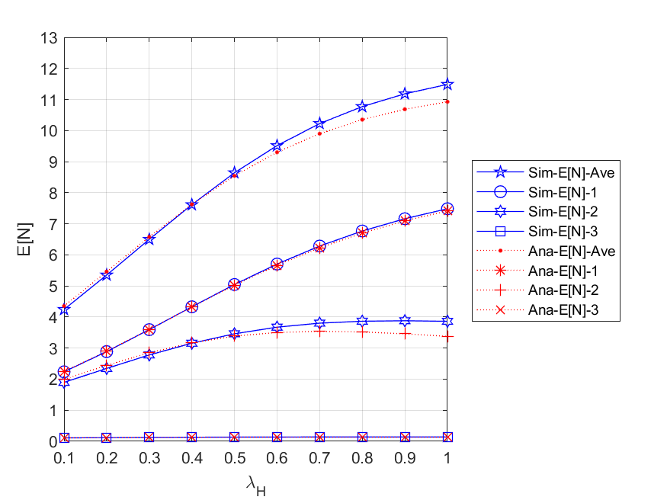

Fig. 5 - 72: The expected number of all packets in the network and each node vs. the external HP packet arrival rate

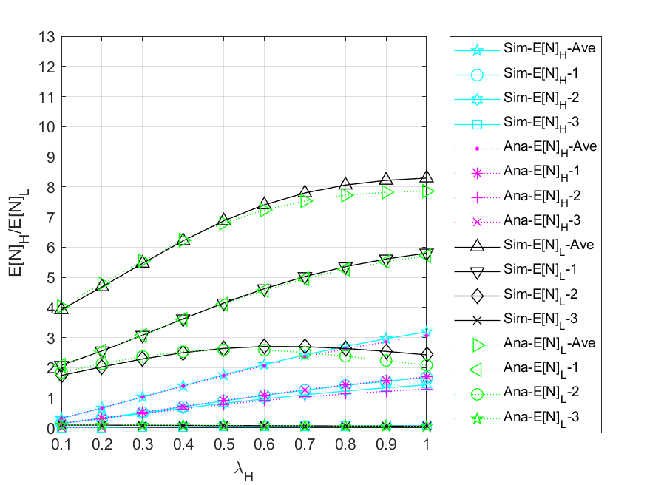

Fig. 5 - 73: The expected number of HP and LP packets in the network and each node vs. the external HP packet arrival rate

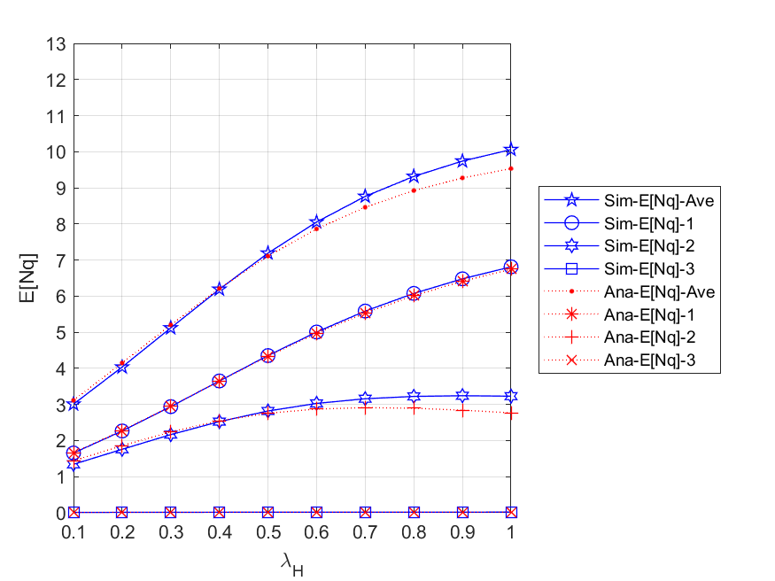

Fig. 5 - 74: The expected number of packets in queue for the network and each node vs. the external HP packet arrival rate

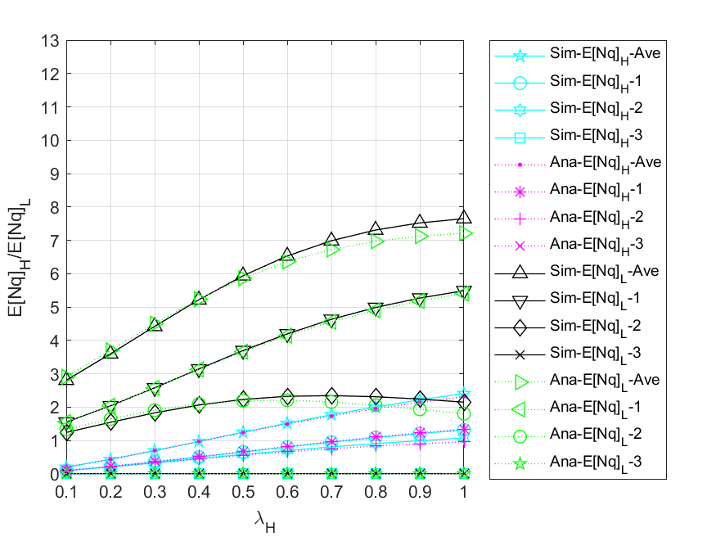

Fig. 5 - 75: The expected number of HP and LP packets in queue for the network and each node vs. the external HP packet arrival rate

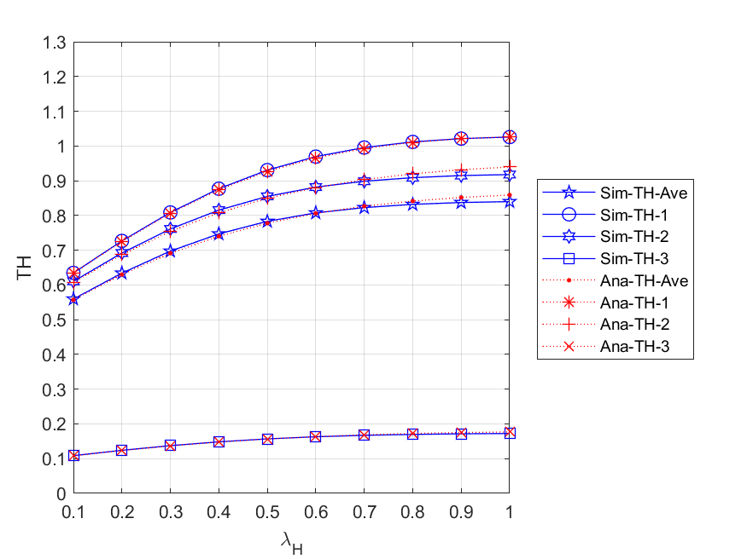

Fig. 5 - 76: The throughputs of the network and each node vs. the external HP packet arrival rate

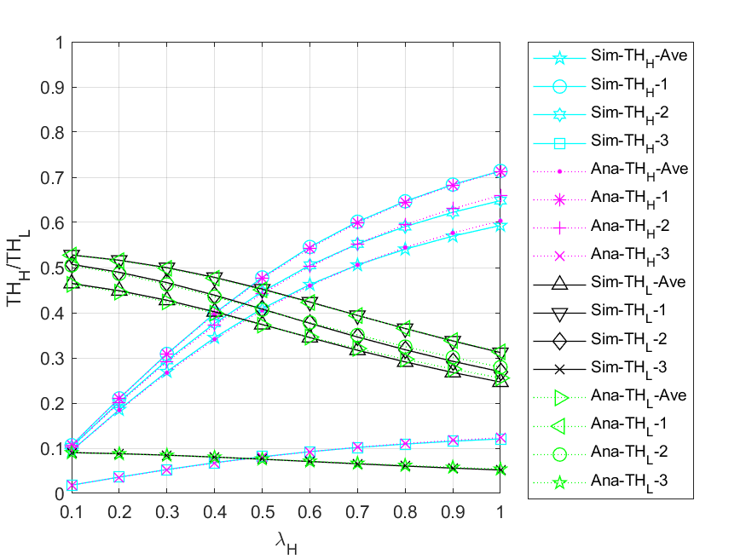

Fig. 5 - 77: The throughputs of HP and LP packets for the network and each node vs. the external HP packet arrival rate

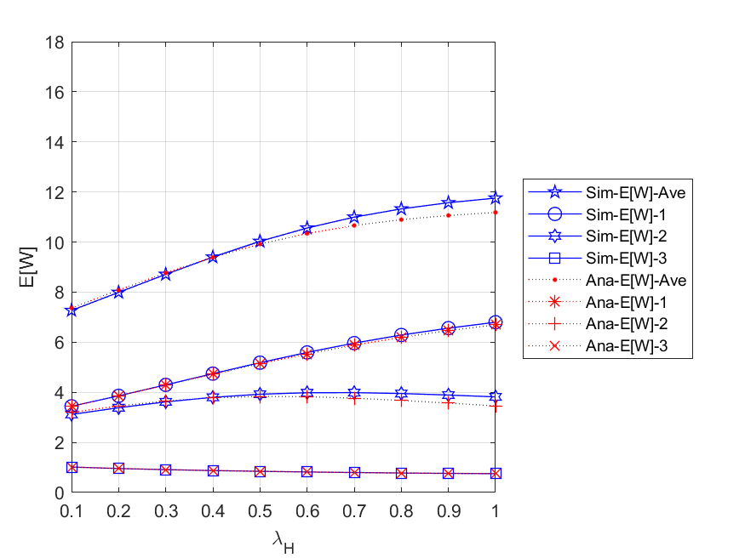

Fig. 5 - 78: The mean waiting time of all packets in the network and each node vs. the external HP packet arrival rate

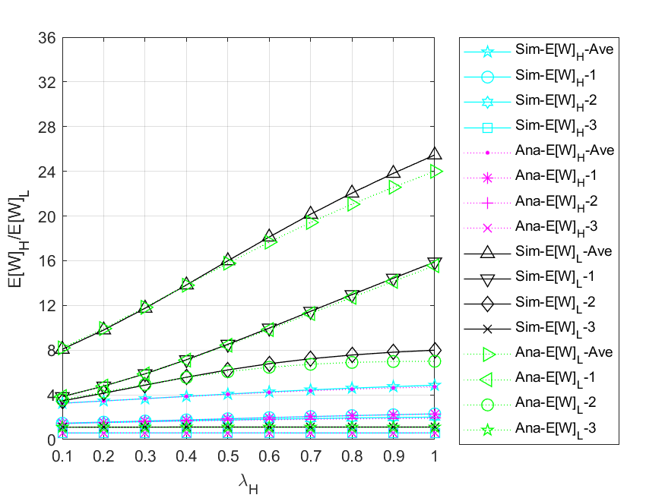

Fig. 5 - 79: The mean waiting time of HP and LP packets in the network and each node vs. the external HP packet arrival rate

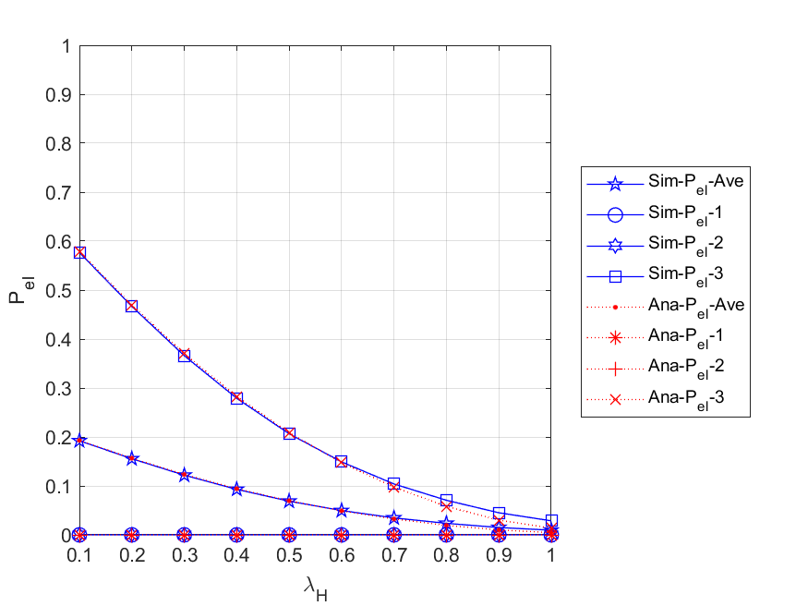

Fig. 5 - 80: The energy loss probabilities of the network and each node vs. the external HP packet arrival rate

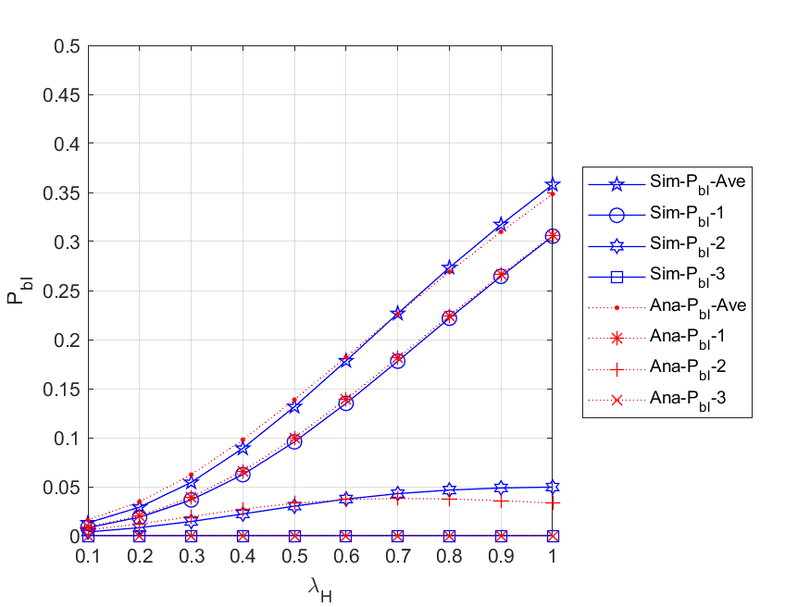

Fig. 5 - 81: The blocking probabilities for all arrived packets of the network and each node vs. the external HP packet arrival rate

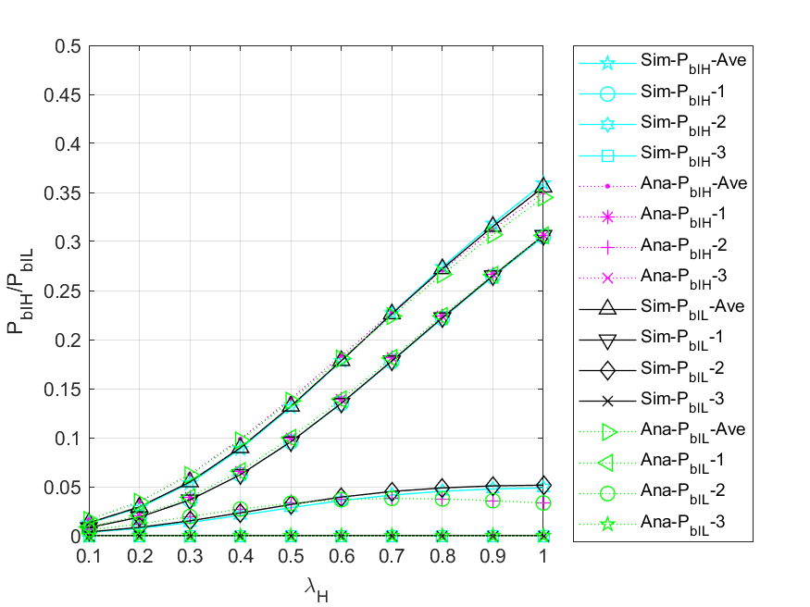

Fig. 5 - 82: The blocking probabilities for arrived HP and LP packets of the network and each node vs. the external HP packet arrival rate

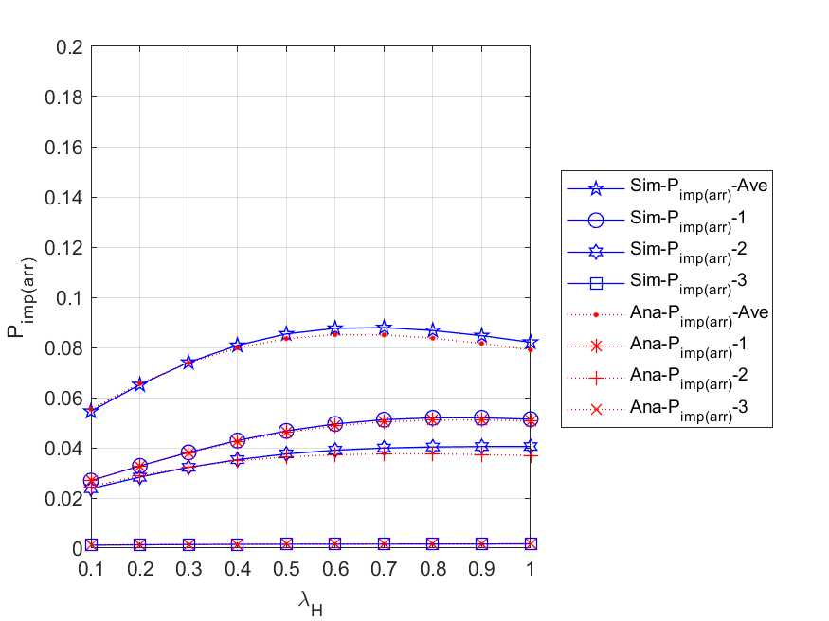

Fig. 5 - 83: The impatient loss probabilities for all arrived packets of the network and each node vs. the external HP packet arrival rate

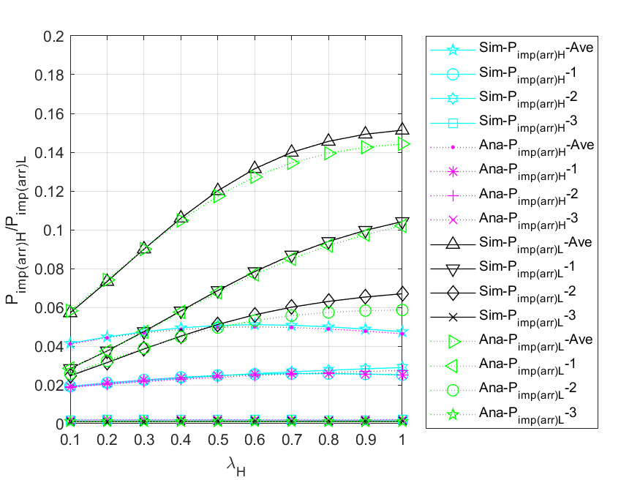

Fig. 5 - 84: The impatient loss probabilities for all arrived HP and LP packets of the network and each node vs. the external HP packet arrival rate

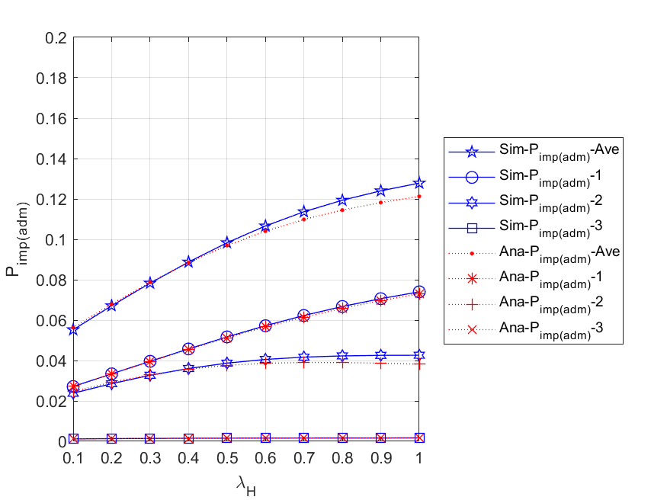

Fig. 5 - 85: The impatient loss probabilities for all admitted packets of the network and each node vs. the external HP packet arrival rate

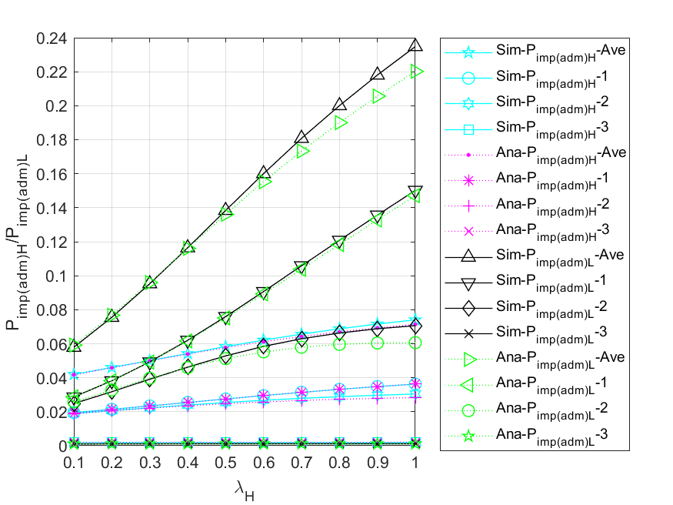

Fig. 5 - 86: The impatient loss probabilities for all admitted HP and LP packets of the network and each node vs. the external HP packet arrival rate

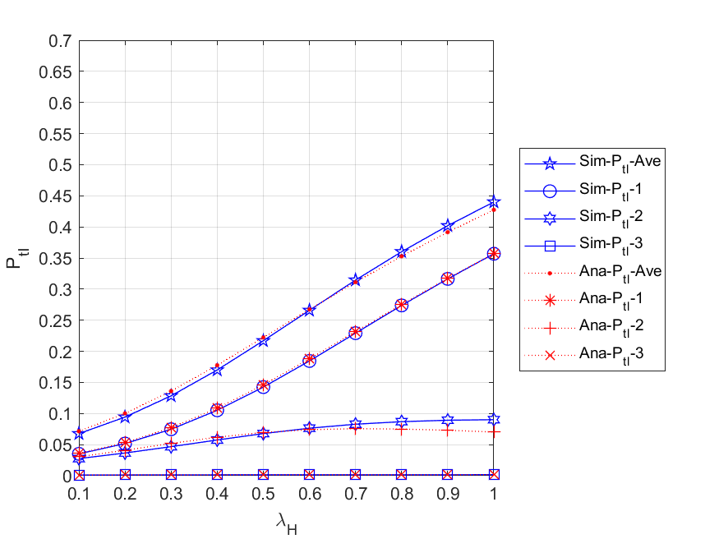

Fig. 5 - 87: The total loss probabilities for all arrived packets of the network and each node vs. the external HP packet arrival rate

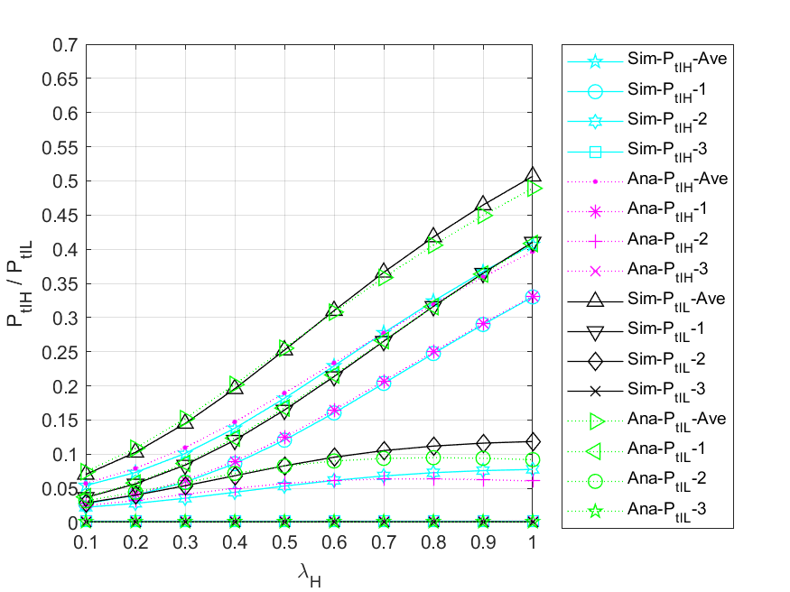

Fig. 5 - 88: The total loss probabilities for all arrived packets of the network and each node vs. the external HP packet arrival rate

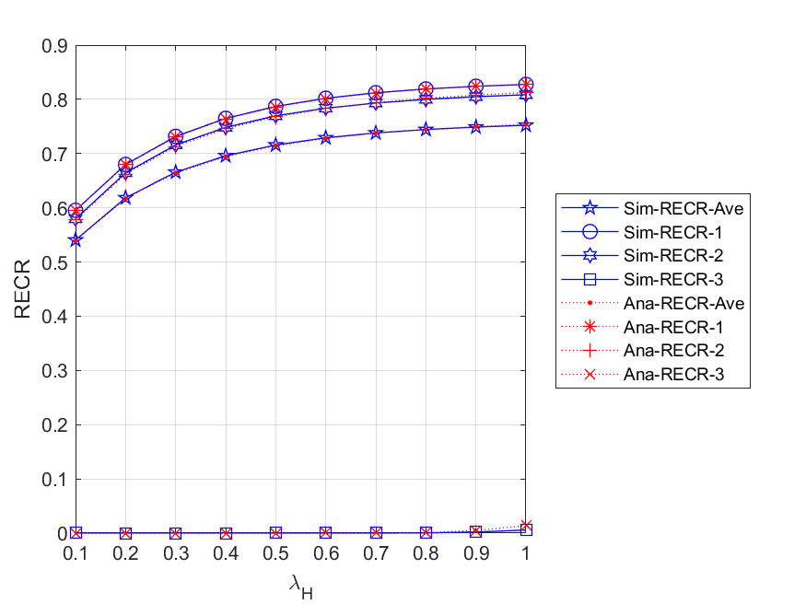

Fig. 5 - 89: The regular energy consumption ratio for serving all packets of the network and each node vs. the external HP packet arrival rate

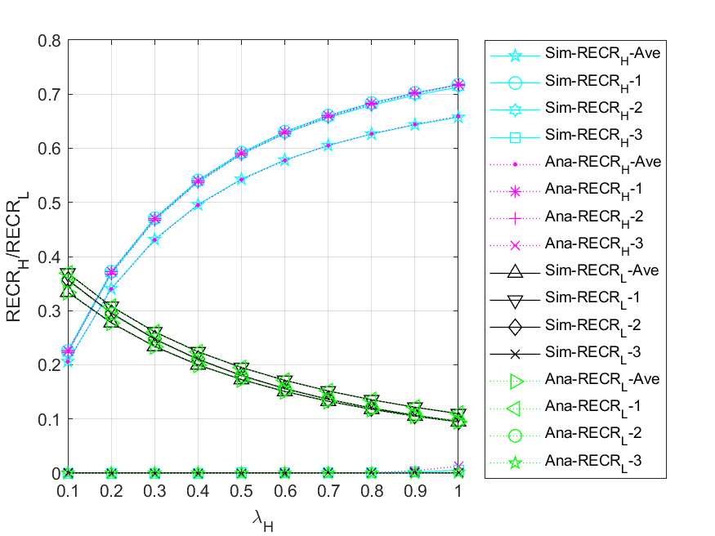

Fig. 5 - 90: The regular energy consumption ratio for serving HP and LP packets of the network and each node vs. the external HP packet arrival rate

* + 1. **Regular battery usage probabilities**

This subsection compares the scenario without regular battery with the default values. More specifically, we study the impacts of the external HP packet arrival rate on various performance measures for different regular battery usage probabilities, i.e., ${θ_{H}}/{θ_{L}}=0.0$ and $0.7$, and the results are shown in Fig. 5 - 91 to Fig. 5 - 98. Further, since our main concern is the overall network performance, only average values of network models are considered.

Fig. 5 - 91 shows the relationship between the expected number of all $(HP,LP)$ packets in the network $E[N]$ $\left({E[N]}_{H},{E[N]}_{L}\right)$ and the external HP packet arrival rate for different regular battery usage probabilities . First, for and , we can observe that the curve with is lower than the curve with at the beginning, but gradually exceeds it as increases. This is because the higher the regular battery usage probabilities, the more packets can be immediately served and routed to the other nodes rather than backlogged in the entry node. Second, for , due to the same reason as mentioned above and the discipline of non-preemptive priority, HP packets can be routed to the other nodes more easily, so the values of are higher than those of . Lastly, for , we can find that gradually decreases as increases. It is because the higher the arrival rate of the external HP packets, the longer LP packets need to wait in the queues, which makes LP packets more vulnerable to impatience and priority discipline.

Fig. 5 - 92 shows the relationship between the throughput of the network $TH$ $\left({TH}_{H},{TH}_{L}\right)$ and the external HP packet arrival rate $λ_{H}$ for different regular battery usage probabilities . For , , and , respectively, it is evident that the curve with is higher than the curve with . This is because the higher the probabilities of regular battery usage, the more likely the packets in each node can be served. In addition, for ${θ_{H}}/{θ_{L}}=0.0$, we observe that the throughput gradually decreases with increasing $λ_{H}$. The reason is that, on the one hand, as increases, the energy request rate will become extremely high, since each HP packet requires two units of energy, resulting in insufficient energy supply. On the other hand, as HP packets have a non-preemptive priority over LP packets, the more HP packets enter the server to complete the service, the fewer LP packets can be served.

Fig. 5 - 93 shows the relationship between the mean waiting time of all $(HP,LP)$ packets in the network $E[W]$ $\left({E\left[W\right]}_{H},{E\left[W\right]}_{L}\right)$ and the external HP packet arrival rate for different regular battery usage probabilities . First, it is obvious to observe that the curve with is lower than the curve with for , , and . The reason is that the higher the probabilities of regular battery usage, the more likely a packet can be served immediately in each node, and the shorter the delay time the packet has in the network. Second, due to the fact that HP packets have non-preemptive priority over LP packets, most LP packets are backlogged and waiting in queues. This results in not only the curve of is always higher than that of for both and , but the difference between the curves of and appears smaller than the difference between the curves. Lastly, we can see from the overall results that the model using the regular battery as an auxiliary energy resource has a significant improvement for both HP and LP packet performance.

Fig. 5 - 94 shows the relationship between the blocking probability for all $(HP,LP)$ arrived packets of the network $P_{bl}$ $(P_{bl_H}, P_{bl_L})$ and the external HP packet arrival rate for different regular battery usage probabilities . Since an arrived packet will be blocked regardless of its priority once the packet queue in the entry node becomes full, , , and are the same for and . In addition, we compare the curves of for different regular battery usage probabilities simultaneously. It is obvious to find that the curve with is higher than the one with . The reason is that the lower the probabilities of regular battery usage, the less likely the packets waiting in the queue can be served, which makes the entry node easier to become full.

Fig. 5 - 95 shows the relationship between the impatient loss probability for all $(HP,LP)$ arrived packets of the network $P_{imp(arr)}$ $(P_{imp\left(arr\right)_H},P_{imp\left(arr\right)_L})$ and the external HP packet arrival rate for different regular battery usage probabilities . According to the figure, no matter for , , and , we can find that the curve with is lower than the curve with at the beginning, but gradually exceeds it as increases. This is because the higher the regular battery usage probabilities, the more packets can be immediately served and routed to the other nodes rather than backlogged in the entry node. However, as the number of arrived packets increases, the other nodes in the network will gradually become congested, so as $λ_{H}$ increases, the impatient loss probability of arrived packets with ${θ_{H}}/{θ_{L}}=0.7$ will become larger than that with ${θ_{H}}/{θ_{L}}=0.0$.

Fig. 5 - 96 shows the relationship between the impatient loss probability for all $(HP,LP)$ admitted packets of the network $P_{imp(adm)}$ $(P_{imp\left(adm\right)_H},P_{imp\left(adm\right)_L})$ and the external HP packet arrival rate for different regular battery usage probabilities . First, it is obvious to find that for , , and , the curve with is lower than the curve with . This is because the higher the probabilities of regular battery usage, the more likely it is that a packet will be served immediately, and the fewer packets will lose patience in the network. Second, since HP packets have non-preemptive priority over LP packets, most LP packets are backlogged and waiting in nodes’ queues. This results in not only is always higher than for both and , but the difference between the curves of and appears smaller than the difference between the curves. Lastly, we can see from the overall results that the model using the regular battery as an auxiliary energy resource has a significant improvement for both HP and LP packet performance.

Fig. 5 - 97 shows the relationship between the total loss probability for all $(HP,LP)$ arrived packets of the network $P_{tl}$ $(P_{tl_H}, P_{tl_L})$ and the external HP packet arrival rate for different regular battery usage probabilities . We can observe from the figure that for , , and , as increases, the values of are always higher than those of . This is because the lower the probabilities of regular battery usage, the easier it is for the network to become congested, and the higher the chance of packet loss due to blocking or impatience. In addition, from the overall results, it is evident that using the regular battery as an auxiliary energy resource can improve the performance of both HP and LP packets.

Fig. 5 - 98 shows the relationship between regular energy consumption ratio for serving all $(HP,LP)$ packets of the network $RECR$ $({RECR}_{H},{RECR}_{L})$ and the external HP packet arrival rate $λ_{H}$ for different regular battery usage probabilities ${θ_{H}}/{θ_{L}}$. For ${θ_{H}}/{θ_{L}}=0.7$, we observe that with the increase of $λ_{H}$, $RECR$ and ${RECR}_{H}$ will increase as well, while ${RECR}_{L}$ will gradually decrease. This is because on the one hand, as increases, the energy request rate will become extremely high due to the energy requirement for each HP packet being two units. On the other hand, since HP packets have non-preemptive priority over LP packets, the more HP packets enter the server to complete the service, the fewer LP packets can be served. In addition, for the case of , regular battery is never used as an auxiliary energy resource, so the corresponding RECR curves always remain zero.

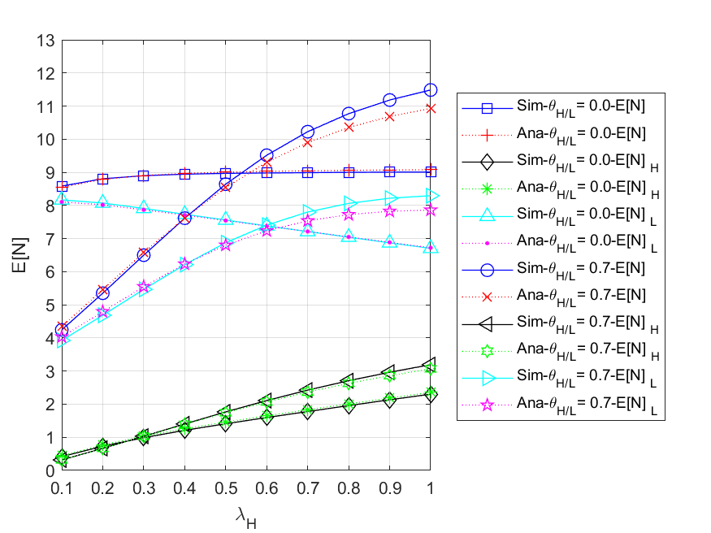

Fig. 5 - 91: The expected number of all ($HP,LP$) packets in the network vs. the external HP packet arrival rate for different regular battery usage probabilities

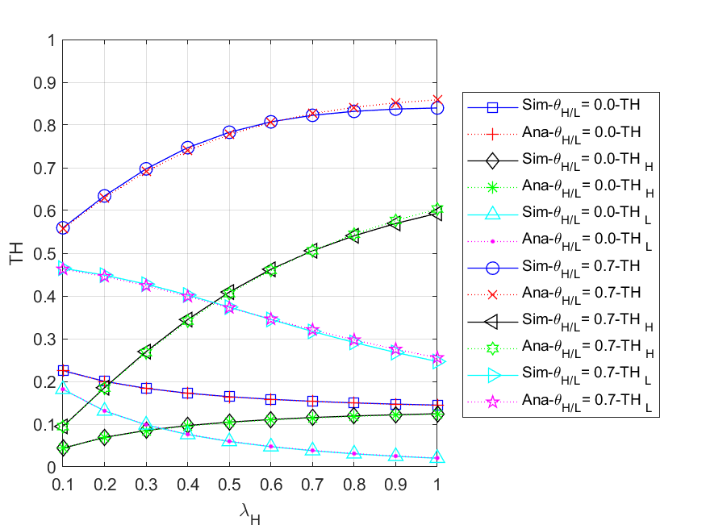

Fig. 5 - 92: The throughput of the network vs. the external HP packet arrival rate for different regular battery usage probabilities

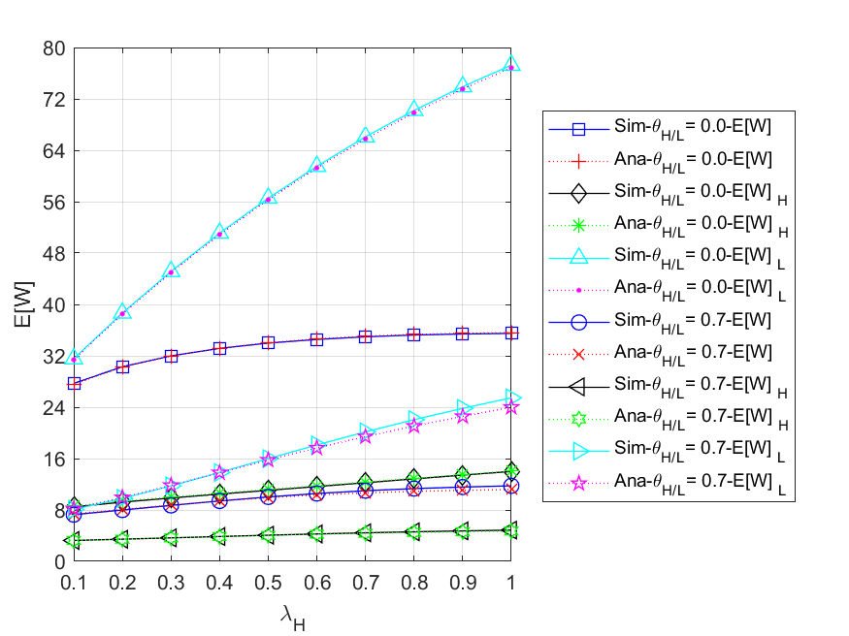

Fig. 5 - 93: The mean waiting time of all ($HP,LP$) packets in the network vs. the external HP packet arrival rate for different regular battery usage probabilities

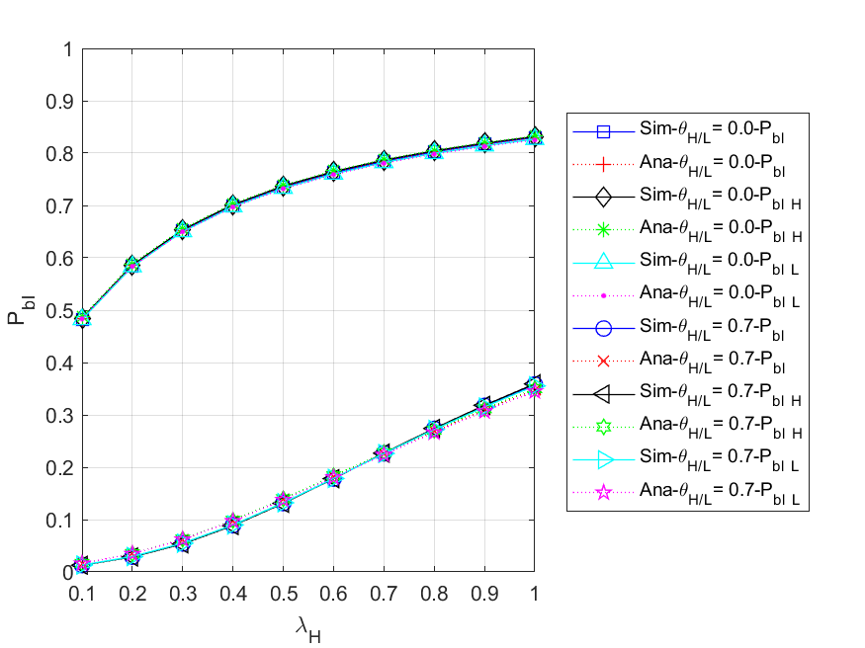

Fig. 5 - 94: The blocking probability for all ($HP,LP$) arrived packets of the network vs. the external HP packet arrival rate for different regular battery usage probabilities

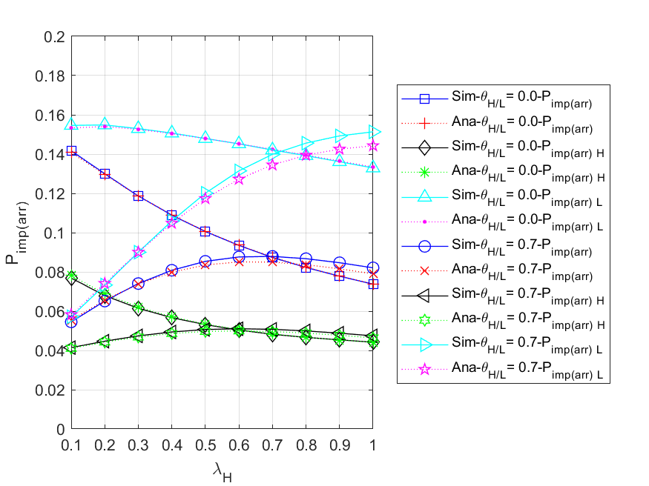

Fig. 5 - 95: The impatient loss probability for all ($HP,LP$) arrived packets of the network

vs. the external HP packet arrival rate for different regular battery usage probabilities

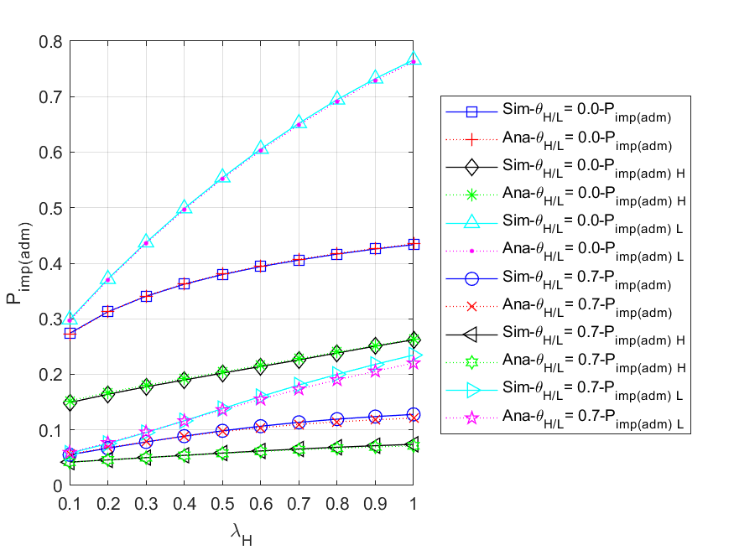

Fig. 5 - 96: The impatient loss probability for all ($HP,LP$) admitted packets of the network vs. the external HP packet arrival rate for different regular battery usage probabilities

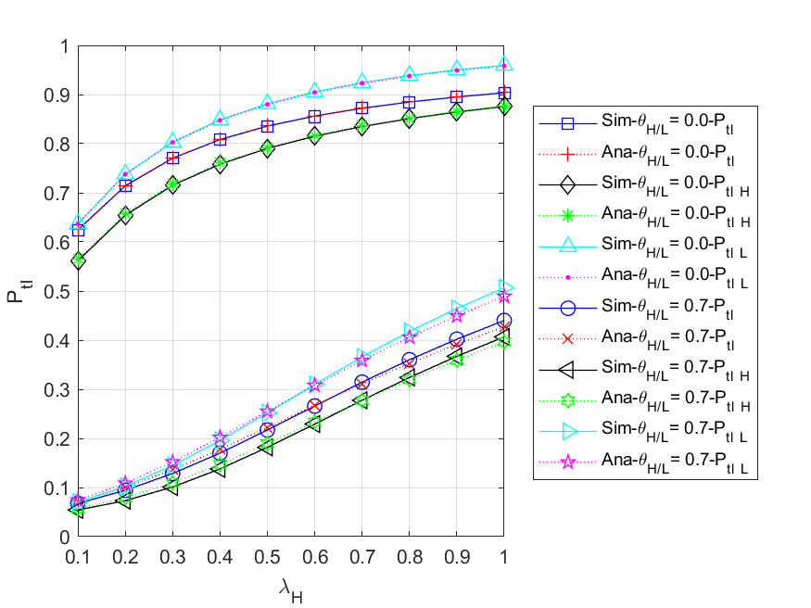

Fig. 5 - 97: The total loss probability for all ($HP,LP$) arrived packets of the network vs. the external HP packet arrival rate for different regular battery usage probabilities

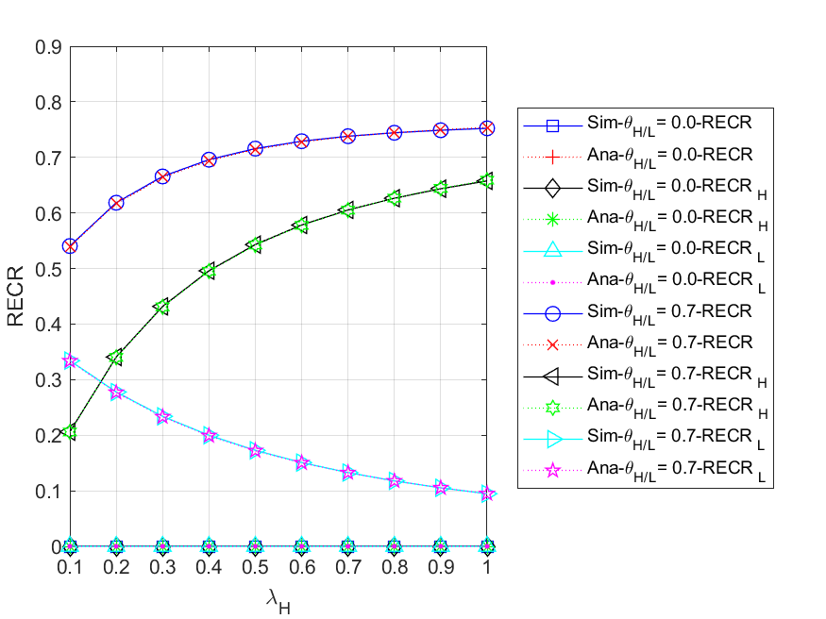

Fig. 5 - 98: The regular energy consumption ratio for serving all packets of the network

vs. the external HP packet arrival rate for different regular battery usage probabilities